ENCLOSURE C
October 16, 2023
OLDHAM COUNTY BOARD OF EDUCATION
CONCERN
Consider Declaration of Surplus Property
DISCUSSION
The disposal of surplus equipment requires the approval of the Board. Some of the items listed have been identified as equipment needing to be recycled, others have been identified as needing to be auctioned via the account that has been setup with Public Surplus (www.publicsurplus.com).
RECOMMENDATION
Authorize the disposal of surplus items as submitted.

On a motion by _______________, seconded by _______________, the Board authorized the disposal of surplus items as presented. ( , )

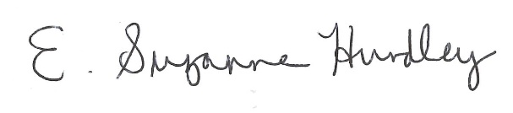
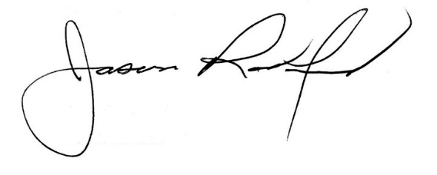

Suzanne Hundley, Board Chair Jason Radford, Superintendent/Secretary

