Director of District Support Services
Board Report - April 2024
Submitted by Katrina Rechtin
Director of Pupil Personnel
BISD 2023-24 Enrollment Information
(Numbers pulled from Infinite Campus on April 4, 2024)
GES |  | BMS/BHS
Preschool | 59 | 6 | 34
K | 40 | 7 | 32
1 | 29 | 8 | 44
2 | 41 | 9 | 47
3 | 36 | 10 | 59
4 | 28 | 11 | 55
5 | 33 | 12 | 64
Total | 266 | Total | 335
BISD Total Enrollment Preschool - 12th Grade: 601

2023-24 BISD Enrollment Summary
Month | Grandview Elementary | Bellevue High School | District
End of 22-23 School Year | 283 | 356 | 639
August 2023 | 267 | 325 | 592
September 2023 | 266 | 330 | 596
October 2023 | 267 | 333 | 600
November 2023 | 269 | 329 | 598
December 2023 | 269 | 328 | 597
January 2024 | 264 | 327 | 591
February 2024 | 262 | 326 | 588
March 2024 | 266 | 335 | 601

BISD Attendance
 | GES | BMS/BHS
August (8/16-8/31) | 96.03% | 95.82%
September (9/1 - 9/30) | 96.22% | 94.44%
October (10/1-10/31) | 96.14% | 92.99%
November (11/1-11/30) | 92.79% | 92.47%
December (12/1-12/6) | 93.61% | 93.74%
January (1/1-1/31) | 94.60% | 93.44%
February (2/1-2/29) | 92.86% | 92.21%
March (3/1-3/31) | 94.17% | 93.16%
August 16th - March 31st | 94.29% | 93.23%
District Attendance Percentage - August 16, 2023 -March 31, 2024 - 93.64%

BISD Attendance Comparison 22-23/23-24
(Start of school through March 31st)
 | 22-23 | 23-24 | Change
GES | 94.02% | 94.29% | +.27%
BMHS | 92.29% | 93.23% | +.94%
DISTRICT | 92.95% | 93.64% | +.69%

- All students in the district competed in a March Madness Attendance Challenge. The final two teams that made it to the Championship were 4th/5th grade and K/1st grade. The winner will be announced on April 5th. The winner will receive popsicles in the park.
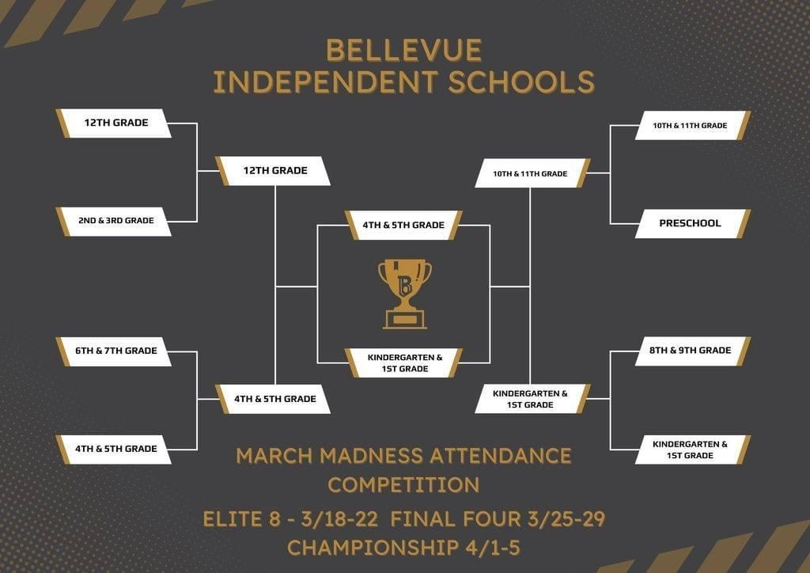

District Assessment Coordinator
- The School Report Card Data
- Winter MAP Summary - This includes achievement data and growth data for reading and math. Growth data is shown for Winter 22/23 to Winter 23/24 and Fall 23/24 to Winter 23/24.
- Spring MAP will take place this week, April 1st-5th. Once the testing window and makeup testing is complete, we will review achievement and growth.
- The District Assessment Calendar can be accessed HERE. This will be updated throughout the year as specific dates are released.
- Kentucky Summative Assessment planning is taking place in both buildings. We are working on scheduling and to ensure all aspects are planned. The testing schedule is included below:
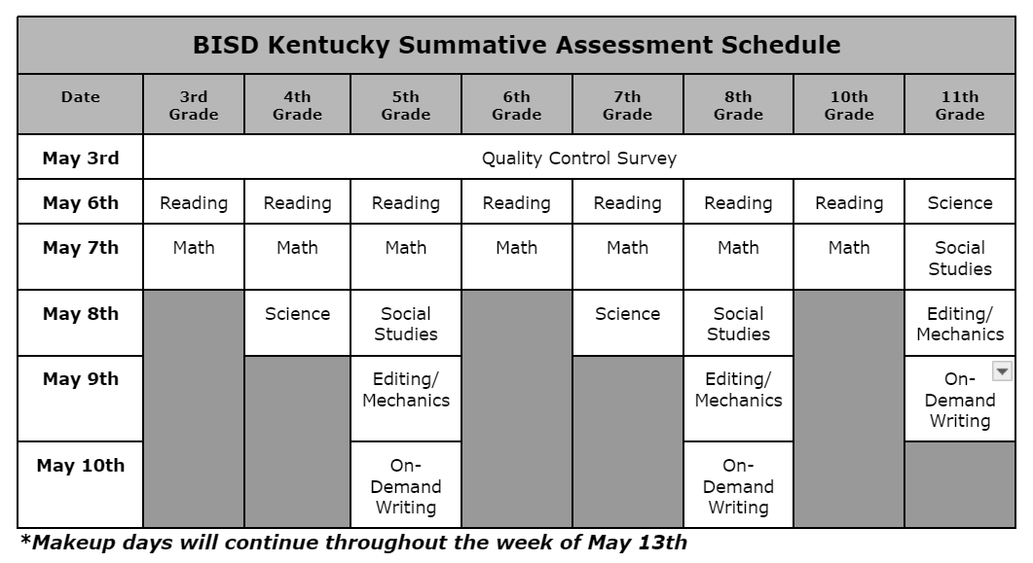
- The article linked HERE will be included in the Bellevue Community News this month.

