Bluegrass Middle School  SBDM Special Meeting Minutes  February 15, 2011  4:00 p.m., Bluegrass Media Center | SBDM Members:  Tracy Arflin, Teacher (present)  Jesse Floyd, Teacher (present)  Melissa VanZant, Teacher (present)  Jason Root, Parent (present)  Shawn Gibson, Parent  Michael Elmore, Principal (present)
- Called to Order
- Welcomed Visitors
- Approved January 19, 2011 Minutes
- Approved the Following Bell Schedule for 2011-2012 School Year
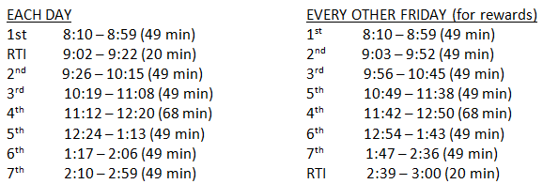
- Approved 2nd Reading of Promotion / Retention Policy
- Approved 1st Reading of Curriculum Policy with Minor Changes
- Approved Final Revision to the Council By-Laws
- Adjourned 4:30 pm. (Next special meeting date was set for March 2, 2011)

