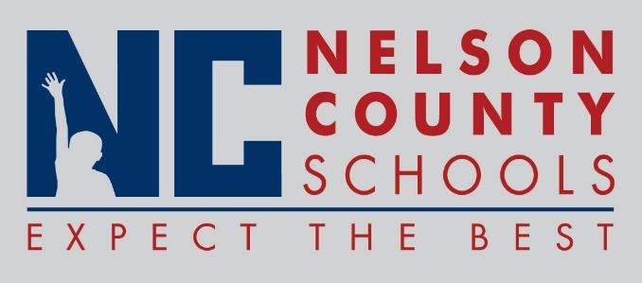

Decision Paper
To: | Nelson County Board of Education
From: | Tim Beck, Director of Student Support
cc: | Dr. Anthony Orr, Superintendent
Date: | June 21, 2016
Re: | 2016-2017 Code of Acceptable Behavior and Discipline

RECOMMENDATION: Approve the 20116-2017 Nelson County Schools Code of Acceptable Behavior and Discipline.

RECOMMENDED MOTION: I move that the Nelson County Board of Education Approve the 2016-2017 Nelson County Schools Code of Acceptable Behavior and Discipline.

