SBDM Minutes
Special Called Meeting
Monday, April 17, 2023

Members Present: Jared Scott, Glenn Lawson, Melissa Mallory, Autumn Miles, Sarah White, Megan McGuirk-Rogers, and Whitney Schuler

Guests: None: Samantha Dennis, Katie Dill, and Gina Pollet

Secretary: Judy Henry

1. Call the Meeting to Order: Mr. Scott called the meeting to order at 4:00 pm

2. Public Comment: None

3. Approve Minutes: (Attachment A) Motion by Glenn Lawson, seconded by Melissa Mallory to approve minutes for March 13, 2023. Consensus.

4. Approve Budget Reports (MUNIS and School Activity): (Attachment B) Motion by Glenn Lawson, seconded by Whitney Schuler to approve the budget reports for month ending March 31, 2023. Consensus.

5. Monthly Review: Enrollment 816

6. Principal’s Report: (Attachment C)

1. Title 1 Money: (Possibilities)
- $17,101 projected for 23-24 school year
i. Supplies-Technology Related: $11,034 designated for a program (AR or Lexia)
- ~$28,000 left from 22-23 school year
- We applied for a $40,000 reading grant with KDE
- If we DON’T get the grant…..$28,000 will go towards reading materials
- If we DO get the grant….$10,000 will go towards reading materials for 4th/5th grade.
2. SBDM Budget
- $114,112 projected for 23-24 school year
i. General Supplies: $10,012 designated for a program (AR or Lexia)
3. KSA
- Quality of School Climate scrimmage today (4% of total accountability)
- Content Scrimmage Tuesday (3rd-5th)
- On Demand Scrimmage Friday (K-5)
4. MAP Results (See Below)
Math

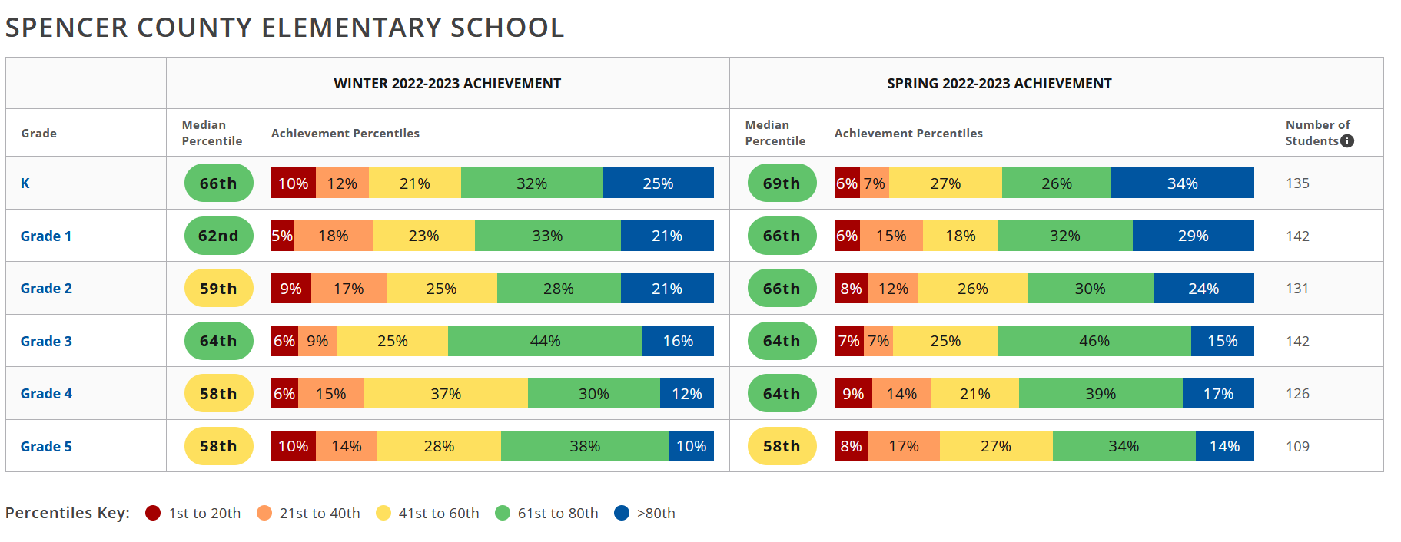

Reading
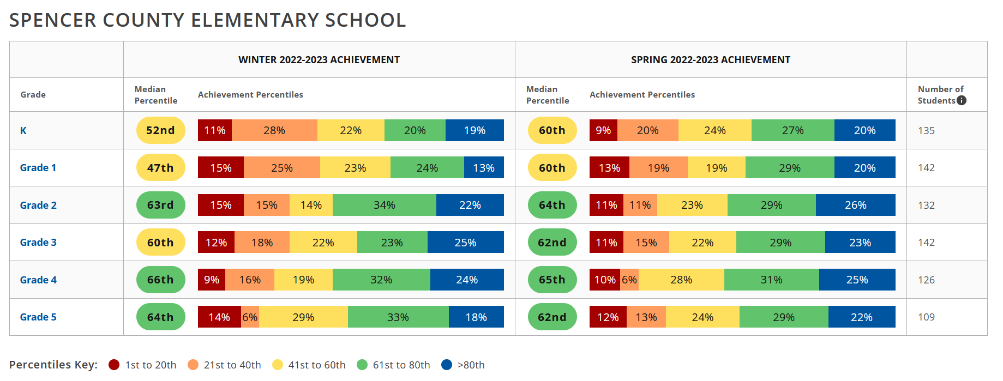

7. Committee Reports:
- Assessment: (Attachment D) Minutes from March 21, 2023
- School Planning & Budget: (Attachment E) Minutes from March 21, 2023
- School Climate, Culture, & Wellness: No report
- Curriculum / Instructional Practices: (Attachment F) Minutes from April 12, 2023
  - Instructional Practices Policy - (Attachment G) Motion by Glenn Lawson, seconded by Autumn Miles to approve the 1st Reading of the Instructional Practice Policy with minor additions/amendments. Consensus.
  - Literacy Plan Policy - (Attachment H) Motion by Glenn Lawson, seconded by Sarah White to approve the 1st Reading of the Literacy Plan Policy with additions/amendments. Consensus.
- PBIS: No report

8. Approve SBDM Budget 23-24 school year: (Attachment I) Motion by Glenn Lawson, seconded by Whitney Schuler to approve the SBDM Budget for 23-24 school year. Consensus.

9. Approve Title 1 Budget 23-24 school year: (Attachment J) Motion by Glenn Lawson, seconded by Megan McGuirk-Rogers to approve the Title 1 Budget for 23-24 school year. Consensus.

10. Approve Parent & Community Volunteer Coordinator/Cafe Monitor: (Attachment K) Motion by Autumn Miles, seconded by Melissa Mallory to approve the Parent & Community Volunteer Coordinator/Cafe Monitor. Consensus.

11. Approve 2nd Reading of the Charitable Fundraiser Policy: (Attachment L) Motion by Sarah White, seconded by Autumn Miles to approve the 2nd Reading of the Charitable Fundraiser Policy. Consensus.

12. Review Visitation Policy: (Attachment M) Motion by Glenn Lawson, seconded by Megan McGuirk-Rogers to approve the 1st Reading of the Visitation Policy with additions/amendments. Consensus.

13. Review/Approve Student Monitoring Systems: Tabled until next month’s meeting. (Waiting for quotes for the monitoring systems).

14. Approve SCES Dance Team Fundraisers and Club Fee: (Attachment N) Motion by Glenn Lawson, seconded by Autumn Miles to approve the SCES Dance Team Fundraisers and Club Fee for 23-24 school year. Consensus.

15. Executive Session as per KRS. 61.810 section 1 subsection f
Motion by Glenn Lawson, seconded by Melissa Mallory to go into Executive Session. Consensus.

Motion by Glenn Lawson, seconded by Sarah White to go into Regular Session. Consensus. No action taken.

16 Adjournment: Motion by Glenn Lawson, seconded by Sarah White to adjourn the meeting at 4:55 pm. Consensus.

Submitted by:
Judy Henry

