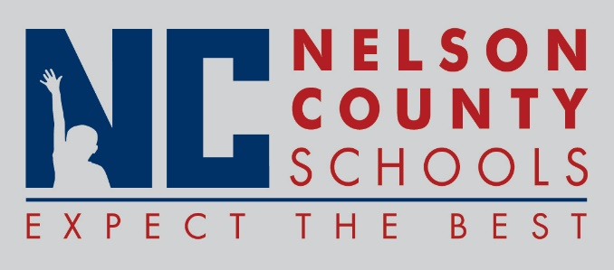

Information Paper
To: | Nelson County Board of Education
From: | Kimberly Brown
cc: | Mr. Tom Brown, Superintendent
Date: | February 20, 2018
Re: | Discussion of Foreign Exchange Policy 09.12

INFORMATION: The Nelson County Schools Foreign Exchange Policy 09.12 is in need of updating and discussion:

- Foreign Exchange students are encouraged to participate in high school graduation experiences;
- In the past, students who complete a year of study in a Nelson County High School received a Certificate of Completion;
- It is possible to conduct a transcript audit to determine if the foreign exchange student holds or has attained the credits to achieve a Kentucky High School Diploma;
- The Nelson County Schools currently accepts F-I visa student’s, could we also accept J-I visa students?
Definitions:

An F-1 visa is issued to international students who are
attending an academic program or English Language
Program at a US College or University. F1 students
must maintain the minimum Course load for full-time
student status. Part-time on campus employment is
allowed during periods of full study.

A J-1 is a non-immigrant visa issued by the United
States to Research scholars, professors and
exchange visitors participating in programs that
promote cultural exchange, especially to obtain
medical or business training within the U.S.

- Identify Issues/Concerns?

