Dayton High School
October 24th, 2018
Board Report from Principal Ryan Kellinghaus
- September SBDM minority election
- Upcoming KPREP data analysis with Rick and some teachers on 10/31 from 8:00-10:30. School-wide analysis with all staff will be on 11/6 to prepare CSIP. Work will be led with key core work processes.
- Testing:
  - CASE for 7th and 8th grade students – Awaiting results… will analyze with middle school/RTI teachers
  - Completing CERT makeups this week and high school RTI teachers will analyze
  - 10/2 ACT was rescheduled by ACT for 10/30
- Middle school dance on 10/5
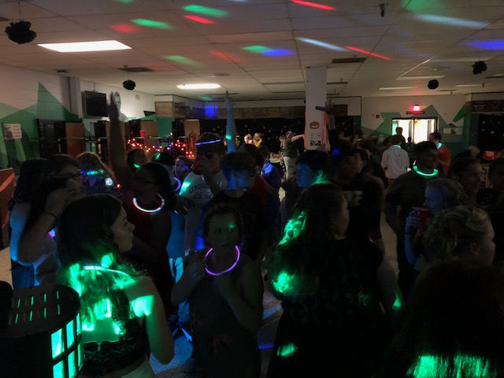
- Band competition - For the first time in nearly 10 years the DHS Marching Band has beaten the Bellevue Band of Gold. The Greendevils had a convincing win at the LaSalle Invitational by nearly 10 points against the Belevue band. Please cheer our band on October 29th – West Clermont HS and November 3rd – Norwood HS (Championships).
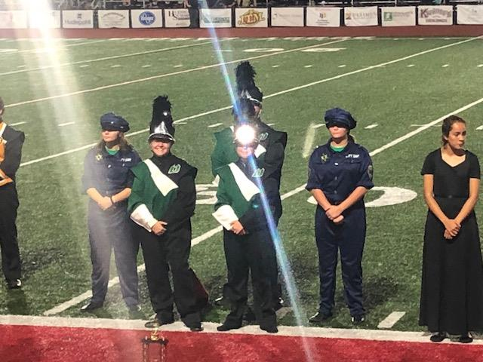
- Please join us for our Veteran’s day assembly coming up on November 9th at 9:00am and for our Family Fun Night of Enchantment on Nov 15th at 6:00pm!

