Regular Meeting Boone County Board of Education
September 10, 2015 7:30 PM
Ralph Rush Professional Development Center
99 Center Street
Florence, Kentucky 41042

I. CALL TO ORDER

The Regular meeting of the Boone County Schools Board of Education September 10, 2015 was called to order by Chairperson Bonnie Rickert at the Ralph Rush Staff Development Center. Mr. Massey informed the board he would not be present.
Attendance Taken at 7:30 PM:

Present Board Members:
Dr. Maria Brown
Ms. Karen Byrd
Ms. Bonnie Rickert
Mr. Steve Templeton

Absent Board Members:
Mr. Ed Massey

Gerry Dusing attended as Board Attorney
Karen Evans, Board Secretary, recorded the minutes.

II. NATIONAL ANTHEM
II.A. The National Anthem was presented by students of RA Jones Middle School.

III. PLEDGE TO THE FLAG
III.A. The Pledge to the Flag was led by students from Stephens Elementary School.

IV. STUDENT BOARD MEMBER REPRESENTATIVE REPORT
IV.A. Michael Henry gave the Student Board Member Representative report. Mr. Henry reported on the Student Advisory board’s progress across Boone County schools and reminded the audience of the Annual 5K Boone for Health Walk on October 24, 2015 at Idlewilde Park in Burlington.

V. GOOD NEWS
V.A. The board recognized the September 2015 Break the Mold Award recipient, Ms. Amy Kelly, of Cooper High School.
V.B. Mr. Tony Lamb of Kona Ice presented the board with a donation check to our schools in the amount of $38,740.00 for last year’s donation funds and another $10,000 to start the 15-16 school year.
V.C. The board recognized Beth McIntire, Laura Dumancic and Katie Hiatt for their support of our students through the wonderful work of GO PANTRY. GO PANTRY provides food for students in need. Mr. Steve Templeton introduced the organizers of this great community project with a background of how GO Pantry was started and the positive impact they continue to make on with our students.
V.D. Mr. Dustin Dichiara, of Chick-fil-A, presented the board with the Stuff-the-Bus winner award check. The $500.00 check will be split with Kenton County Family Resources as well as Boone County Family Resource Center. Over 2,000 items was collected for our students in need.
V.E. The board recognized and congratulated the September 2015 Parent Power Award recipients as follows:

September Boone County Schools Parent Power Award Recipients are:
Boone County High School: Kim Hurst, Katie Sharp
Cooper High School: Jackie Myers
Ryle High School: Jeremy Erickson, Cherie Shields, Christina Gonzales, Dianna Taylor
Erbenbeck Elementary School: Staci Leiker
Florence Elementary School: Kayla Wharff
Goodridge Elementary School: Tony Carota, Chris Scherff
Kelly Elementary: Julie Lancaster
Longbranch Elementary: Erin Tuemler Hermann
New Haven Elementary School: Krista Brassine
North Pointe Elementary School: Jean Mason
Ockerman Elementary School: Richard Klein
Stephens Elementary School: Chris Schroder

V.F. The board recognized the 2015 Boone County Schools Retirees for their dedication and service to our students and schools.

KATHY BACELIERI
JANET BAKER
BRENDA BALDWIN
JENNIFER BARNHILL
MARILYN BAUMGARTNER
VICKI BEGLEY
PATRICK BERRY
KIMBERLY BORGMAN
VICKI BOWMAN
CATHERINE BRIGGS
JEANNE BURING
JACQUELINE BURTON-RATCLIFF
LINDA CARTER
PATRICK COLLINS
BARBARA CRIDER
DIANA CURTIS
JUNE EILERS
GREGORY FRANK
BRENDA FREKING
ELLEN GRIMME
MARY HAARBERG
MARY HACKER
RICHARD HALL
MARY HANGER
BEVERLY HASTINGS
CHARLES HOBBS
CHERYL HODGES
SANDRA HOLTZAPFEL
SHARON HOWARD
CAROLYN INGRAM
LARRY JAHNKE
ANDREW JESENSKY
RICK JONES
JAY JORDAN
CAROL KANABROSKI
LINDA KELLS
ADELE KLARE
NANCY LEISL
PEGGY MCCLURE
MAUREEN MCDONALD
RITA MERCHANT
LINDA NAPIER
LISBETH NORTHCUTT
RONALD OTTE
SHEILA PEENO
LINDA PUMPHREY
CATHLEEN RAHSCHULTE
LYNDA RANDALL
JANET RANSDELL
JOHN SCHEPER
WAYNE SHIPLEY
MARY SMITH
STEPHEN SORRELL
SANDRA STROTMAN
ELISABETH STURNIOLO
DENNIS SULLIVAN
CONSTANCE VANTREECK
JANICE WALBOURN
REBEKAH WARNER
ANN WILFORD
VIRGIL WILSON
KAREN WOODWARD
DAVID YOUNG
PAMELA ZELLER
MARK ZIEGLER

V.G. Introduction of Mrs. Linda Black, new Director of Elementary Learning Services.

VI. AUDIENCE OF CITIZENS
Mr. Kirk Mackenzie, music teacher at Stephens Elementary, thanked the board for the new phone system. He stated it had been needed for several years. He spoke on the many important messages from parents that he would receive days later if at all with the old system. Mr. Mackenzie said he felt the new system was defiantly beneficial to him and the other teachers and thanked the board for their decision to make this possible.

VII. RECOMMENDED ACTION - CONSENT AGENDA
Dr. Poe, Superintendent, recommended the Consent Agenda items A-W for Board Approval, as presented.

- A motion was made by Karen Byrd, seconded by Maria Brown, to approve the consent agenda items A-W, as presented. Karen Byrd, Maria Brown, Steve Templeton and Bonne Rickert voted, “aye” MOTION: The motion passed 4-0.

VII.A. Minutes of the regular board meeting of August 13, 2015.
The board approved the minutes of the regular board meeting of August 13, 2015, as presented.
VII.B. Bill List
VII.C. Treasurer's Report - Report given by Mrs. Linda Schild, Treasurer
VII.D. Leaves of Absence
The board approved the following persons submitted leave of absence requests::
Recommended by Principal/Supervisor for approval:
Bailey, Sarah, Teacher @ New Haven Elem, 10/6/2015 – 11/13/2015
Brendel, Elaine, Assistant Principal @ Ryle High School, 8/17/2015 – 8/28/2015
Carter, Amber, Teacher @ Stephens Elem, 8/12/2015 – 10/13/2015
Earsing, Melinda, Teacher @ Cooper High School, 11/6/2015 – 11/13/2015
Elliott, Regina, Teacher @ Camp Ernst Middle, 8/12/2015 – 10/9/2015
Kelly, Janet, Café Wrk @ Erpenbeck Elem, 8/11/2015 – 10/13/2015
*King, Holly, Teacher @ Ockerman Elem, 10/8/2015 – 12/18/2015
Kleier, Traci, Teacher @ Stephens Elem, 9/22/2015 – 10/30/2015
Lovins, Marissa, Teacher @ Ockerman Middle, 8/10/2015 – 9/18/2015
Vanover, Karyn, Para-Educator@ New Haven Elem, 8/13/2015 – 8/31/2015
Not Recommended by Principal/Supervisor for approval:
Amended Leaves:
Fischer, Patrice, Psychologist @ Student Services, 10/13/2015 - EOY
Gilliam, Regina, Custodian @ Burlington Elem, 6/22/2015 – 8/10/2015
McGuire, Leah, Custodian @ Burlington Elem, 6/24/2015 – 8/24/2015
Ritchie, Jonathan, Custodian @ Boone County High, 4/22/2015 – 10/19/2015
Slay, Sandy, Bookkeeper @ Finance, 7/6/2015 – 9/4/2015
Cancelled Leaves:
Baldwin, Lynn, Teacher @ Conner High School, 11/1/2015 – EOY (Dis. Retired)
Breeze, Marjorie Brooke, Teacher @ Special Education, 8/12/2015 – EOY (Resigned)

VII.E. Board Meeting Minutes of the August 27, 2015 Public Tax Hearing.
The board approved the minutes of the August 27, 2015 Public Tax Hearing and Special Board Meeting as presented.
VII.F. Independent Contractor Agreement Services Agreement Center for Applied Informatics (CAI)
The board approved the Independent Contractor Agreement Services Agreement Center for Applied Informatics (CAI), as presented.
VII.G. Change Order #1- Paving 2015 Cooper High School, Longbranch Elementary, Thornwilde Elementary and Ryle High School BG# 15-064.
The board approved the Change Order #1- Paving 2015 Cooper High School, Longbranch Elementary, Thornwilde Elementary and Ryle High School BG# 15-064 with the addition of $4520.00, as presented.
VII.H. Change Order #1 Roofing 2015- BES,GES, NHE, Boone County Area Technology Center BG#15-063.
The board approved the Change Order #1 Roofing 2015- BES,GES, NHE, Boone County Area Technology Center BG#15-063 with a deduction of $385.00, as presented.
VII.I. Change Order #1 Erpenbeck Elementary - Controls Upgrades BG#15-065
The board approved the Change Order #1 Erpenbeck Elementary - Controls Upgrades BG#15-065 in the additional amount of $9321.00, as presented.
VII.J. BG#15-303 New Haven Elementary Schematic Design Drawings
The board approved the BG#15-303 New Haven Elementary Schematic Design Drawings, as presented.
VII.K. Sales Campaigns
The board approved the Sales Campaigns, as presented.
VII.L. School Based Behavioral Health Screening Initiative Agreement
The board approved the School Based Behavioral Health Screening Initiative Agreement, as presented.
VII.M. Change Order #1 Boone County High School Replacement BG#15-062
The board approved the Change Order #1 Boone County High School Replacement BG#15-062 with the total addition of $5438.00, as presented.
VII.N. Surplus Items- Technology
The board approved and declared the technology items presented as surplus and approve the disposal of the items, as presented.
VII.O. Equipment Maintenance Agreement Florence Elementary Copiers
The board approved the equipment maintenance agreement for Florence Elementary three copiers with Millennium Business Systems, as presented.
VII.P. Surplus Platform Decking -Sale
The board approved the Surplus Platform Decking sale, as presented.
VII.Q. Schlechty Center Membership
The board approved the Schlechty Center Membership for 15-16, as presented.
VII.R. NCERT Membership 15-16
The board approved the NCERT Membership 15-16, as presented.
VII.S. Northern Kentucky Cooperative for Educational Services 2015-2016 Membership
The board approved the Northern Kentucky Cooperative for Educational Services 2015-2016 Membership, as presented.
VII.T. American Association of School Administrators 2016 Leadership Conference Ed Massey
The board approved the American Association of School Administrators 2016 Leadership Conference in Arizona on Feb 11-13, 2015 for Ed Massey, as presented.
VII.U. ARC/503 Chairperson for 15-16 School Year
The board approved the ARC/503 Chairpersons for 15-16 School Year, as presented.
VII.V. Field Trip Request
The board approved the Field Trip request, as presented.

School | Date Of Trip | Location | Reason
Boone County High School | April 21-23, 2016 | Gatlinburg, TN | Educational
Conner High School | October 23, 2015 | Indianapolis, IN | Marching Band Contest
Conner Middle School | March 11-13, 2016 | Huntsville, AL | Educational
Conner Middle School | April 22-24, 2016 | Chicago, IL | Educational
Conner Middle School | March 17-20, 2016 | Washington, DC | Educational
Cooper High School | October 23, 2015 | Brooks, KY | Educational
Ryle High School | September 26, 2015 | Nicholasville | Soccer Game

VII.W. Project AWARE Grant
The board approved the Project Aware grant, as presented.

VIII. RECOMMENDED ACTION - OLD BUSINESS
VIII.A. No Old Business

IX. RECOMMENDED ACTION - NEW BUSINESS
IX.A. Boone County School District Working Budget for 2016

Dr. Poe, Superintendent recommended for board approval the Boone County School District Working Budget for 2016, as presented.

- A motion was made by Steve Templeton , seconded by Karen Byrd, to approve the Boone County School District Working Budget for 2016, as presented. Karen Byrd, Maria Brown, Steve Templeton and Bonne Rickert voted, “aye” MOTION: The motion passed 4-0.

X. SUPERINTENDENT'S REPORT

Dr. Jim Detwiler, Assistant Superintendent Learning Support Services, presented a powerpoint and handouts to the board with a report updating the Boone County World Language program. Dr. Detwiler, presented the 2014-20415 K-5 World Language Rosetta Stone Pilot program in relationship to the district’s 5 year strategic plan of World Class Learners. Dr. Detwiler spoke at length on the Kentucky program of World Language and Global Competency. Discussion on High School baselines calculated using the 14-15 data in the fall of 2015 and accountability reporting in 15-16. Elementary baselines calculated using 2015-2016 data in the fall of 2016 and accountability reporting in 2016-2017. The pilot programs began at Collins Elementary and Ockerman Elementary.
Ms. Mary Beth McLain, World Language Teacher at Collins Elementary, presented on the program at Collins and the many success that she personally sees every day. She spoke on how the program began, changes made, and why it works. Ms. McLain gave examples of students in action and presented two world language student to speak to the board in Spanish. Ms. McLains detailed overview of the program entailed a usage report and the future of the program.

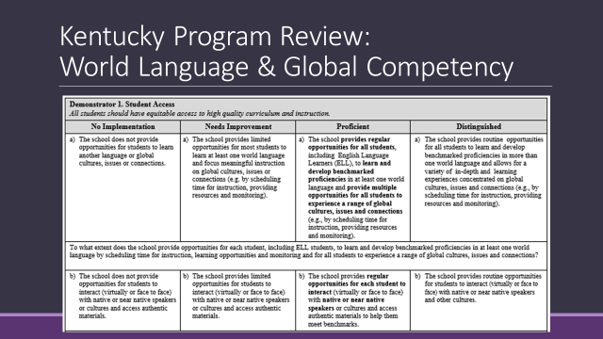
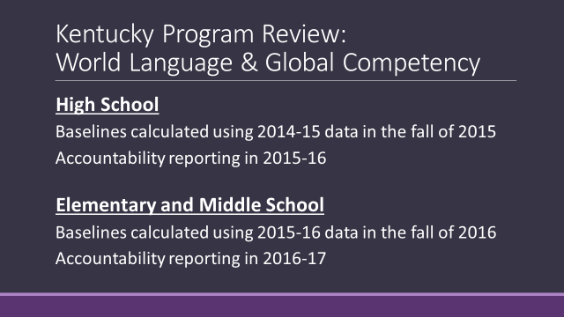

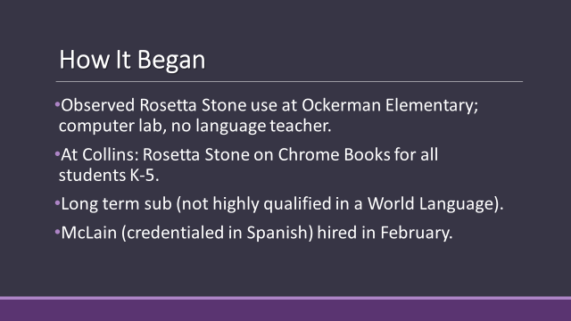

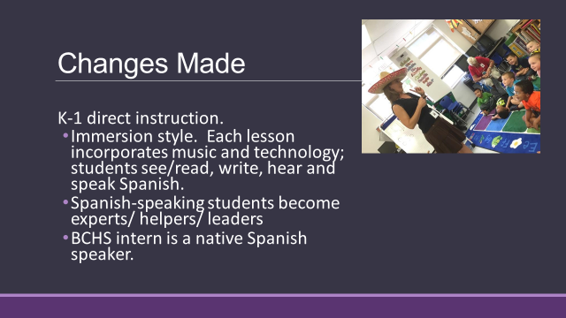

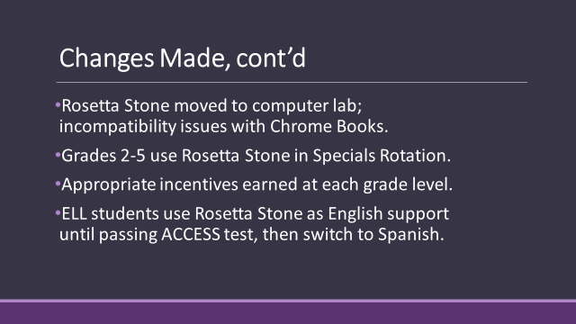
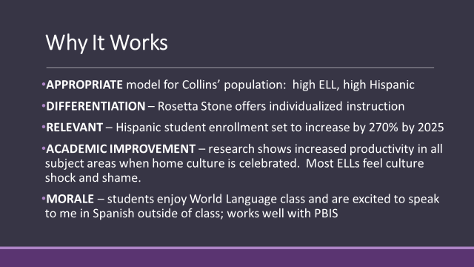
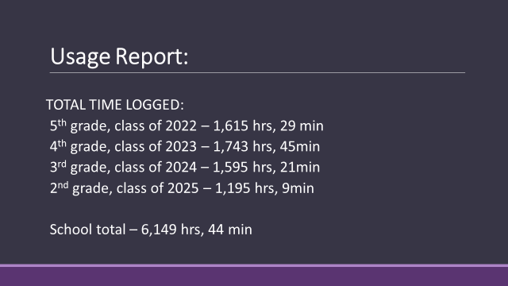

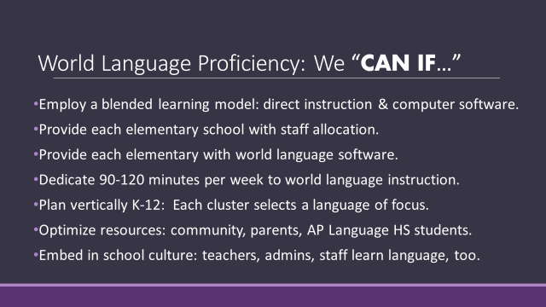

Kim Best, principal OES, presented an update to the board on the Ockerman Elementary program and the success of the program.

Dr. Poe discussed the program and its success and with the ability to now move forward with World Language from kindergarten to graduation, all of our students will have the opportunity to learn another language, which will be invaluable for their future careers.

- Dr. Poe discussed the Freedom Centers National Sing-along day on Friday, Sept. 11, 2015. Over 1,000 of our school students will be singing the National Anthem in honor and remembrance of the 9/11 tragedy.
- Dr. Poe announced the Professional Development for Board Members Workshop will be held at Ralph Rush on September 21, 2015 at 6:30 pm. This is an open meeting and all our welcome.

- Karen Byrd, announced the KSBA Regional Dinner will be held on October 20, 2015 at Receptions.

XI. INFORMATION, PROPOSALS, COMMUNICATIONS
XI.A. Human Resource Actions
XI.B. Worker's Compensation Claims
XI.C. Overtime Report
XI.D. Construction Status Report
XI.E. Energy Management Report August
XI.F. Kentucky Innovation Lab Network 15-16 Letter of Commitment for Boone County School

- Bonnie Rickert reported September 26, Go Pantry will be collecting food and other items at the Kroger Store in Hebron, Kentucky. The GP website will have more details.

XII. AUDIENCE OF CITIZENS
Lisa Newell and Hannah Ferguson, Education Majors at NKU and Gateway attended the meeting.

XIII. CLOSED EXECUTIVE SESSION PER KRS 61.810
XIII.A. No closed session

XIV. ADJOURN

- A motion was made by Karen Byrd, seconded by Maria Brown, to adjourn the meeting. Bonnie Rickert, Maria Brown, Karen Byrd and Steve Templeton voted, “aye” MOTION: The motion passed 4-0.

Meeting was adjourned at approximately 8:57 pm

_____________________________________
Bonnie Rickert/Chairperson

_____________________________________
Karen Evans/Secretary

