Regular Meeting Boone County Board of Education
March 09, 2017 7:30 PM
Ralph Rush Professional Development Center
99 Center Street
Florence, Kentucky 41042

I. CALL TO ORDER

The Regular meeting of the Boone County Schools Board of Education March 09, 2017 was called to order by Chairperson Ed Massey at the Ralph Rush Staff Development Center.

Attendance Taken at 7:30 PM:

Present Board Members:
Dr. Maria Brown
Mr. Ed Massey
Mr. Matt McIntire
Ms. Bonnie Rickert

Ms. Karen Byrd - unable to attend due to work commitment.

Gerry Dusing attended as Board Attorney
Karen Evans, Board Secretary, recorded the minutes.

II. NATIONAL ANTHEM
II.A. The National Anthem was presented by students the Gray Middle School 8th Grade Choir.

III. PLEDGE TO THE FLAG
III.A. The Pledge to the Flag was led by students with the U-Knighted Dolphins from Florence Elementary.

IV. STUDENT BOARD MEMBER REPRESENTATIVE REPORT
IV.A. Bradley Rodriquez gave a brief Student Board Member Representative report, reporting the last meeting was canceled due to school canceled. Bradley reported that the Delegate Assembly was postponed until the April meeting.

V. GOOD NEWS
V.A. The board recognized the 2017 March Break the Mold Winner, Ms. Carly Louden, Special Education Teacher at Stephens Elementary
V.B. The board recognized Mr. James Demtsakis, teacher at Ryle High School, as the 2017 NAACP Teacher of the Award recipient.
V.C. The board recognized the 2017 March Parent Power Award Recipients.
Congratulations to the 2017 March Parent Power Award Winners:

Boone County High School Alan Johnson
Conner High School Julie Welch
Cooper High School Adam Chaney
Joe Richard
Susan Pastor-Richard
Jimmy & Julie Threadgill

Ryle High School Mark Evans
Suzanne Kamp

Camp Ernst Middle School Julie Bond
Valerie Baily
Conner Middle School RJ Oliver
Burlington Elementary Josh Stidham
Josh Pabst
Adrianne Howson

Florence Elementary Sarah Scott

Goodridge Elementary Taylor Moore
Erin Humbert
Amanda Severns
Chris Scherff

Kelly Elementary Jordan & Rachel Jones
Ruby Butcher
William Johnson

Longbranch Elementary Sami & Seth Baker

New Haven Elementary Jennifer Gray

Thornwilde Elementary Lisa Cobble
Heather Wylann
Jenifer Inman

VI. AUDIENCE OF CITIZENS
No one spoke.

VII. RECOMMENDED ACTION - CONSENT AGENDA
Dr. Randy Poe, Superintendent, recommended the board approve the following Consent Agenda items A – V, as presented.

- A motion was made by Bonnie Rickert, seconded by Maria Brown, to approve the consent agenda items A-V, as presented. Maria Brown, Matt McIntire, Ed Massey and Bonne Rickert voted, “aye” MOTION: The motion passed 4-0.

VII.A. Minutes of the regular board meeting of February 9, 2017.
The board approved the minutes of the regular board meeting of February 9, 2017, as presented.
VII.B. Bill List
VII.C. Treasurer's Report was given by Mrs. Linda Schild.
VII.D. Leaves of Absence
The following persons submitted leave of absence requests was approved:
Recommended by Principal/Supervisor for approval:
Braun, Pam, Staff Support @ Burlington Elem, 2/20/2017 – 3/9/2017
Bryant, Kathleen, Teacher @ Ockerman Elem 4/3/2017 - EOY
Franklin, Rebecca, Guidance Counselor @ Stephens Elem, 3/20/2017 – 4/7/2017
Hall, Barbara, Café Worker @ Goodridge Elem, 1/30/2017 – 2/17/2017
Murray, Ronald, Custodian @ Stephens Elem, 2/8/2017 – 5/3/2017
Rowe, Elizabeth, Para Educator @ Gray/Ryle, 2/22/2017 – 3/6/2017
Sheperd, Alexandra, Teacher @ Burlington Elem, 4/26/2017 – 5/25/2017
Short, Susan, Teacher @ Burlington Elem, 2/10/2017 – 3/10/2017
Staten, Jennifer, Teacher @ Burlington Elem, 4/28/2017 - EOY
Sudenga, Jim, Bus Driver @ Transportation, 1/30/2017 – 2/17/2017
Turner, Halee, Teacher @ Cooper High School, 4/24/2017 – 5/5/2017
Winstel, Amy, Teacher @ Ryle High School, 2/6/2017 – 2/27/2017
Not Recommended by Principal/Supervisor for approval:
Nothing to Report
Amended Leaves:
Cahill, Rose Ann, Café Wrkr @ Boone County High, 9/7/2016 - EOY
Casson, Sarah, Teacher @ Gray Middle School, 1/25/2017 – 2/24/2017
Craddock, Jessica, Teacher @ Ockerman Elem, 3/17/2017 - EOY
Drake, Regina, Café Aide @ Yealey Elem, 11/28/2016 – 2/17/2017
Gilliam, Regina, Custodian @ Burlington Elem, 1/20/2017 – 4/14/2017
Gripshover, Andrea, Teacher @ Burlington Elem, 3/29/2017 – 4/28/2017
Kirby, Brian, Bus Driver @ Transportation, 2/17/2017 – 4/7/2017
Maynard, Diana, Bus Driver @ Transportation, 1/23/2017 – 2/3/2017
Pettit, Misty, Café Worker @ Boone County High, 1/11/2017 – 2/17/2017
Ritchie, Jonathan, Custodian @ Conner Middle School, 1/11/2017 – 3/24/2017
Shields, Ashley, Teacher @ New Haven Elem, 3/17/2017 – 5/19/2017
Toebbe, Laura, Teacher @ Ockerman Elem, 3/27/2017 – EOY
Walker, Nedra, Bus Driver @ Transportation, 2/7/2017 – 3/21/2017
Cancelled Leaves:
Dirksing, Mark, Teacher @ Cooper High School, 1/6/2017 – 1/27/2017
Jones, Arlene, Para Educator @ Burlington Elem, 12/19/2016 – 2/17/2017
Neil, Marilyn, Bus Aide @ Transportation, 2/16/2017 – 2/28/2017
VII.E. Declaration Statement
The board approved the superintendent to employ teachers or substitute teachers with emergency or adjunct instructor certification when no qualified teachers have applied for vacant positions, as presented.
VII.F. Surplus Equipment Sale
The board approved the Surplus Equipment Sale for March 7, 2017, recommend to the highest bidders, as presented.
VII.G. Surplus Technology
The board approved the approval and declared certain items surplus and to appr0ve the disposal of the items according to board policy, as presented.
VII.H. Conner High School Postage Equipment Rental Agreement
The board approved the Conner High School Postage Equipment Rental Agreement with Neopost, as presented.
VII.I. Insurance Broker Service Renewal
The board approved the Insurance Broker Service renewal bid to Roeding Insurance for the period of July 1, 2016 through June 30, 2017, as presented.
VII.J. Gaming Account for Conner High School
The board approved the Conner High School to open a gaming account for the primary purpose of operating a raffle to raise funds for a turf soccer/football field, as presented.
VII.K. Financial Auditor Services Renewal
The board approved the Financial Auditor Services renewal awarded to Barnes Dennig Company, as presented.
VII.L. Uniform Service Agreement
The board approved the Uniform Service Agreement for maintenance personnel in the Transportation Department to Cintas, as presented.
VII.M. Bid Award and Revised BG-1 for Central Office Annex Renovations BG#17-017
The board approved the Bid Award and Revised BG-1 for Central Office Annex Renovations BG#17-017, which will be on March 7, 2017 and information posted on March 9, 2017,as presented.
VII.N. Bid Award and revised BG-1 for Conner High School Reroofing BG# 17-084
The board approved the Bid Award and revised BG-1 for Conner High School Reroofing BG# 17-084, the bid will open on March 7 and information will be posted on March 8th, 2017, as presented.
VII.O. Modified Job Description - Chief Operating Officer/Deputy Superintendent
The board approved the Modified Job Description - Chief Operating Officer/Deputy Superintendent, as presented.
VII.P. Summer Food Service Program
The board approved the the Summer Food Service Program, as presented.
VII.Q. Kentucky Crime Prevention Through Environment Deign Checklist for the Ballyshannon Middle School
The board approved the Kentucky Crime Prevention Through Environment Design Checklist for the Ballyshannon Middle School, as presented.
VII.R. Change Order #1 Conner Middle School HVAC Phase 2 BG# 16-172
The board approved the Change Order #1 Conner Middle School HVAC Phase 2 BG# 16-172, this change order accepts the alternate #1 proposal, with addition of $117,000 as presented.
VII.S. Change Order #2 Ballyshannon Middle School BG#15-2279
The board approved the Change Order #2 for Ballyshannon Middle School BG#15-2279 in the amount of $76,996 addition, as presented.

VII.T. Bid Award and Revised BG-1 for Cooper High School Track Refurbishment BG# 17-018
The board approved the Bid Award and Revised BG-1 for Cooper High School Track Refurbishment BG# 17-018 to Current Sports, as presented.
VII.U. Field Trips
The board approved the Field Trips, as presented.

School | Date Of Trip | Location | Reason
Collins Elementary | April 5, 2017 | Fort Boonesborough/KY Horse Park | Educational
Conner Middle School | March 16, 2017 | Louisville | KMEA Orchestra Assessment
Conner Middle School | April 5, 2017 | Conner Prairie | Educational
Conner High School | March 31, 2107 | Louisville | State Archery Tournament
Conner High School | March 22, 2017 | Cold Springs | KMEA Assessment for Choir
Cooper High School | April 4, 2017 | Wright Patterson AF Base | Educational
Gray Middle School | May 18-22, 2017 | California | Lego League Championship
Kelly Elementary | April 17, 2017 | Frankfort | Educational
Longbranch Elementary | April 20, 2017 | COSI | Educational
Mann Elementary | April 28, 2017 | Frankfort | Educational
Ryle High School | April 25-28, 2017 | Anaheim, CA | DECA Nationals competition
Ryle High School | July 13-15, 2017 | Dalton, GA | Football Games
Ryle High School | August 28, 2017 | Lexington | Football Game
BCS District Robotics | March 22, 2017 | Huntsville, AL | Educational

VII.V. Bid Award and revised BG-1 for Paving 2017 Project BG#17-083
The board approved the Bid Award and revised BG-1 for Paving 2017 Project BG#17-083, the bid opening will be on March 7 and the bid award will be added on March 8th, as presented.

VIII. RECOMMENDED ACTION - OLD BUSINESS
VIII.A. No Old Business

IX. RECOMMENDED ACTION - NEW BUSINESS
IX.A. Request District Emergency Day for March 1, 2017
Dr. Poe recommended the board approve the request for district emergency day for March 1, 2017, as presented.

- A motion was made by Matt McIntire, seconded by Maria Brown, to approve the request for district emergency day for March 1, 2017, as presented. Maria Brown, Matt McIntire, Ed Massey and Bonne Rickert voted, “aye” MOTION: The motion passed 4-0.

Ed Massey and Dr. Poe thanked all the staff for making sure all the students were safe and all protocols and procedures were followed in the recent storm that caused so much damage in the district. Schools were closed due to the wind damages that caused power lines down and the many schools that had no power to operate that day.

IX.B. Request District Emergency Day for Kelly Elementary March 2, 2017
Dr. Poe recommended the board approve the request for district emergency day for Kelly Elementary on March 2, 2017, as presented.

- A motion was made by Maria Brown, seconded by Bonnie Rickert, to approve the request for district emergency day for Kelly Elementary on March 2, 2017, as presented. Maria Brown, Matt McIntire, Ed Massey and Bonne Rickert voted, “aye” MOTION: The motion passed 4-0.

Dr. Poe, discussed the need for another emergency day specifically for Kelly due to the power not being restored after the storm. In an emergency day situation the state does not require the staff to make up the day.

X. SUPERINTENDENT'S REPORT
X.A. Mike Ford, Director of Pupil Personnel, gave the following power point presentation to the board on Attendance data for the Boone County School District. Mr. Ford discussed the growth of the district and the positive attendance percentage of 96.02 for the district.

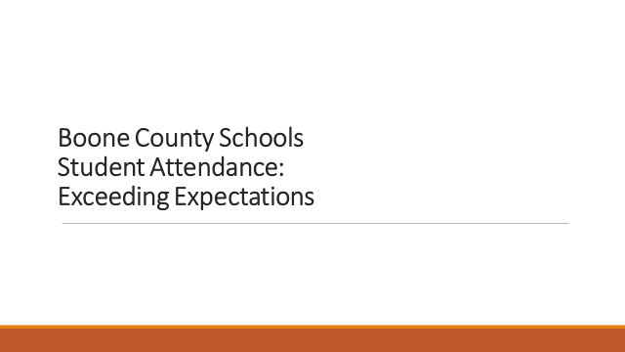

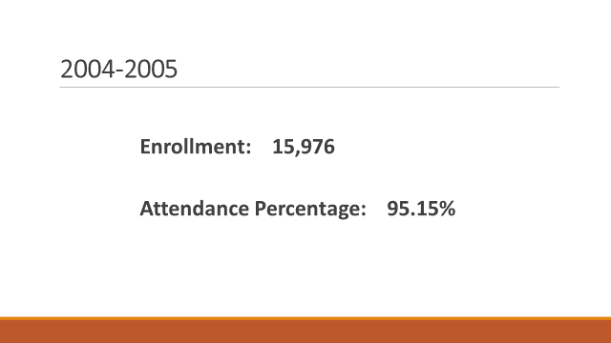

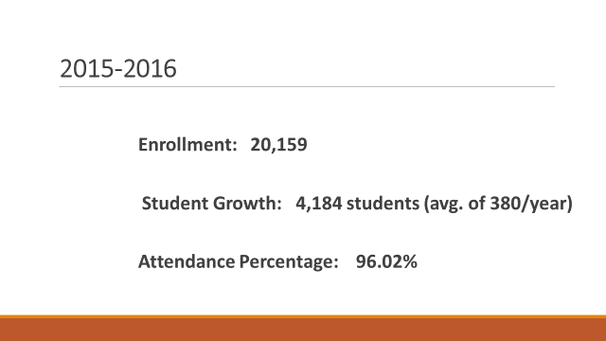

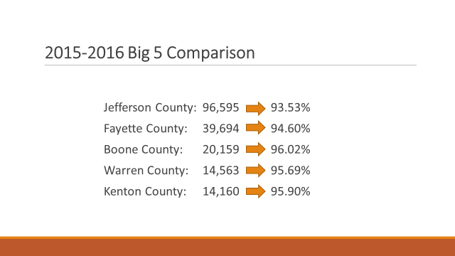
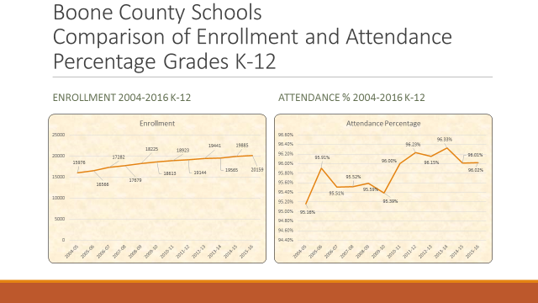

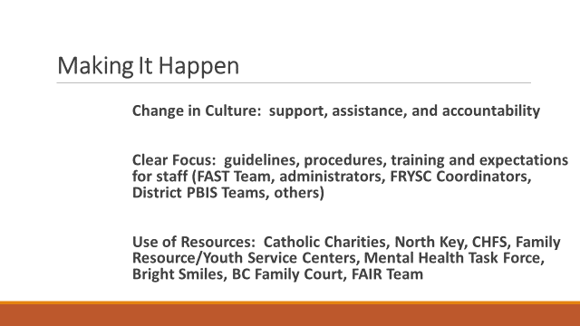

- Dr. Poe announced the tentative graduation dates for the High Schools and stressed the importance that these days are tentative only and depend on no additional weather related emergency school closings. Dr. Poe explained the BB & T arena facility is only a hold date until we are sure of no more emergency weather closings. The tentative graduation date schedule is as follows: Ryle High School – June 1st at 7:30pm, Boone High School – June 2nd at 7:30 pm, Conner High School- June 3rd at 10:00 am, Cooper High School – June 3rd at 2:00 pm. The last official day of school will be approved at the April board meeting and announced at that time.

XI. INFORMATION, PROPOSALS, COMMUNICATIONS
XI.A. Human Resource Actions
XI.B. Worker's Compensation Claims
XI.C. Overtime Report
XI.D. Construction Status Report
XI.E. Energy Management Report
XI.F. Education & Workforce Development Grant Letter
XI.G. FYI- Fernside Supporting Children and Families through Grief

- Ed Massey discussed the upcoming board member National School Board Association (NSBA) conference at the end of March. Ed Massey, Bonnie Rickert and Dr. Poe will be attending for the district.
- Ed Massey reported on the recent American Association of School Administrators (AASA) conference attended by Dr. Poe and Mr. Massey. Mr. Massey reported the entire essence of the conference was around personalized learning and discussed the conference provided valuable information to bring back to the district to continue work to improve all education for all students.
- Ed Massey discussed the some of the bills in the legislation and the Senate still working on. Mr. Massey spoke on the Charter Schools, the underfunding of programs the State mandates, SBDM Council Bill which would give an appeal process to the boards.
- Dr. Poe addressed the informational stage of the legislation and bills at this time, and he will continue to closely monitor.
- Dr. Brown discussed the removal of funding on mandate from Charter Schools.
- Bonnie Rickert publicly congratulated Cooper Basketball team for the Regional win, from all the board members.

- Dr. Poe announced the Special Board Workshop on Curriculum and Instruction Grading Policy 08.221 on March 21, 2017 at 6:30 pm, at Ralph Rush Professional Development Center.

- Dr. Poe announced the Special Board Workshop on the Accreditation Report on April 26, 2017 at 3:30 pm, at Ralph Rush Professional Development Center.

XII. AUDIENCE OF CITIZENS
(brief summary)
The following students attending college education majors introduced themselves to the board:
Kayleigh Wilhoite, Kylie Cosiett, Morgan Parrott, Gemma Viveiros, Katie Claxton, – Gateway, Peggy Nienaber- University of Cumberlands. Caroline Murray, Miranda Raper, Caitlin Brown, Kelli Harman – NKU.

XIII. CLOSED EXECUTIVE SESSION PER KRS 61.810
XIII.A. No closed session

XIV. ADJOURN

- A motion was made by Bonnie Rickert, seconded by Matt McIntire, to adjourn the meeting. Bonnie Rickert, Maria Brown, Ed Massey and Matt McIntire voted, “aye” MOTION: The motion passed 40.

Meeting was adjourned at approximately 8:42 pm.

_____________________________________
Ed Massey/Chairperson

_____________________________________
Karen Evans/Secretary

