THE NORTHERN KENTUCKY PARTNERSHIP ACADEMY FOR EARLY LEARNING LEADERS

WHO: PRESCHOOL AND KINDERGARTEN TEACHERS
WHEN: THURSDAY, MARCH 19, 5-8 P.M.
WHERE: METS CENTER
3861 OLYMPIC BOULEVARD, ERLANGER, KY

Dinner will be provided.
$15 for KAECE members/$30 for non-KAECE members

Choose between an infant/toddler (fine motor sensory) or preschool (art) “make & take” workshop. Each participant will earn two (2) hours of approved ECE-TRIS training.

Register by March 6 through Constant Contact at:
http://events.constantcontact.com/register/event?llr=uoi69ddab&oeidk=a07eaiicf6lf16b2a30

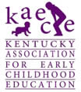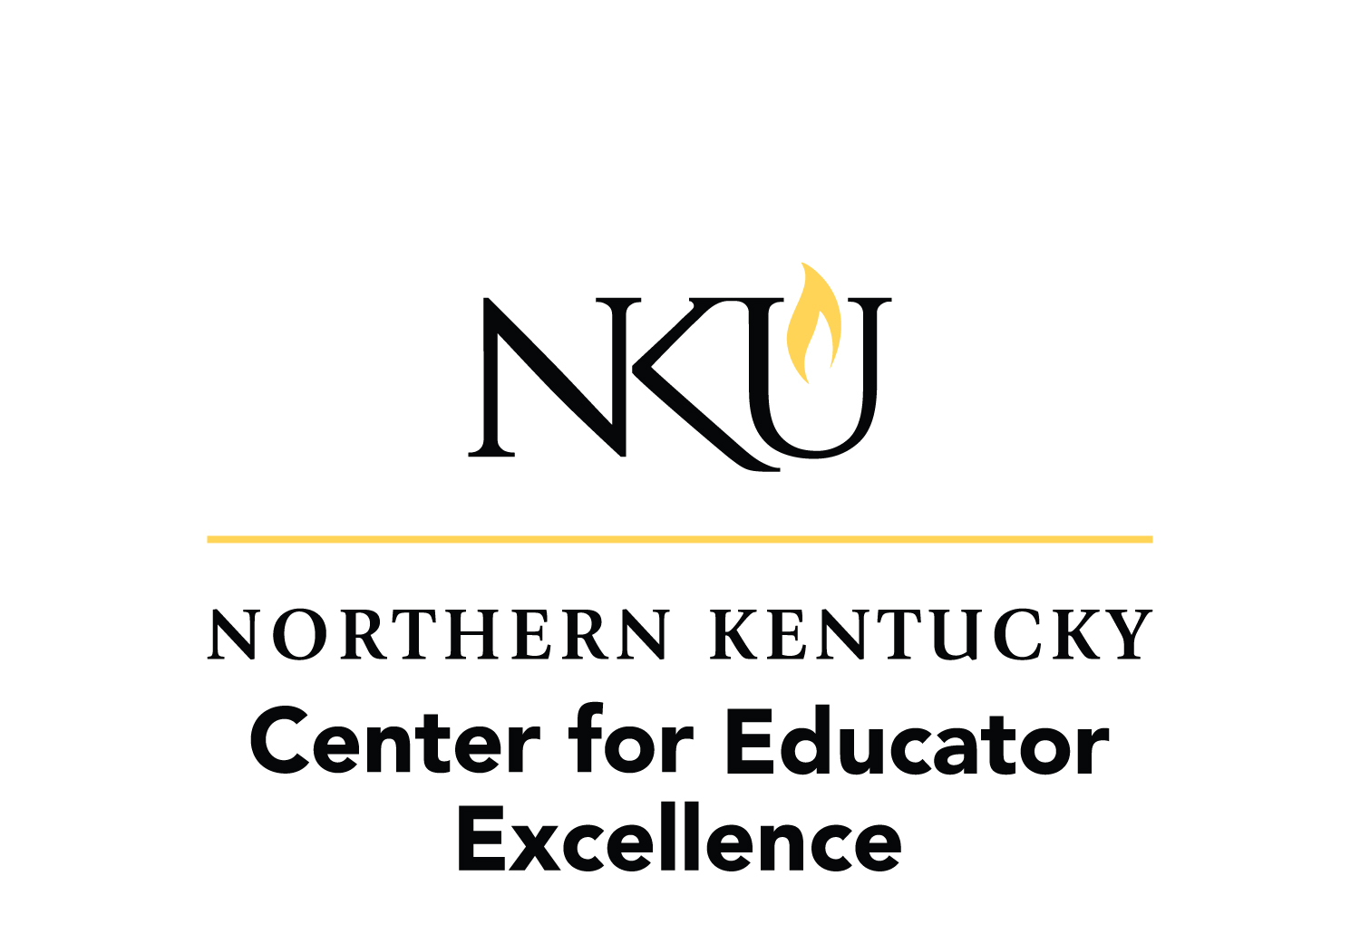

This publication was prepared by Northern Kentucky University. NKU is an affirmative action/equal opportunity institution. MC01206

