THIS IS AN INFORMATON PAPER:
TO: Members of the Hardin County Board of Education
FROM: Teresa Morgan, Superintendent
DATE: March 16, 2021
SUBJECT: Quotes for Student Accident Insurance/Roberts Insurance & Investments

DISCUSSION:
HCS has purchased Student Accident Insurance for all students for the past several years, rates are as follows: (2018-19) for $65,607, (2019-2020) 67,868. This year Robert’s Insurance & Investments has lowered the rate, under plan 4B with Berkley Accident and Health to $66,797.20 from last year. Competing companies offer the same plan with the following quotes Liberty Mutual Company ($67,277.20), Zurich American Insurance Company ($107,991.2), AXIS Insurance Company ($ 116,191.20), and Hartford Insurers ($110,744.20).
See Roberts bid info below:
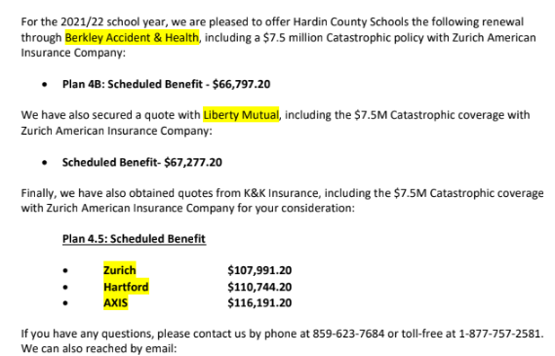

For the school year of 2018-19 there were a total of 29 injuries, total claim (bills)-725, with the amount claimed ($697,201.75), with Roberts paying out $61,314.98. For the current school year, 2019-20, total injuries numbered at 9, with 66 claims (bills), with the amount claimed ($59,449.04), with Roberts paying out $6,251.68 at this time.

