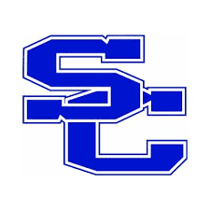
SPENCER COUNTY PUBLIC SCHOOLS
Board of Education Agenda Item

Meeting Date 7/25/2022

Topic/Title SCHS Fundraisers_____________

Presenter(s)

Type of Information/Board Action
☐ Information only. No Board action required.
☐ Action requested at a future meeting: Click or tap to enter a date.
☒ Consent agenda for approval at this meeting.
☐ Action requested at this meeting.

Board review is a result of:
☐ State or federal law or regulation.
☐ Board of Education policy.
☐ Past practice.
☐ Other:

Previous Review, Discussion, or Action
☐ No previous Board review, discussion, or action.
☐ Previous review/action on: Click or tap to enter a date. Action: Click or tap here to enter text.

Background/Summary of Presented Information

Football Boosters | Spirit Wear | Aug – Nov 2022 | Equipment and Apparel for Football Team | Adults/Students
Athletic Booster | Reverse Raffle | Sept 24, 2022 | Boys Basketball and Football Equipment | Adults

Financial Considerations
☐ There is NO financial impact on resources.
☐ There is a financial impact on Board resources. Chief Financial Officer must review.
Click or tap here to enter text. Chief Financial Officer’s initials, if required

Superintendent’s Recommendation
☐ Recommend approval as presented.

