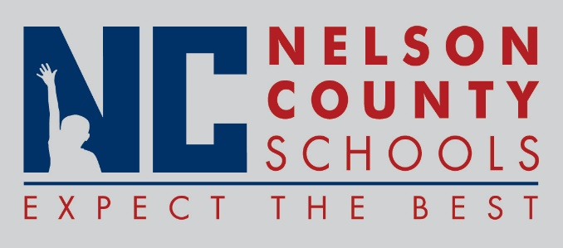

Decision Paper
To: | Nelson County Board of Education
From: | Tom Brown, Superintendent
Date: | December 7, 2017
Re: | 2018 Board Meeting Dates

RECOMMENDATION: Approve request for 2018 Board Meeting Schedule.

RECOMMENDED MOTION: I move that the Nelson County Board of Education approve the 2018 Board Meeting Schedule as presented.

