MINUTES
December 11, 2023
OLDHAM COUNTY BOARD OF EDUCATION
CONCERN
Consider Approval of Meeting Minutes.
DISCUSSION
The draft minutes of the November 20, 2023, Regular Board Meeting, are available for review and approval.
RECOMMENDATION
Approve the minutes of the following meetings as presented.
November 20, 2023 – Regular Board Meeting
(1) Suzanne Hundley, Chairperson, (2) Larry Dodson, Board Vice Chair; and (3) Joe Dennis, Board Member, (4) Carly Clem, Board Member (5) Allison Sheffer, Board Member, and Dr. Jason Radford, Superintendent and Secretary to the Board were present.

On a motion by _______________, seconded by _______________, and unanimously carried, the Board approved the minutes of the November 20, 2023, Regular Board Meeting. ( , )
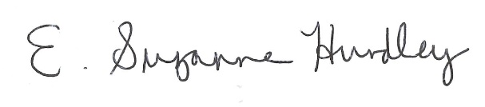
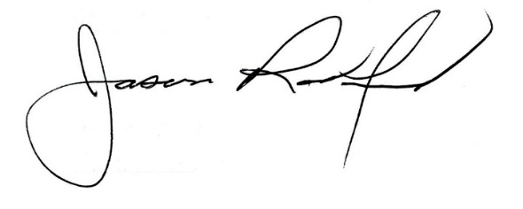

___________________________________ ______________________________
Suzanne Hundley, Board Chair Jason Radford, Superintendent/Secretary

