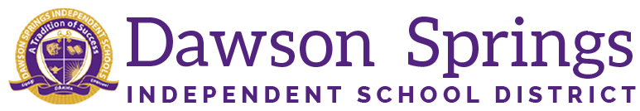

Dawson Springs Elementary School
Where the teachers and students give 100% every day and failure is not an option.
Panthers Prowling to Proficiency!

January 2022 Board Meeting
Elementary Principal Report
Jennifer Ward

Good Afternoon Board Members,

In the aftermath of the tornados that ripped through our town prior to our Christmas break, Dawson Springs Elementary School is back on track! Words cannot describe the joy and overwhelming love that all of our staff members hold for each and every single one of our students. On the morning of January 18, 2022, we welcomed back our students with open arms! Hugs were shared, laughs were heard, and a new feeling of “normal” has started to take over again.

We have a tremendous amount of work ahead of us! When considering the past two years and the challenges that have been thrown at us: COVID, virtual instruction, quarantines of staff and students, and now tornado destruction, it is easy to see how students have fallen behind academically. Our main goal is to focus on getting them caught up. This is not going to be an easy task, and we are fully aware of the challenges we face.

Just like with COVID, and now the tornado aftermath, Dawson Springs Elementary School is up to the challenge. We are fully committed to ensuring the quality education of our students each and every single day. We know, without a shadow of a doubt, that there is no substitute for students sitting in their desks in the classrooms receiving in-person instruction from their teachers. However, when the challenge is before us, we teach!

Dawson Springs Independent School has always been, and will always be the hub of our community. Whether it be COVID, tornado disaster relief, or the education of our children, we will stand up to the challenge and meet it head-first! We will continue to be the very best, and we will continue to overcome obstacles that are placed in front of us. We are a family. We are not always perfect, but we are always family. We are PANTHERS!

