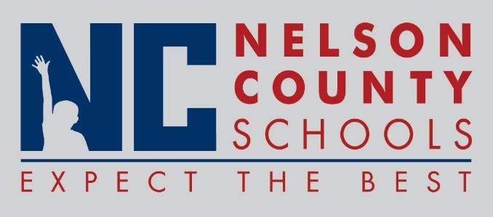

Decision Paper
To: | Nelson County Board of Education
From: | Bob Morris, Director of Student Support
cc: | Dr. Anthony Orr, Superintendent
Date: | July 18 , 2017
Re: | Policy Updates for 2017-2018

RECOMMENDATION: Approve the below listed policy updates for 2017-2018 as written for their second reading.

04.92 Uniform Guidance
06.2 Safety
07.1 Food/School Nutrition Services
07.12 Vending Machines
08.11 Course of Study
08.113 Graduation Requirements
08.1131 Alternative Credit Options
08.133 Extended School/Direct Student Services
08.13451 Title I Parent Family Engagement Policy

RECOMMENDED MOTION: I move that the Nelson County Board of Education Approve the listed policy updates for 2017-2018.

