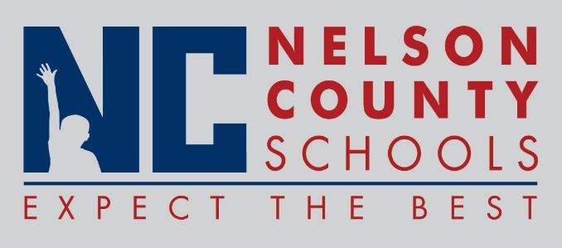

Information Paper
To: | Nelson County Board of Education
From: | Tim Beck, Director of Student Support
cc: | Dr. Anthony Orr, Superintendent
Date: | June 21, 2016
Re: | Personnel Notifications

Employment: Dan Duncan Teacher NCHS
Tiffiney Deopoere PT District
Amber Gootee CCR Coordinator District
Amy Vittitow Teacher FH
Elizabeth "Brooke" Dunn Teacher NCHS
Ryanh Fugitt Teacher BOS
Amanda Tucker Teacher BOS
Dana Ashley IA I OKH
Staci Vittitow IA I OKH
Caitlin Smith Teacher FH
Shelby Mattingly Teacher FH
Samantha Seger Teacher FH
Haley Victery Teacher FH
Ashley Carrico Spec Ed BMS
Kelsey White Speech Path District
Emily Pile PreK Teacher ELC

Transfers: Angie Ford OKH to BOS Special Ed Teacher

Reinstatements/One Year Certification: None

Classified Subs: None

Certified Substitute: Laura Barnett, John Barron, Rebecca Brady, Bobby Chowning, Gloria Coleman, Mary Edelen, Mary Etheredge, Elizabeth Harned, Margaret Jury, Amanda Lanham, Andrew McGuire, Sahila Meharry, William Metcalf, Renee Shannon, Joann Shields, Shirl Thomas, Shawn Veech, Pat Murray Boone, Amanda Weakley, Jose Lopez

Student Workers: Brittany Burman, Patrick Cecil, Paul Hockensmith, Hannah Viens, Jacob Hopkins, Katherine Allen, Selena Allen, Samuel Cecil, Robert Pierce, Macy Hagan

Non-Renewals: Mary Balles Spec Ed Teacher OKH

Resignation: Jackie White IA III BMS
Rebecca Chesser Classified Sub Districtwide
Stephanie James (Wimpset) Speech Pathologist Districtwide
Amber Selby Teacher New Haven

Retirements: Denise Haydon Teacher CCES

Reprimands/Terminations: None

