THIS IS AN INFORMATION PAPER

TO: Hardin County Board Of Education

FROM: The PAC

DATE: January 5, 2022

SUBJECT: PAC NEWS

BART’S BLOG – JANUARY 2022
Sharing Stories Both Old and New
We opened our doors back in 2001 and twenty years later we are delighted to have become the home for memorable experiences for thousands of Hardin County students and families each year. The PAC has shared stories from around the world and from right around the corner and now we hope you’ll share your PAC stories with us. Please go to https://thepac.net/pac20/ to upload a 30-second video or photo and share your favorite PAC memory with us in celebration of twenty years of quality performing arts for all of Hardin County.
Speaking of sharing stories, this month marks the end of our four-year cycle of Sherlock Holmes adaptations with the PAC bringing the fourth and final novel, The Valley of Fear, to our stage. Can Holmes escape the final problem? Don’t miss the thrilling conclusion to the series! Tickets are on sale now at ThePAC.net.
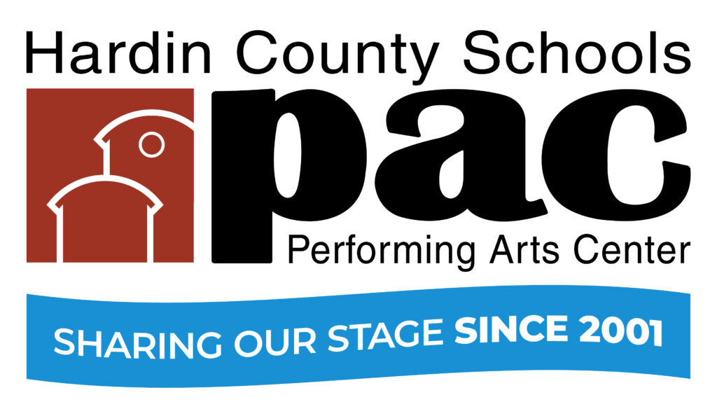

December Audience Survey Winners
Congratulations to DANIELLE COLE, HOLLY RICHARDSON, JENNIFER WHITEHEAD, KYLE LUCAS, TIFFANY SNODGRASS, JOHN BUTLER, SUSAN D’AMICO, DEBBIE LEWIS, JESSE HAWKINS, ANNA HAMILTON & KRISTI TOMS – each a lucky winner of a $20 PAC gift certificate for completing a December Audience Survey.

Spotlight
This month The PAC Spotlight shines on professional actor David Hussey who is playing “Sherlock” in this month’s Valley of Fear at the PAC and East Hardin Middle School’s Colton Smith both of whom have recently performed at Derby Dinner Playhouse. After having performed “Buddy” in Elf back in 2019 at the Derby, David returned there to play “Oscar” in The Odd Couple this fall. Colton, on the other hand, just made his Derby debut playing “Flick” in A Christmas Story at the Derby last month.
What have been your most rewarding PAC experiences?
- COLTON: One of my biggest passions is acting so anytime I get to take the stage gets me excited and teaches me new techniques.
- DAVID: Sharing time with such wonderful people!
What did you learn from your PAC experiences?
- COLTON: It teaches me how to be a better dancer especially and how to handle doing most of my work at home.
- DAVID: That there’s a wonderful facility with top-notch people there in Etown!
Why is the PAC important to you?
- COLTON: It is important to me because my grandparents have taken me to various shows at the PAC as long as I can remember. Also, it was where I did my very first show and now have a family with Youth Theatre of Hardin County.
- DAVID: It keeps art alive and thriving!
Why should the PAC be important to others?
- COLTON: Because you could start traditions of coming as a family to a lot of the shows and performances there. Also, you can find happiness. If you are feeling down, you can escape into a breathtaking adventure with these new characters that you are being introduced to.
Any other comments you’d like to share?
- COLTON: I am honored to be chosen for this opportunity and ecstatic for YTHC’s 50th anniversary and their production of Little Mermaid this summer.
- DAVID: I’m thankful to Bart Lovins for his unending positivity, creativity, joy, humor, and drive.
Learn more about them both and all the other PAC Spotlight Ambassadors we’ve recognized over the years.
David Hussey as Buddy the Elf at Derby Dinner Playhouse
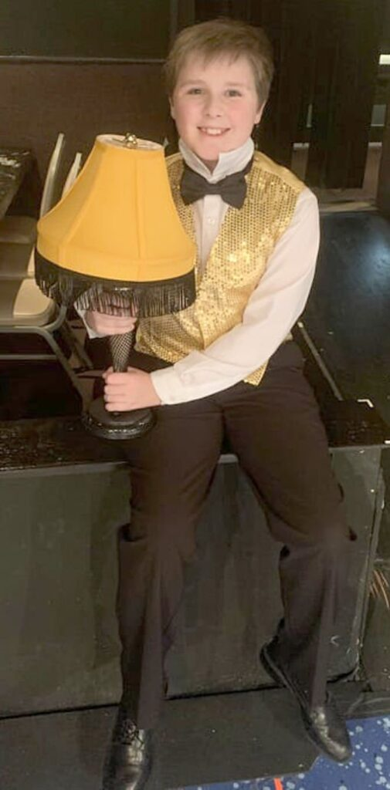
Colton Smith as Flick in A Christmas Story at Derby Dinner Playhous

NOW SHOWING – JANUARY 2022
January 15 | Youth Theatre of Hardin County Winter Drama Workshop (First of three). In preparation for the summer musical production of THE LITTLE MERMAID. 11AM - 2PM. POC Greg Thompson at ythc.greg@gmail.com Pre-registration is recommended.
January 28-31 | The PAC PRESENTS: ProAm Classical THE NOVEL STAGE ADVENTURES OF SHERLOCK HOLMES: THE VALLEY OF FEAR. (120 Mins). Sherlock’s Last Bow! Summoned by a coded message, the great detective finds that he and his faithful friend are too late, that Scotland Yard is stumped, and that Moriarty is behind it all. Can Holmes escape the final problem? Rated PG: Includes era-accurate language, drinking, smoking… and murder. Best for: Grades 6 and above. Best for Grades 6 and above. Tickets are $19 + $3 fee. All tickets reserved through www.thepac.net or 270-769-8837 X 4 or 5. Producing Partners: Barnes & Noble Booksellers, Cubero Group, Jerry Cormier in Loving Memory of Shirley Cormier, Chris and Peggy Ryan for Ray and Ethel, Bart Lovins, The Liske Family, Jimmie Dee Kelley in Tribute to Nelson Kelley.
COMING SOON – FEBRUARY 2022
February 6, 7 | CANCELED: American Spiritual Ensemble. Celebrating the Negro Spiritual, this critically acclaimed choir has thrilled audiences around the world with their dynamic renditions of classic spirituals and Broadway hits. Rated G. Best for: Grades 3 and above. Sunday Matinee, 3 PM. School Day performance, Monday, Feb 7. 9:30 AM. Tickets: $12 + $3 = $15. All tickets reserved through the PAC at www.thepac.net or 270-769-8837 X 4 or 5. Producing Partners: Marvin and Joyce Benjamin Fund of Central Kentucky Community Foundation, Elizabethtown Noon Rotary Club, Alan L. Thomas Piano Tuning & Repair. Ticket holders for this event will be contacted by the PAC to arrange refunds.
February 12 | Youth Theatre of Hardin County Winter Drama Workshop (Second of three). In preparation for the summer musical production of THE LITTLE MERMAID. 11 AM- 2 PM. POC Greg Thompson at ythc.greg@gmail.com Pre-registration is recommended.
February 10-13 | North Hardin High School Winter Musical BEAUTY & THE BEAST. Thursday & Friday School Day performances. Public performances: Saturday, 7 PM and Sunday, Matinee 3 PM. POC Cassie Lucas 270-351-3167. All tickets reserved through the PAC at www.thepac.net or 270-769-8837 X 4 or 5
February 17 | Hardin County Board of Education Meeting. 6 PM. Student recognitions.
February 18,19 | North Hardin High School Drama Club Production. POC Donna Thomas 270-351-3167. All tickets reserved through the PAC at www.thepac.net or 270-769-8837 X 4 or 5
February 25, 26 | John Hardin High School Choir production of THE WEDDING SINGER POC Phyllis Westfall 270-769-8906. All tickets reserved through the PAC at www.thepac.net or 270-769-8837 X 4 or 5.
February 26 | Sherlockapalooza at Crowne Pointe. Watson the big screen? A movie marathon of the PAC’s four-year salute to the great detective with panel discussions, merchandise sales, and special guests. A Study in Scarlet: 10AM (120 mins) The Sign Of Four: 1PM (120 mins) The Hound of the Baskervilles: 4PM (120 mins) The Valley of Fear (Premiere): 7PM (120 mins). For more information call the Box Office.

IN REVIEW – DECEMBER 2021
On December 2, 108 students with West Hardin Middle School Band under the direction of Laura Hedges presented a concert before an audience of 466.
On December 4, 50 choir members and guests of Heart of Kentucky Men's Chorus presented a concert before an audience of 252.
On December 5, Glen Rice Family and Friends presented "A Christmas Homecoming" concert before an audience of 162.
On December 7, 120 students with Central Hardin High School Band under the direction of Trevor Ervin presented a concert before an audience of 297.
On December 8, 190 students from G C Burkhead Elementary School under the direction of Aaron Dale presented a Christmas Musical before audiences totaling 360.
On December 9, 52 adult members with the Heartland Winds under the direction of David Coffing presented a free concert before an audience of 295.
On December 12, 100 student dancers with Center Stage Dance Studio performed a Christmas Gala before an audience of 333.
On December 17, 18 & 19, the PAC PRESENTED one school day performance and 4 public performances of THE NUTCRACKER under the direction of Sherry Barnard of The Dance Center of Elizabethtown. Included in the cast were 145 participants, 79 adults, 66 students, 22 professionals and 123 amateurs. An audience of 90 HCS & 41 Non-HCS students attended the school day performance and a total of nearly 1,500 attended the public performances. A live stream of the production was seen by family and friends in ten states including California, Georgia, Indiana, Louisiana, Michigan, Minnesota, South Dakota, Texas, Washington, DC as well as Kentucky.
On December 20, 28 dancers with Allegro Dance Theatre presented THE NUTCRACKER ON THE SHELF - The Short Version before an audience of 133.
Total Served in DECEMBER: 665 HCS Students, 78 Non-HCS Students, 689 Adults, and 3,787 Audience Members.

