John Hardin SBDM Council
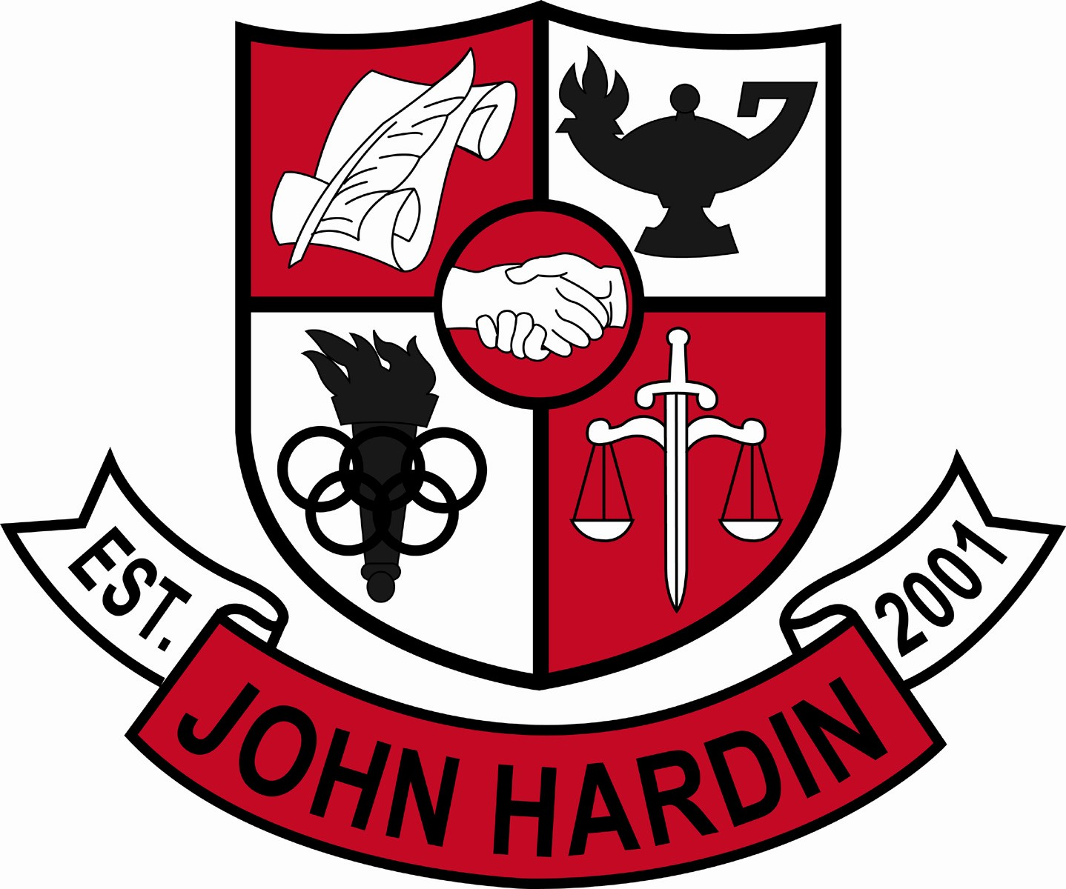
Meeting Minutes

August 9, 2016
4:00 p.m.

- Call to Order at 4:03
Members present: Mark Wells, Alex Shearer, Aurora Selbe, Kelly Smith, Jan O’Daniel and Michael Moritz.
- Approval of Agenda ORDER #16-17/0011
The council approved the agenda as written.
Motion: Moritz Second: O’Daniel
Selbe – Yes
O’Daniel – Yes
Shearer– Yes
Wells – Yes
Smith – Yes
Moritz – Yes
- Approval of Minutes ORDER #16-17/0012
The council approved the minutes as written.
Motion: Shearer Second: Moritz
O’Daniel – Yes
Selbe– Yes
Wells – Yes
Shearer – Yes
Smith – Yes
Moritz – Yes
- Public Comment – No Comment
- Principal’s Update
  - Open House/Back to School Bash – The event went really well and was held inside to due weather. The event will be held inside again next year. Coaches will be asked to set up at 7:30 pm instead of 6:00 pm.
  - First Day of School – Last years, one on one scheduling helped to reduce the number of schedule changes resulting in a quiet start.
- Financial Report ORDER #16-17/0013
The Financial Report for August was reviewed and accepted.
Motion: Selbe Second: O’Daniel
O’Daniel – Yes
Shearer – Yes
Smith – Yes
Selbe – Yes
Wells – Yes
Moritz- Yes

- School Safety Report ORDER #16-17/0014
The council reviewed and approved the school safety report as written.
Motion:Smith Second: Selbe
O’Daniel – Yes
Shearer – Yes
Smith – Yes
Selbe – Yes
Wells – Yes
Moritz – Yes
- Personnel
Hired: April Bowman-Health Science; Dylan Lambert – Science; Jedy Hodge – LMC Clerk; Vicky Lawson – Nurse; Erik Krivitsky – Boys Assistant Soccer Coach; Amy Hollingsworth – Special Ed Assistant
Vacancies: Freshmen Volleyball Coach; 50% Stipend Boys Assistant Soccer Coach; Freshmen Baseball Coach; Custodian
- New Business –
- Student Athlete Social Media – More research will be conducted to determine if the policy can be implemented and who will be responsible for enforcing it.
- Agenda Items for Next Meeting
- Adjorn
The meeting was adjourned at 4:29 p.m. The motion was made by Mr. Shearer and seconded by Ms. O’Daniel.

