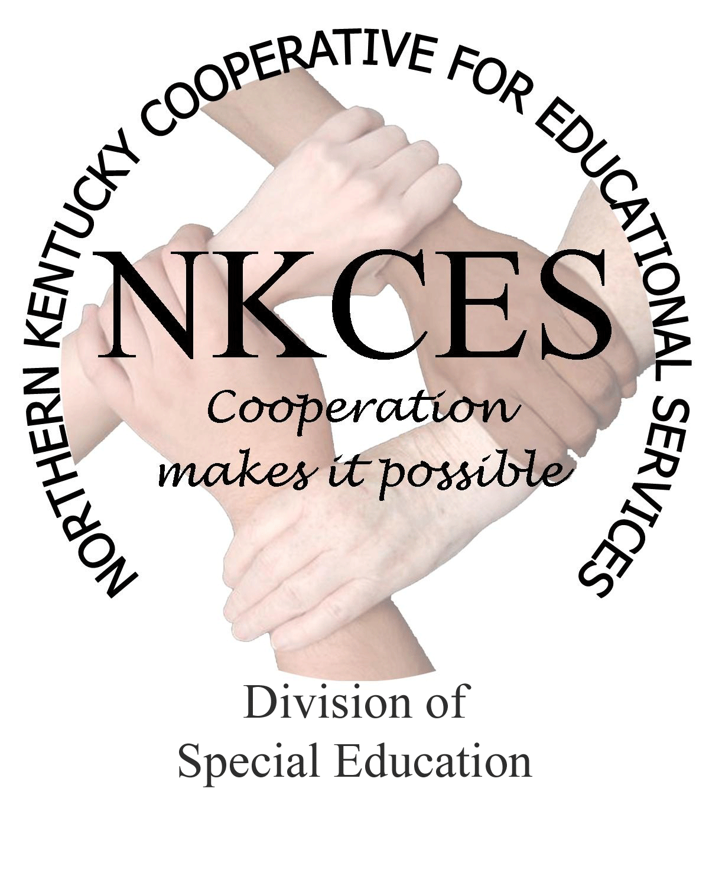
Northern Kentucky Cooperative for Educational Services, Inc.

Member Districts

Beechwood Independent • Bellevue Independent • Boone County • Campbell County

Covington Independent • Dayton Independent • Erlanger-Elsmere Independent

Ft. Thomas Independent • Kenton County • Ludlow Independent • Newport Independent

Pendleton County • Silver Grove Independent • Southgate Independent

Walton-Verona Independent • Williamstown Independent

March 3, 2014

Curtis Hall, Executive Director
NKCES
5516 E. Alexandria Dr.
Cold Spring, KY 4-176

Re: Superintendents Report

Dear Curtis:

Spring is approaching and that means planning for next year begins. We are in the midst of restructuring our work by focusing on the word, "Imagine". Imagine if every district could close the gap, imagine every student being proficient across all content areas, and imagine every district reaching their targets. Imagine if NKCES reviewed every districts CDIP's and focused their work on the areas that were priortized during the spring district planning meetings. Imagine if NKCES held Data Retreats to assist districts in looking closely at their data, which led to focused plans for improvement. Imagine NKCES offering free summer workshops that were focused on content areas that assist All teachers with strategies and activities to bring to their classrooms in the fall. Imagine if NKCES along with NKU offered, "Instructional Coaching" training based on Jim Knight's work in the fall. Imagine if NKCES offered standards training for Paraeducators this summer. Imagine if NKCES offered a free Parent Conference where they obtain information on how to assist their child.

Imagine no longer! These activities are going to become reality over the months ahead. We want to become very intentional with all of our activities, enabling us to assist Dr. Holiday's charge to "Close the Gap". We will be more intentional with our district planning meetings:
- By taking a close look at the district CDIP and pinpointing what activites NKCES can provide during the 2014-15 school year.
- By initializing Closing the Gap at the forefront with trainings and programs that continue assisting teachers in making their students successful within their optimal level.
- By focusing on differentiation of instruction that intertwines throughout the content of literacy and math for all students.
- By offering instructional coaching training, which will assist coaches or related positions that equip them with strategies for succssess among their staff and students.

NKCES consultants and myself have recently become ceritified Data Retreat trainers. The purpose for the Data Retreat workshop is to analyze the schools effectiveness and set goals for improvement. The Data Retreat is a time of reflective collaboration and illumination that leads to focused plans for improvement. It is the beginnning of an annual process, not a one time event. The Leadership team gathers for a three day retreat and prepares for a year of ongoing improvement.

This training will eventually be offered to all districts throughout our region. The process not only requires 3 days of traing, but also ongoing check points with our staff in order to stay on track and review progress of the plan that is put into place during the planning meetings. Currently, we have plans to begin with Erlanger-Elsmere school district. They may be piloting the first N KY Data Retreat and answering the question, "What will it take for every student to learn in every classroom in our district"?
We are excited for this opportunity and look forward to presenting “Imagine” to your district in the future.

Our spring District Planning meetings have begun. If you have not scheduled and confirmed your meeting we are looking forward to hearing from you. This is an opportunity to hear about the work we have accomplished in your district to date, as well as look at your CDIP and data to determine the areas we will concentrate on next year.

Thank you again for affording us the opportunity to work with your staff as well as imagining closing the gap!

Sincerely,

Linda Alford
Regional Director of Special Education

