John Hardin SBDM Council
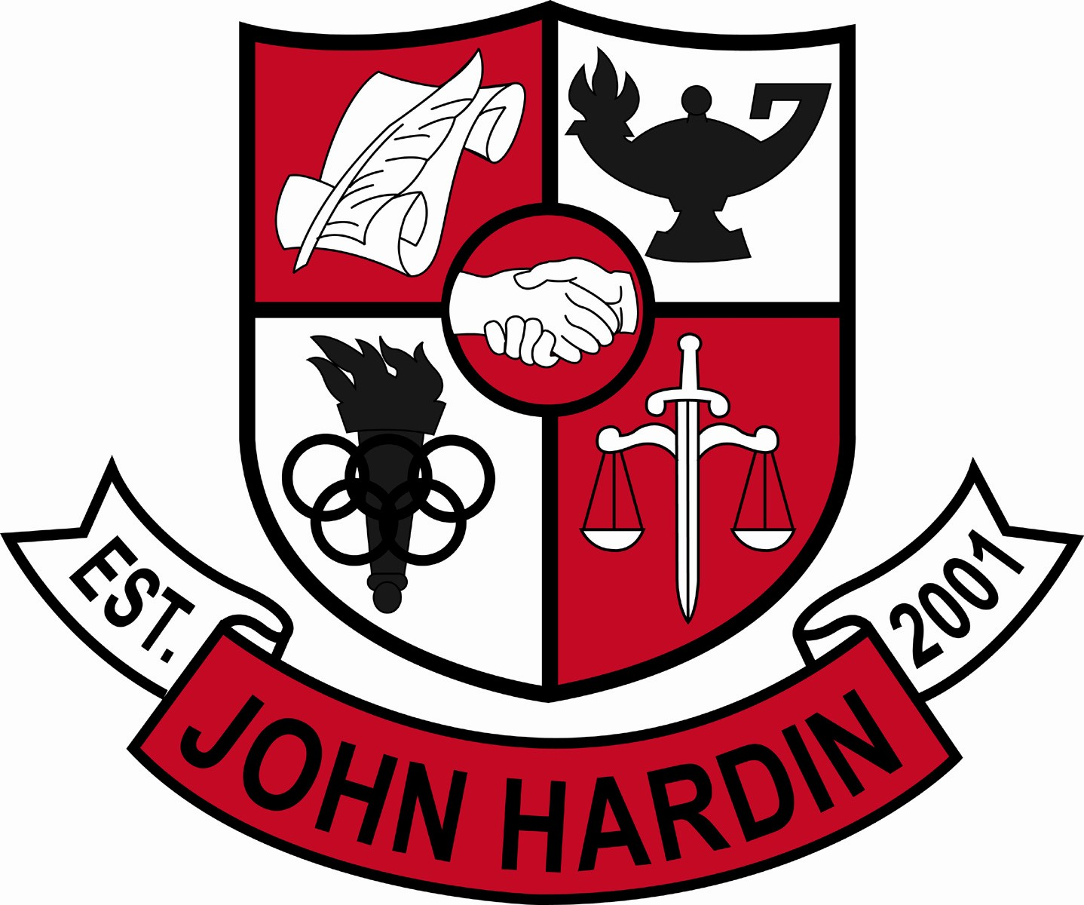
Meeting Minutes

April 13, 2017
4:00 p.m.

- Call to Order at 4:04
Members present: Jan O’Daniel, Alex Shearer, Aurora Selbe, Kelly Smith, Mike Moritz, and Mark Wells.
Guest: Chris Reed
- Approval of Agenda ORDER #16-17/0041
The council approved the agenda as written.
Motion: Moritz Second: Selbe
Moritz - Yes
Selbe – Yes
O’Daniel – Yes
Shearer– Yes
Wells – Yes
Smith - Yes
- Approval of Minutes ORDER #16-17/0042
The council approved the minutes as written.
Motion: O’Daniel Second: Smith
O’Daniel – Yes
Selbe– Yes
Moritz - Yes
Wells – Yes
Shearer – Yes
Smith - Yes
- Good News Report –
  - FCCLA – The following students competed and received awards at the State FCCLA conference. Kait Humphrey and Madison Smith, 1st Place in Chapter Service Project Display; Becca Smith and Reyna Shelby, 2nd Place in Chapter in Review
  - Archery – The team competed at state.
  - VEX Robotics – The team will compete in the World Competition on April 19-20 in Louisville, KY.
- Green Team – 490 lbs of caps were collected by the team. The caps were recycled into a bench for the school.
- Art– Art students competed in the Juried Art Competition at Campbellsville University. Timothy Lever, 1st place for Sculpture and 2nd place for Drawing; Kat Young, 3rd place for Drawing; Maggie Muehleman, 2nd place for Ceramics.
- Media Art – Daeshionna Kimbrough competed in Media Arts held at Western Kentucky University and received 1st place for Feature Film.

- FFA- Students competed in the Lincoln Trail FFA Regional Speaking Contest. The following students placed 1st or 2nd and will compete at State in June. Paige Geer, 1st Place in Beef Impromptu; Chanelle Dau Pino, 1st Place in Floral Design Impromptu; Sierra Voshell, 1st in Equine Impromptu; Ana Moyers, 2nd Place, Small Animal Impromptu.
- Public Comment – No comments
- Principal’s Update
- In case of inclement weather, graduation will be held in the gymnasium of Central Hardin High School. This location eliminates “By Ticket Only” allowing more family members to attend.
- Program Review
The council reviewed and accepted the report. ORDER #16-17/0043
Motion: Shearer Second: Selbe
Mortiz – Yes
Shearer – Yes
Smith - Yes
Selbe – Yes
Wells – Yes
O’Daniel - Yes
- Professional Development 2017-2018 ORDER # 16-17/0044
The council reviewed and approved the professional development plan for 2017-2018.
Motion: Smith Second: Shearer
O’Daniel – Yes
Mortiz – Yes
Shearer – Yes
Smith - Yes
Selbe – Yes
Wells – Yes
- School Compact 2017-2018 ORDER #16-17/0045
The council reviewed and approved the school compact plan for next year.
Motion: Smith Second: Moritz
O’Daniel – Yes
Selbe– Yes
Moritz - Yes
Wells – Yes
Shearer – Yes
Smith - Yes
- Parent Involvement Policy 2017-2018 ORDER #16-17/0046
The council reviewed and approved the parent involvement policy for next school year.
Motion: Shearer Second: Selbe
Moritz - Yes
Selbe – Yes
O’Daniel – Yes
Shearer– Yes
Wells – Yes
Smith - Yes
- Financial Report ORDER #16-17/0047
The financial report for March was approved as written.
Motion: Selbe Second: O’Daniel
O’Daniel – Yes
Selbe– Yes
Moritz - Yes
Wells – Yes
Shearer – Yes
Smith - Yes
- Personnel
Hired: Ralph Tucker, Assistant Track Coach 50% Stipend; Leland Warsaw, Assistant Track Coach 50% Stipend
Vacancies: Custodian
- Agenda Items for Next Meeting
  - Budget
- Adjourn
The meeting was adjourned at 4:36p.m. The motion was made by Ms. Selbe and seconded by Mr. Shearer.

