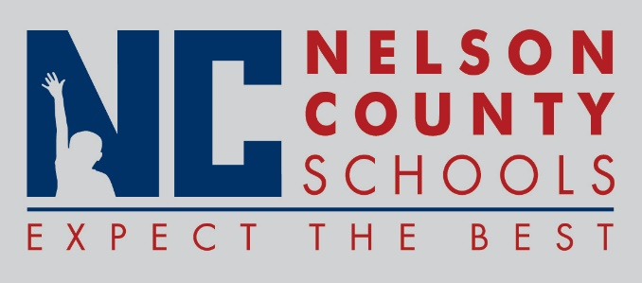

Information Paper
To: | Nelson County Board of Education
From: | April Peach, Director of Food Service
cc: | Dr. Anthony Orr, Superintendent
Date: | December 15, 2015
Re: | Community Eligibility Provision Report

The reported comparison data is for August – November 2014 and August – November 2015. The data compares students’ participation in the National School Lunch and Breakfast Program, for the schools operating under the Community Eligibility Provision. The data will continue to be collected throughout the program year and used to determine continued, as well as expanded participation in the provision.

No action required.

