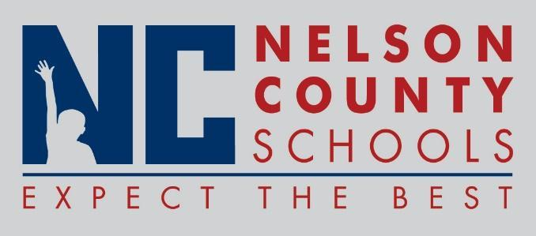

Decision Paper
To: | Nelson County Board of Education
From: | Tiffanie Clark, Director of Special Education
cc: | Wes Bradley, Superintendent
Date: | 6/19/18
Re: | CKEC Mini Grant

RECOMMENDATION: Approve CKEC Mini Grant for math curriculum and training.
RECOMMENDED MOTION: I move that the Nelson County Board of Education approve as presented.

