Campbellsville Independent School District

Board of Education
136 South Columbia Avenue, Campbellsville, KY 42718

Phone: 270-465-4162 Fax: 270-465-3918

OCTOBER Board Meeting
October 19, 2020, 6:00 PM
CISD Board of Education
136 South Columbia Ave
Campbellsville, KY 42718

Attendance Taken at 6:01 PM:

Present Board Members:
Ms. Pat Hall
Ms. Angie Johnson
Mr. Mitch Overstreet
Ms. Barkley Taylor
Ms. Suzanne Wilson

I. Call to Order
I.A. Welcome
I.B. Roll Call
I.C. Adoption of Agenda

Order #3948 - Motion Passed: Motion to Adopt Agenda passed with a motion by Ms. Angie Johnson and a second by Ms. Suzanne Wilson
Ms. Pat Hall Yes
Ms. Angie Johnson Yes
Mr. Mitch Overstreet Yes
Ms. Barkley Taylor Yes
Ms. Suzanne Wilson Yes

II. Communications
II.A. Board
II.A.1. Mr. Smith’s PGP for 2020-2021
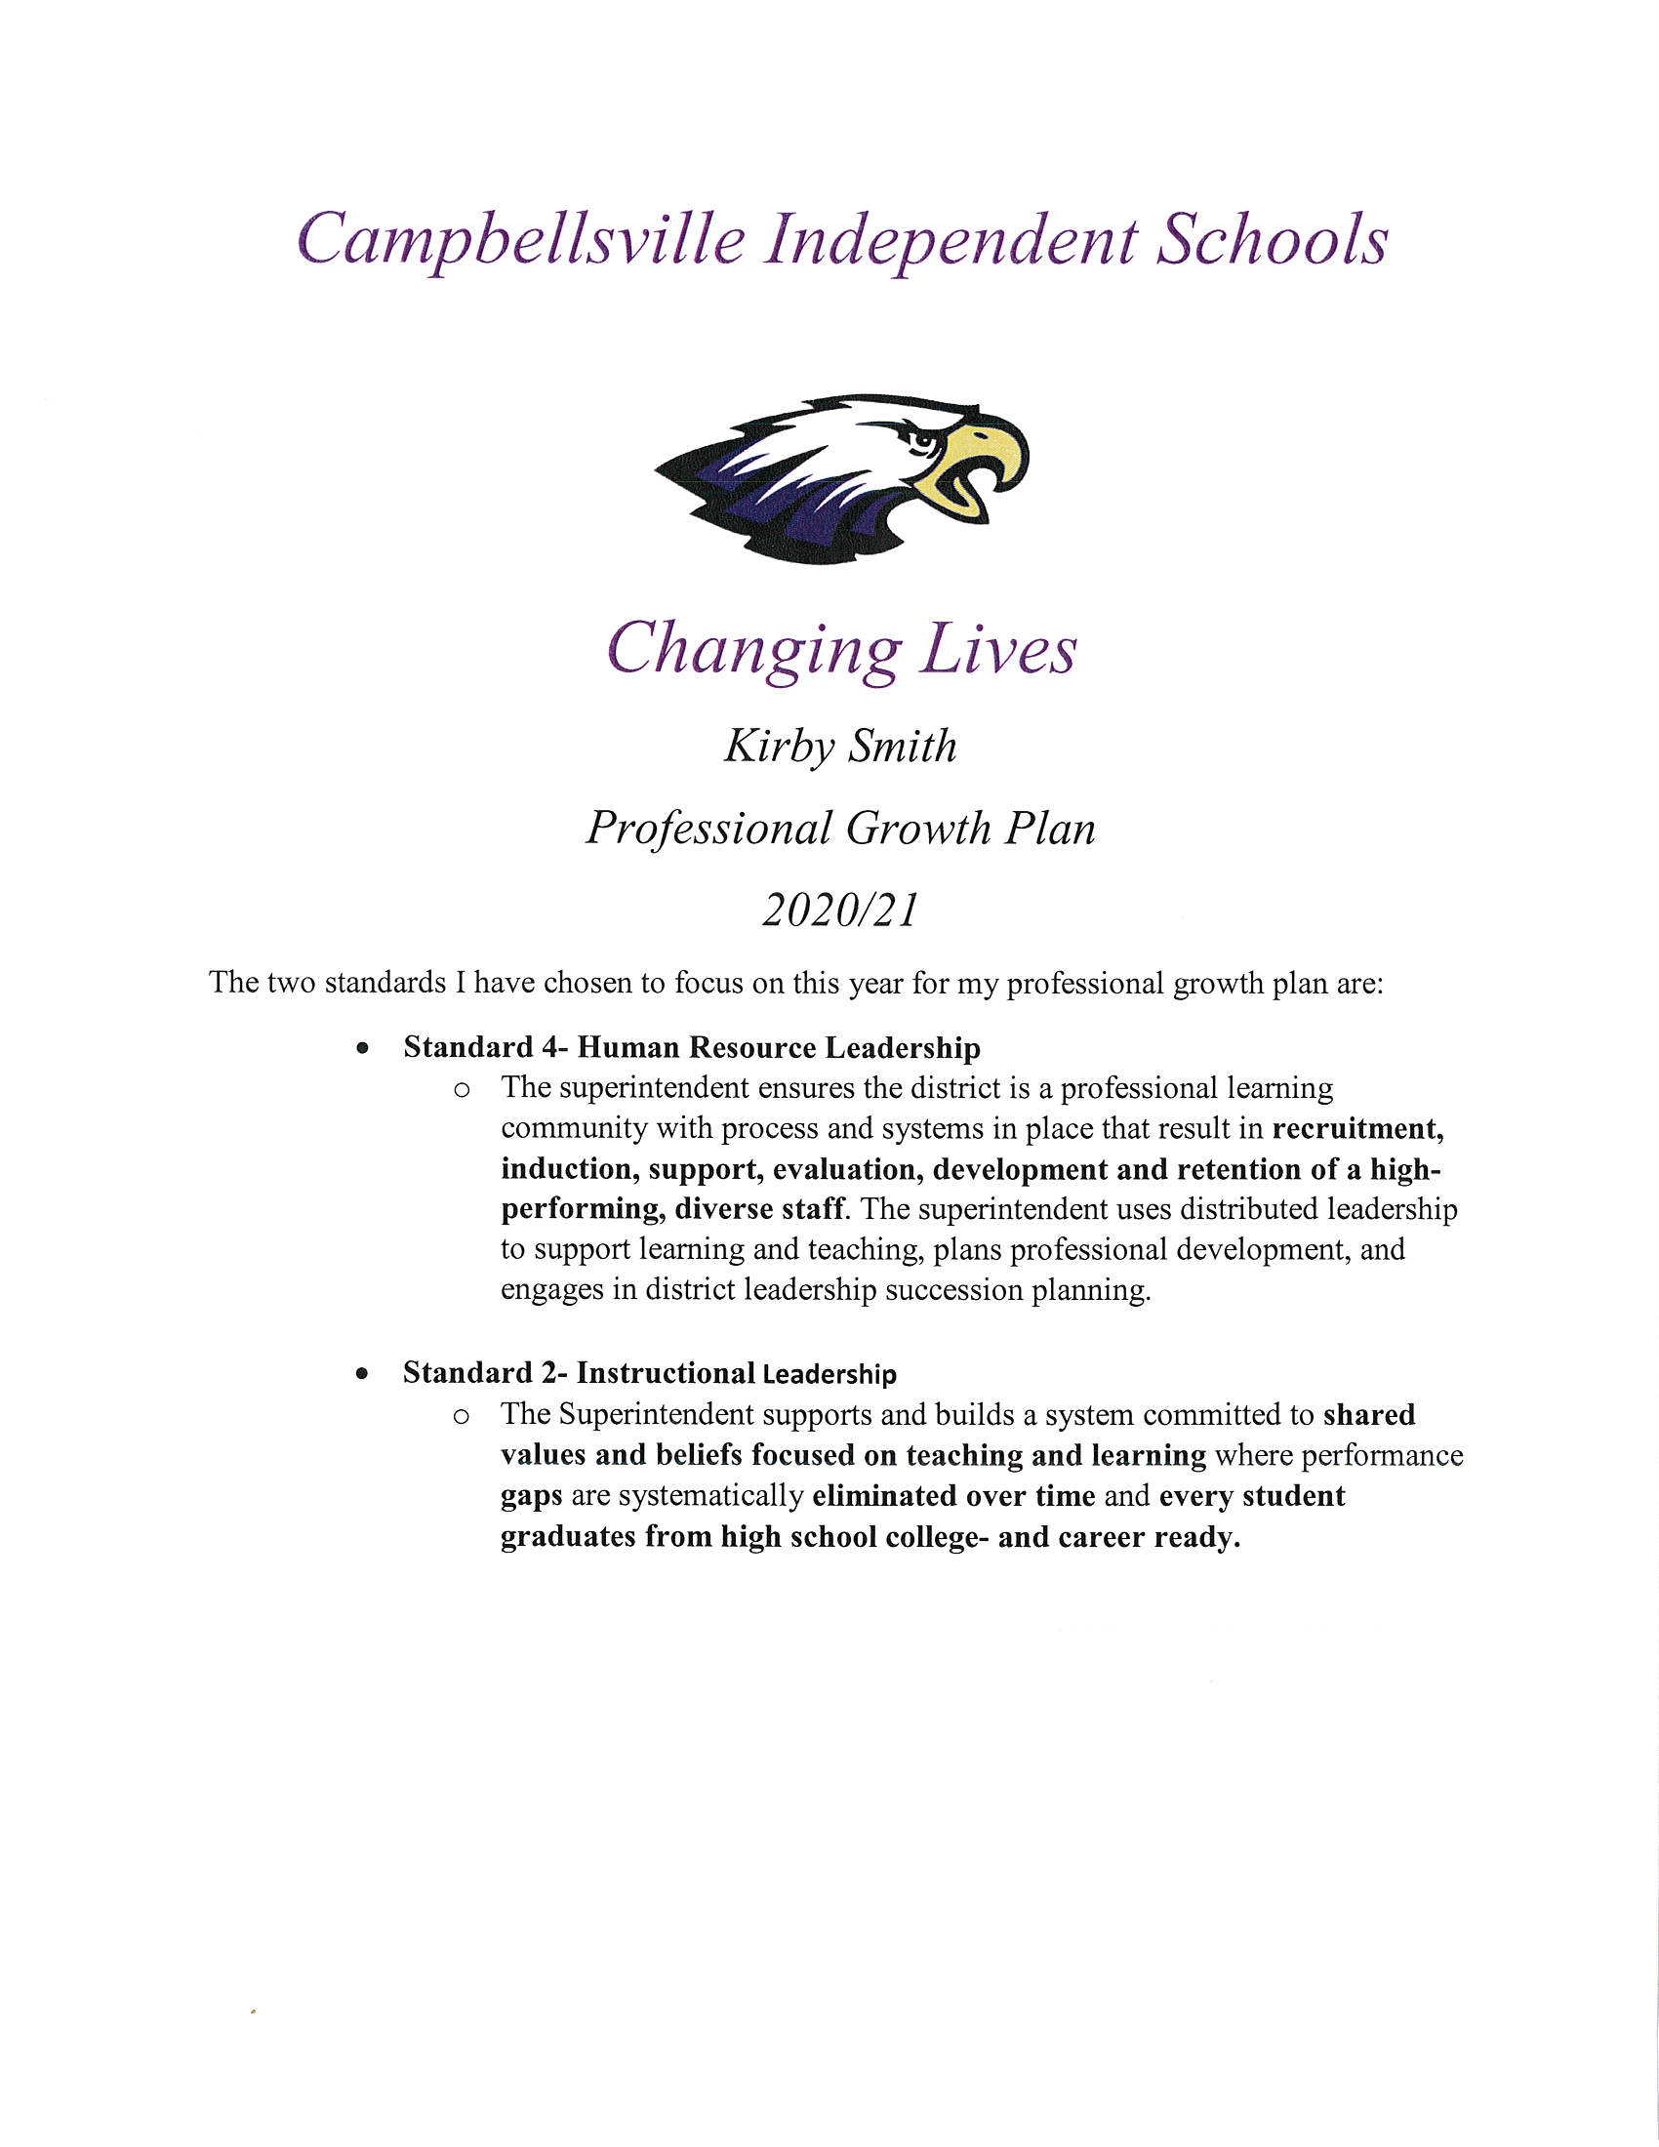

II.B. Community
II.C. Staff
II.D. Superintendent Report
Discussion:
Mr. Kirby Smith, Superintendent:

- We just completed our third week of in person instruction and although our county has seen an increase in COVID, cases as a District our numbers are ok.
  - Currently we have three active cases- 1 with student (CHS) and two employee’s (CES and board office). We have eight students that are quarantined due to household contact or close contact. We have two employees quarantined, waiting on test results.
  - Let me remind you and everyone watching that we have a COVID 19 dashboard with all this information on it that is updated daily. The dashboard is located on our website.

- Hybrid learning schedule- although not ideal, it is our best chance to have face-to-face instructional days.

- Typically, at this time of the year I am going over test results from the previous year. However, as you all well know we did not test last year. However, we do have one thing to report on and that is our graduation rate, which is up from last year. It is 98.5%

- Last week was National School Lunch Week so I want to give a big shout out to all our school lunch employees. They do a tremendous job every day of not just providing a great meal but doing so with a smile and caring attitude.

- October is National Principal Month so I want to give a huge shout out to Ms. Doretha Sanders, Mr. Zach Lewis and Mr. Weston Jones for all they do for our students.

- Turf update- Mr. Kidwell, Mr. Jones, Mr. Davis and I all met virtually last week with architects in regards to our turf project. At this time, Mr. Kidwell our building and grounds director will give you an update on the turf project.

- I am providing each of you with a copy of my calendar for September, October and November.

Order #3949 - Motion Passed: Motion to Approve Consent Agenda Items passed with a motion by Ms. Barkley Taylor and a second by Ms. Angie Johnson
Ms. Pat Hall Yes
Ms. Angie Johnson Yes
Mr. Mitch Overstreet Yes
Ms. Barkley Taylor Yes
Ms. Suzanne Wilson Yes

III.A. Student Learning and Support
III.A.1. Approve Nonresident Contracts with Adair, Green, Marion, Larue and Taylor County Schools
III.A.2. Approve to pay ACT Fee for all Juniors
III.A.3. Approve Contract with Soliant for Occupational Therapy Services
III.A.4. Approve Contract with Eluma for Virtual Speech Language Therapy Services
III.A.5. Approve Title IX Sexual Harassment Interim Policy and Procedure Update
III.A.6. Adoption of the September 9th, 2020 Special Called Board Meeting and September 14th, 2020 Regular Monthly Board Meeting, Minutes
III.A.9. Finance Report
Mr. Chris Kidwell, Associate Superintendent/Finance Director, presented the Finance Report.
a. Bills and Salaries
1. Regular Monthly Expenditures
2. School Activity Funds
3. Personnel Report on Employment Status

IV. Adjournment

Order #3950 - Motion Passed: Motion to Adjourn Board Meeting at 6:29 p.m. passed with a motion by Ms. Angie Johnson and a second by Ms. Barkley Taylor
Ms. Pat Hall Yes
Ms. Angie Johnson Yes
Mitch Overstreet Yes
Ms. Barkley Taylor Yes
Ms. Suzanne Wilson Yes

_____________________________________ ______________________________________
Kim Thompson, Board Clerk Pat Hall, Chairperson

_____________________________________
Kirby Smith, Superintendent/Board Secretary

