Missed 11 days of school:
8/21, 9/26, 12/12, 1/04, 1/05, 1/08, 1/09, 1/16, 1/17, 1/18, 1/19
2 hours early dismissal: 1/12 (dismissed @ 1:00 PM)
Today – 1/23/18
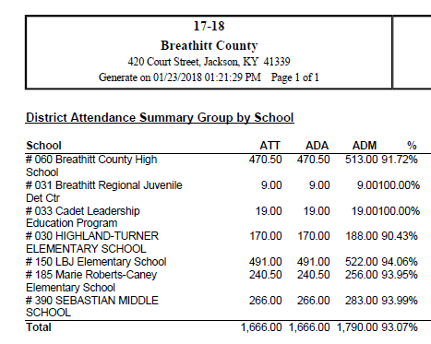
YTD – 7/31/17—1/23/18
