Regular Meeting Boone County Board of Education
October 11, 2018 7:30 PM
Ralph Rush Professional Development Center
99 Center Street
Florence, Kentucky 41042

I. CALL TO ORDER

The Regular meeting of the Boone County Schools Board of Education October 11, 2018 was called to order by Chairperson Bonnie Rickert at the Ralph Rush Staff Development Center.
Attendance Taken at 7:30 AM:

Present Board Members:
Dr. Maria Brown
Ms. Karen Byrd
Mr. Matt McIntire
Ms. Bonnie Rickert
Mr. Ed Massey arrived at 8:30 pm due to a prior commitment.

Claire Parson attended as Board Attorney
Karen Evans, Board Secretary, recorded the minutes.

Mr. Eric McArtor, Deputy Superintendent, sat in for Dr. Randy Poe, who was at a conference.

II. NATIONAL ANTHEM
The National Anthem was presented by video from students of Conner High School.

III. PLEDGE TO THE FLAG
The Pledge to the Flag was led by students from Erpenbeck Elementary

IV. STUDENT BOARD MEMBER REPRESENTATIVE REPORT
Nick Rassenfoss, Interim Student Board Representative gave the Student Board Member Representative report. Nick reported on the last Superintendent Student council meeting and the ideas on how to work on inclusion with students, Gerry Gels spoke to the students on Ignite Institute opportunities, Ms. Hicks lead the group in a leadership activity. Nick spoke on the kick-start of the Drug Free Clubs of America.
Anna Impellitteri, video update from Mexico and spoke on the importance of student voice and leadership and the hopes of moving forward with true change coming from the students.

V. GOOD NEWS
V.A. The board recognized and congratulate the 2018 October Break the Mold recipient, Ms. Jessica Klosinski, STEAM Teacher from Erpenbeck Elementary
V.B. The board recognized and congratulated, Ms. Connie Crigger, Principal at Mann Elementary, as the 2018 Kentucky Association of School Administrators Administrator of the Year Recipient
V.C. The board recognized and congratulated Mr. Tim Schlotman, Boone County High School Principal, recipient of the 2018 KMEA Outstanding Administrator
V.D. The board will recognized and congratulated Mr. Bill Kidwell, teacher at Gray Middle School, recipient of the 2018 KMEA Middle School Teacher of the Year
V.E. The board recognized and congratulated Mr. Brad Steward, teacher from Cooper High School as the recipient of the 2018 KMEA High School Teacher of the Year.
V.F. The board recognized and congratulated Mr. Dave Weber, retired Boone County High School Teacher, recipient of the 2018 KMEA Citation for Service Award.
V.G. The board recognized and congratulated Ms. Kimberly Fry, teacher at Erpenbeck Elementary School as the recipient of the 2018 Kentucky World Language Association Teacher of the Year.
V.H. The Bosch Grant Check Presentation.
V.I. PBIS Fidelity Award Presentations.

Congratulations to the following schools......

BCHS(Silver), CHS(Silver), RCHS(Gold), CEMS(Silver), OMS(Silver), BES(Silver), EES(Bronze), FES(Silver), KES(Silver), MES(Silver), NHES(Silver), OES(Silver), SES(Bronze), TES(Gold) and YES(Bronze)

V.J. The board will recognize the 2018 October Sportsmanship Award Recipients.

Congratulations to the following students!!

BCHS: Jasmine Caudill- Ms. Stacy Ezell, Mother accepted award.
CHS: Bryce Huff
RCHS: Michael Spencer
RHS: Devyn Eubank

VI. RECOMMENDED ACTION - CONSENT AGENDA

Mr. Eric McArtor, Deputy Superintendent, recommended the board approve the Consent Agenda items A- RR, as presented.

- A motion was made by Maria Brown, seconded by Karen Byrd, to approve the consent agenda items A-RRR, as presented. Matt McIntire, Karen Byrd, Maria Brown, and Bonnie Rickert voted, “aye” MOTION: The motion passed 4-0.

VI.A. Minutes of the regular board meeting of September 13, 2018.
The board approved the minutes of the regular board meeting of September 13, 2018, as presented.
VI.B. Bill List
VI.C. Treasurer's Report, given by Ms. Linda Schild.
VI.D. Leaves of Absence
The following persons submitted unpaid leaves of absence requests were approved:
Recommended by Principal/Supervisor for approval:
Adridge, Kelly, Teacher @ Florence ES 11/15/2018 – 12/19/2018
Anneken, Lorraine, Teacher @ Camp Ernst MS 9/17/2018 – 10/1/2018
Aschermann, Brenna, Teacher @ Erpenbeck ES 10/1/2018 – 11/20/2018
Cruz, Rudolfo, Custodian @ Boone County HS 9/10/2018 – 12/10/2018
Farrell, Sena, Bus Driver, @ Transportation 8/15/2018 – 8/29/2018
Herkner, Jennifer, Para Ed @ North Pointe ES 9/21/2018 – 12/26/2018
Hill, Andrea, Psychologist @ Burlington ES 9/17/2018 - EOY
Jackson, Erin, Café worker @ Florence ES 8/29/2018 – 10/1/2018
Schneider, Erica, Café Worker @ Ballyshannon MS 9/21/2018 – 10/1/2018
Not Recommended by Principal/Supervisor for approval:
Nothing to Report
Amended Leaves:
Bray, Courtney, Teacher @ Goodridge ES 9/18/2018 – 10/15/2018
Duell, Nicole, Teacher @ Longbranch ES 8/13/2018 – 11/20/2018
Kuhn, Amanda, Teacher @ Goodridge ES 9/10/2018-10/17/2018
Perry, Donna, Transportation Aide @ Transportation 8/27/2018 – 9/27/2018
Cancelled Leaves:
Isaacs, Jessica, Teacher @ Imagineering Academy 10/11/2018 – 10/26/2018

VI.E. Easycmb Subscription Renewal at New Haven Elementary School
The board approved the Easycmb Subscription Renewal at New Haven Elementary School, monitoring site, as presented.
VI.F. Kagan Professional Development at Gray Middle School
The board approved the Kagan Professional Development at Gray Middle School, as presented.
VI.G. Revised BG-1 for Steeplechase New School BG#19-078
The board approved the Revised BG-1 for Steeplechase New School BG#19-078, as presented.
VI.H. Revised BG-1 for Steeplechase Site Acquisition BF#18-234
The board approved the Revised BG-1 for Steeplechase Site Acquisition BF#18-234, as presented.
VI.I. BG-1 Application for Boone County Bus Maintenance Addition
The board approved the BG-1 Application for Boone County Bus Maintenance Addition, as presented.
VI.J. BG-1 Application Learning Support Services Renovations
The board approved the BG-1 Application Learning Support Services Renovations, as presented.
VI.K. Executive Charter for Conner Middle-Camp Joy Trip
The board approved the Executive Charter for Conner Middle-Camp Joy Trip, as presented.
VI.L. Executive Charter for Ryle High School Band
The board approved the Executive Charter for Ryle High School Band Trip to Bowling Green, as presented.
VI.M. BG-1 Application Burlington Elementary Renovations
The board approved the BG-1 Application Burlington Elementary Renovations, as presented.
VI.N. Field Trips
The board approved the Field Trip Request, as presented.

School | Date Of Trip | Location | Reason
Conner High School | April 4-9, 2019 | Orlando, FL | Band & Orchestra Performance
Conner High School | October 24-26, 2018 | Indianapolis, IN | FFA National Convention
Conner Middle School | November 1-2, 2018 | Clarksville, OH | Educational
Ryle High School* | September 29, 2018 | Bowling Green State University | Marching Band Competition
- All travel by commercial carrier is due to schedule/cost.

VI.O. Memorandum of Understanding between ISL Learning and Ballyshannon Middle School
The board approved the Memorandum of Understanding between ISL Learning and Ballyshannon Middle School, as presented.
VI.P. Yealey Elementary Agreement with Missoula Children's Theatre for Drama Camp
The board approved the Yealey Elementary Agreement with Missoula Children's Theatre for Drama Camp, as presented.
VI.Q. Facility Use Agreement Boone County Pee Wee Football League for Yealey Elementary
The board approved the Facility Use Agreement Boone County Pee Wee Football League for Yealey Elementary, as presented.
VI.R. Sales Campaign Approvals
The board approved the Sales Campaigns, as presented.
VI.S. Newport Aquarium for Ryle High School Senior Dinner Dance
The board approved the Newport Aquarium Agreement for Ryle High School Senior Dinner Dance, as presented.
VI.T. Taylor Tours for Conner High School Band and Orchestra
The board approved the Taylor Tours for Conner High School Band and Orchestra, as presented.
VI.U. Revised BG-1 for Door Stations District-wide BG#18-394
The board approved the Revised BG-1 for Door Stations District-wide BG#18-394, as presented.
VI.V. Change Order #1 Door Stations District-wide BG#18-394
The board approved the Change Order #1 Door Stations District-wide BG#18-394, as presented.
VI.W. Change Order #2 ATC Ventilation system BG#18-177
The board approved the Change Order #2 ATC Ventilation system BG#18-177, as presented.
VI.X. Convection Steamer for RA Jones Middle School Bid
The board approved the Convection Steamer for RA Jones Middle School Bid, as presented.
VI.Y. Surplus Technology Equipment
The board approved the Surplus Technology Equipment, as presented.
VI.Z. Food Service Sanitation Contract Renewal
The board approved the Food Service Sanitation Contract Renewal with Smart Systems, Inc., as presented.
VI.AA. Camp Ernst Middle School Dell Computer Lease
The board approved the Camp Ernst Middle School Dell Computer Lease, as presented.
VI.BB. Masterpath Vending Agreement with Ockerman Elementary School
The board approved the Masterpath Vending Agreement with Ockerman Elementary School, as presented.
VI.CC. Modular Classroom Lease Agreement with Tri-State Building
The board approved the Modular Classroom Lease Agreement with Tri-State Building, as presented.
VI.DD. The Children's Theatre Performance Contract for Florence Elementary
The board approved The Children's Theatre Performance Contract for Florence Elementary, as presented.
VI.EE. The Children's Theatre Performance Contract for Kelly Elementary
The board approved The Children's Theatre Performance Contract for Kelly Elementary, as presented.
VI.FF. The Children's Theatre Performance Contract for Burlington Elementary
The board approved The Children's Theatre Performance Contract for Burlington Elementary, as presented.
VI.GG. Facility Use Agreement Belleview Baptist Church for Burlington Elementary
The board approved the Facility Use Agreement Belleview Baptist Church for Burlington Elementary, as presented.
VI.HH. Group sale Contract for Cooper High School
The board approved the Group sale Contract for Cooper High School, as presented.
VI.II. Hypersign-Ockerman Elementary School
The board approved the Hypersign-Ockerman Elementary School, as presented.
VI.JJ. Agreement between Florence Elementary and Mike Hemmelgarn Show
The board approved the Agreement between Florence Elementary and Mike Hemmelgarn Show, as presented.
VI.KK. Agreement between Florence Freedom and Cooper High School Baseball Team
The board approved the Agreement between Florence Freedom and Cooper High School Baseball Team, as presented.
VI.LL. Agreement between Receptions, Inc. and Conner High School
The board approved the Agreement between Receptions, Inc. and Conner High School, as presented.
VI.MM. Agreement for Consultation Services between the Boone County Schools and Jerome Bowles-Renewal
The board approved the Agreement for Consultation Services between the Boone County Schools and Jerome Bowles-Renewal , as presented.
VI.NN. Agreement between Conner High School and Thomas More College
The board approved the Agreement between Conner High School and Thomas More College, as presented.
VI.OO. Conner High School and YMCA RC Durr Contract
The board approved the Conner High School and YMCA RC Durr Contract, as presented.
VI.PP. The Bosch Community Fund Stem Grant
The board approved the Bosch Community Fund Stem Grant, as presented.
VI.QQ. Appointment of School Board Attorney 18-19
The board approved the Appointment of School Board Attorney 18-19 as Adams, Stepner, Wolterman & Dusing, as presented.
VI.RR. Conner High School Copier/Printer Lease Agreement- Update and Addendum
The board approved the Conner High School Copier/Printer Lease Agreement- Update and Addendum, as presented.

VII. RECOMMENDED ACTION - OLD BUSINESS
VII.A. No Old Business

VIII. RECOMMENDED ACTION - NEW BUSINESS

VIII.A. 09.436 Board Policy Update 1st Reading
Eric McArtor, Deputy Superintendent, recommended the board to approve the 09.436 Board Policy Update 1st Reading, as presented.

- A motion was made by Matt McIntire, seconded by Maria Brown, to approve the recommended 09.436 Board Policy Update 1st Reading, as presented. Matt McIntire, Karen Byrd, Maria Brown, and Bonnie Rickert voted, “aye” MOTION: The motion passed 4-0.

VIII.B. Letter of Intent between Boone County Board of Education and Kenton County School District, Operation of the Ignite Institute at the Roebling Innovation Center

Eric McArtor, Deputy Superintendent, recommended the board approve the Letter of Intent between Boone County Board of Education and Kenton County School District, Operation of the Ignite Institute at the Roebling Innovation Center, as presented.
- A motion was made by Karen Byrd, seconded by Matt McIntire, to approve the recommended Letter of Intent between Boone County Board of Education and Kenton County School District, Operation of the Ignite Institute at the Roebling Innovation Center, as presented. Matt McIntire, Maria Brown, Karen Byrd and Bonnie Rickert voted, “aye” MOTION: The motion passed 4-0.

VIII.C. Intent to Utilize KDE for the Audit and Turnaround CSI Processes at RA Jones Middle School
Eric McArtor, Deputy Superintendent, recommended the board to approve the Intent to Utilize KDE for the Audit and Turnaround CSI Processes at RA Jones Middle School, as presented.

- A motion was made by Matt McIntire, seconded by Maria Brown, to approve the recommended Intent to Utilize KDE for the Audit and Turnaround CSI Processes at RA Jones Middle School, as presented. Matt McIntire, Maria Brown, Karen Byrd and Bonnie Rickert voted, “aye” MOTION: The motion passed 4-0.

X. SUPERINTENDENT'S REPORT
Mrs. Krista Decker, LSS Director of Assessment, gave a detailed powerpoint presentation on the overview of the Districts Achievement Data.

Intent to Utilize KDE for the Audit and Turnaround CSI Processes at RA Jones Middle School

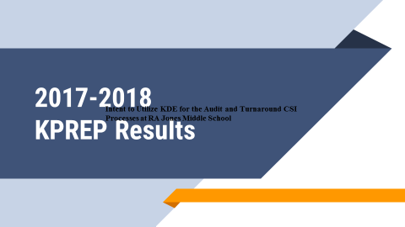

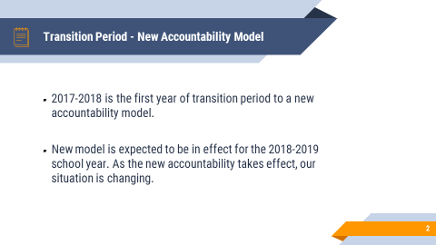
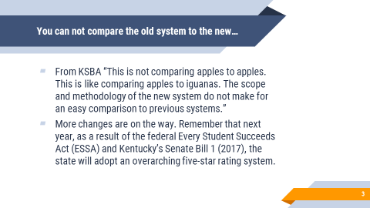

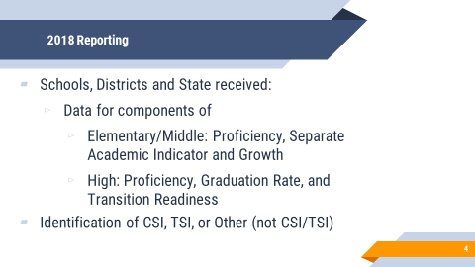

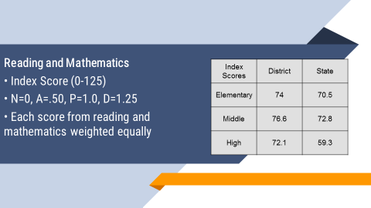

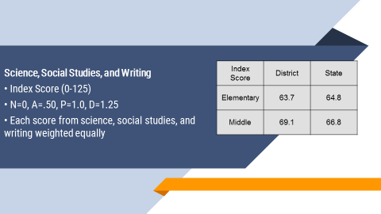

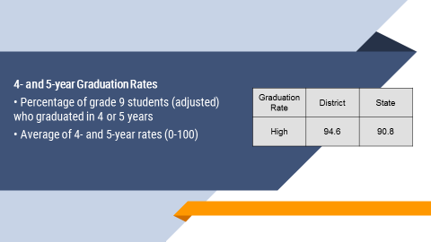

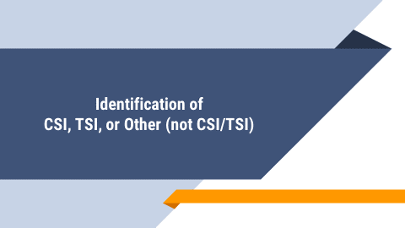
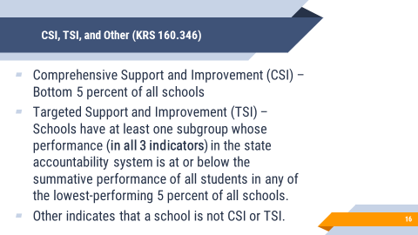
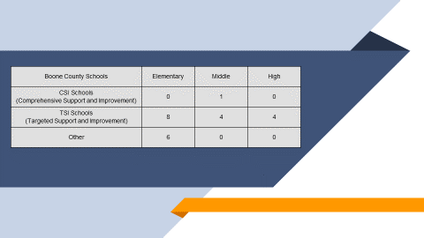

IX.B. Mr. Bill Hogan, Director of Innovation, presented the following powerpoint to update the board on the district Innovation Programs.

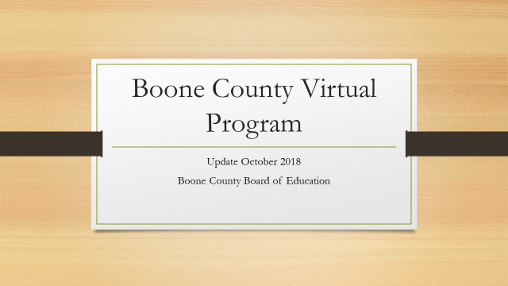
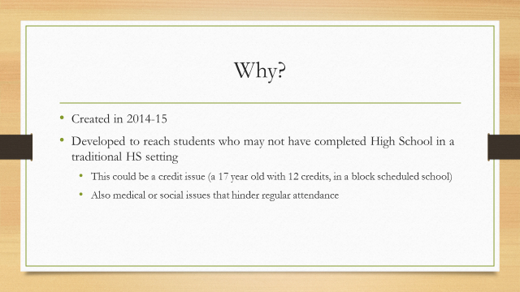

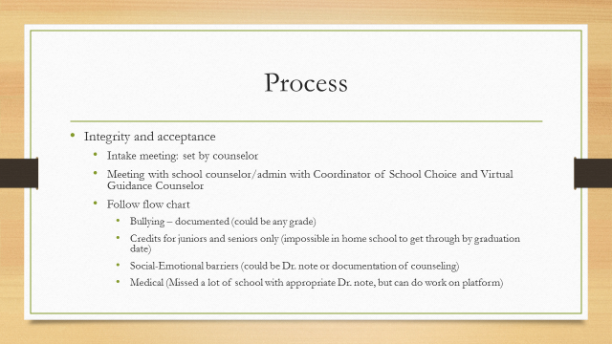

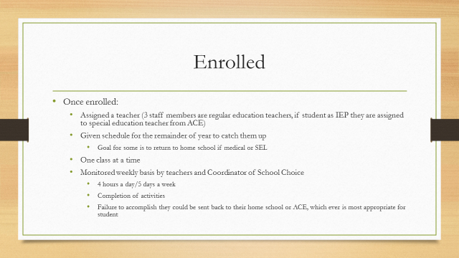

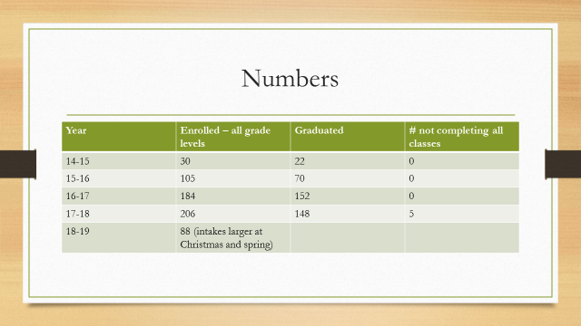

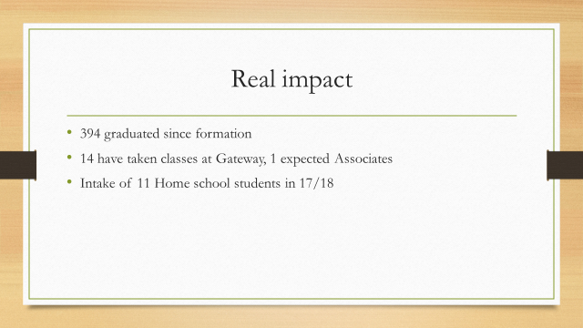
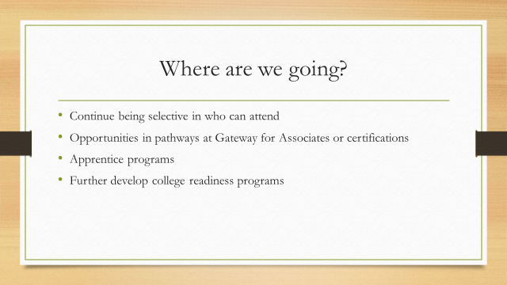
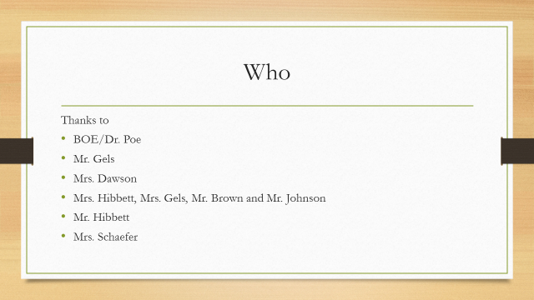

- Eric McArtor announced the board workshop on October 8th at 6:30 for the Gean Kern, Book Study.
- Ed Massey reported on the APQC Conference.
- Ed Massey reported Mr. Hershel Williams, United States Medal of Honor Recipient, will be visiting our district schools of Kelly Elementary and Conner High School. Mr. Massey invited Mr. Williams to visit our students.

X. INFORMATION, PROPOSALS, COMMUNICATIONS
X.A. Human Resource Actions
X.B. Worker's Compensation Claims
X.C. Overtime Report
X.D. Construction Status Report
X.E. Energy Management Report
X.F. 2018 Kentucky Schools Energy Management Report
X.G. 09.436 AP.1 Board Procedure Update

XI. AUDIENCE OF CITIZENS
Attending College Students: NKU- Eric Hoffman, Brandi Norman, Bailey Baker, Candice Roell, Cheyane Combs, Alison Green, Jackeline Dove, Allie Stinson, Brooke Shea, Peter Arnold. Gateway- Kiara Otero, Rebecca McDonals.

XII. CLOSED EXECUTIVE SESSION PER KRS 61.810
XII.A. No closed session

XIII. ADJOURN

- A motion was made by Maria Brown, seconded by Matt McIntire, to adjourn the meeting. Ed Massey, Bonnie Rickert, Karen Byrd, Maria Brown and Matt McIntire voted, “aye” MOTION: The motion passed 5-0.

Meeting was adjourned at approximately 8:39 pm

_____________________________________
Bonnie Rickert/Chairperson

_____________________________________
Karen Evans/Secretary

