Chuck Abell
Acting Superintendent

Amanda Butler
Chief Academic Officer

Steven Rucker
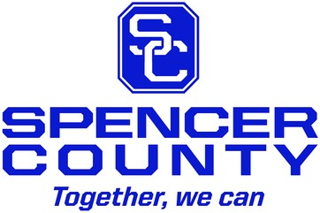
Chief of Student Supports

Todd Russell
Director of Special Education

Administrator Meeting
10/25/22

- Board Meeting Agenda
- School Updates
- Assessment Update
  - Ky. Summative Assessment
- Alchemy Collaborative / Rebranding Update
- Summer School / Dates
- Minority SBDM Members
- MTSS District Meeting
  - November 15th (1:00-3:00)
- Food Service / Transportation Updates
- Facilities Committee
  - Legislative Meeting
- EOC Process
- Truancy Checklist
- Hillview Process
- Strategic Plan / Supper with the Supt.
  - Planning Meeting on Oct. 31st
  - November 17th
  - December 8th
- ECE Updates
- Focus Plans (November 11th )
- Spencer Christian High School
- Areas for Improvement

(502) 477-3250 110 Reasor Avenue Taylorsville, KY 40071 Fax (502) 477-3259 Equal Education and Employment Institution

