Today – 96%
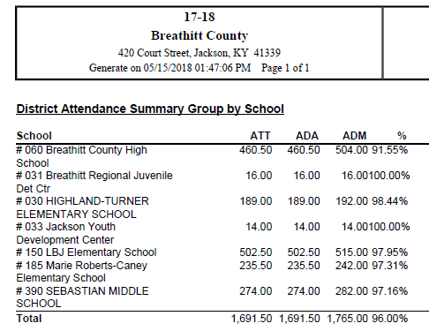
Month 9 (May 1 – May 15: ends 5/28/18) – 94.06%
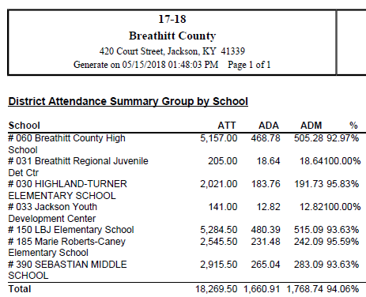
Current Year – without adjustments – 93.35%
