THIS IS A DECISION PAPER

TO: Hardin County Board of Education

FROM: Teresa Morgan, Superintendent

DATE: April 18, 2024

SUBJECT: Building Lease for the Residential Maintenance Program

DISCUSSION:
Due to the increase in student numbers within our Residential Maintenance Pathway, I am requesting to lease a building in Hardin County that will meet our instructional needs. The lease price will be $8200 a month plus utilities.

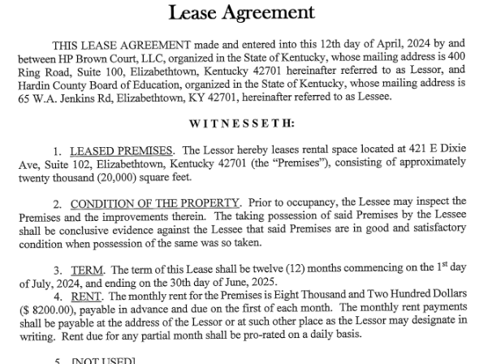

PROPOSAL:
The Board of Education approves the funding to lease a building for the Residential Maintenance program.

*See attached lease agreement

RECOMMENDATION:
It is recommended that the Hardin County Board of Education approve the funding and lease agreement with HP Brown Ct LLC to lease a building for the Residential Maintenance program.

RECOMMENDED MOTION:
I move that the Hardin County Board of Education approve the funding and lease agreement with HP Brown Ct LLC to lease a building for the Residential Maintenance program.

