John Hardin SBDM Council
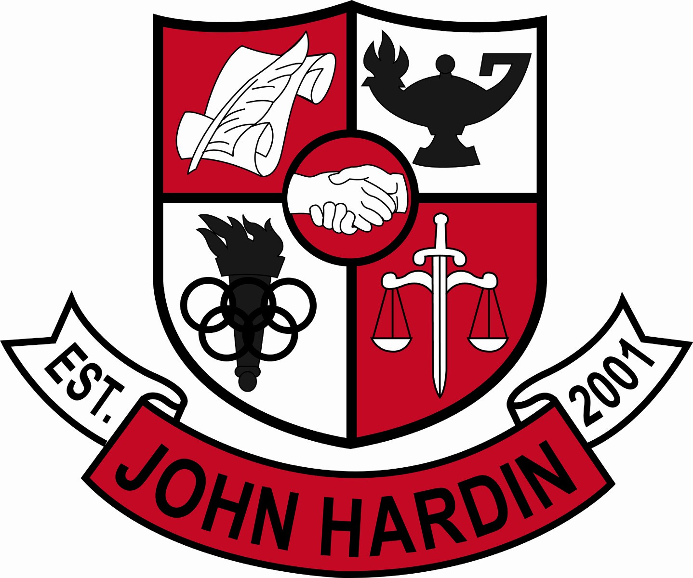
Meeting Minutes

November 13, 2014
4:00 p.m.

- Call to Order at 4:02 p.m.
Members present: Patrick Avery, Alex Shearer, Stacey Moore, Jana Haws, Pauline Crittenden, and Lynne Gibson.
Members absent: Geraldine Rodgers
Visitors present: Bobby Lewis
- Approval of Agenda ORDER #14-15/0011
The council approved the agenda as written.
Motion: Avery Second: Shearer
Avery - Yes
Crittenden – Yes
Gibson – Yes
Haws – Yes
Moore – Yes
Rodgers - Absent
Shearer - Yes
- Approval of Minutes ORDER #14-15/0012 The council approved the minutes as written.
Motion: Haws Second: Moore
Avery - Yes
Crittenden – Yes
Gibson – Yes
Haws – Yes
Moore – Yes
Rodgers - Absent
Shearer - Yes
- Principal’s Update
- Minority Election – Teacher’s elected Geraldine Rodgers; Parent elections will be held Nov. 21st – nominations are being accepted now.
- Data Analysis – Staff spent the entire PL Day in October review data; looking for gaps, strengths, weaknesses, growth; the cores are coming up with specific plans for improvement in their areas
- Student Achievements - attached a copy of the newsletter where Ms. Gibson shared successes from the first trimester

- Financial Report ORDER #14-15/0013
The council reviewed and accepted the financial report for September.
Motion: Shearer Second: Moore
Avery - Yes
Crittenden – Yes
Gibson – Yes
Haws – Yes
Moore – Yes
Rodgers - Absent
Shearer – Yes ORDER #14-15/0014
The council reviewed and accepted the financial report for September.
Motion: Moore Second: Avery
Avery - Yes
Crittenden – Yes
Gibson – Yes
Haws – Yes
Moore – Yes
Rodgers - Absent
Shearer – Yes
- School Compact/Parent Involvement Policy ORDER #14-15/0015
The council approved the School Compact and Parent Involvement Policy as submitted.
Motion: Shearer Second: Avery
Avery - Yes
Crittenden – Yes
Gibson – Yes
Haws – Yes
Moore – Yes
Rodgers - Absent
Shearer – Yes
- Arts/Humanities Credit
The council accepted the proposal for credit to be awarded as a first reading but would like clarification on whether it needs to be the same specialization or cross-discipline.
- Scheduling/Curriculum for 2015-16 ORDER #14-15/0016
The council approved the proposed changes to class offerings for next school with the deletion of Multicultural America and clarification on Dance, Independent Study.
Motion: Shearer Second: Moore
Avery - Yes
Crittenden – Yes
Gibson – Yes
Haws – Yes
Moore – Yes
Rodgers - Absent
Shearer – Yes
- Personnel
Vacancies: Currently have a few coaching assistant positions open
Hired: Don Bradley for English for the remainder of the school year

- Questions and Concerns from Council
- Did the finals schedule work for everyone? No major complaints were received. Still concerns about the length of time but out-weighs seeing students after they’ve been tested
- Agenda Items for Next Meeting
- Arts/Humanities Credit
- Adjourn
The meeting was adjourned at 5:06 p.m. The motion was made by Mr. Shearer and seconded by Ms. Moore

