Regular Meeting Boone County Board of Education
September 14, 2017 7:30 PM
Ralph Rush Professional Development Center
99 Center Street
Florence, Kentucky 41042

I. CALL TO ORDER

The Regular meeting of the Boone County Schools Board of Education September 14, 2017 was called to order by Bonnie Rickert Vice-Chair at the Ralph Rush Staff Development Center.
Attendance Taken at 7:30 PM:

Present Board Members:
Dr. Maria Brown
Ms. Karen Byrd
Mr. Matt McIntire
Ms. Bonnie Rickert

Absent Board Members:
Mr. Ed Massey informed the board he would not be able to attend due to educational trip.

Gerry Dusing attended as Board Attorney
Karen Evans, Board Secretary, recorded the minutes.

II. NATIONAL ANTHEM
The National Anthem was presented by students from Conner Middle School Choir.

III. PLEDGE TO THE FLAG
The Pledge to the Flag was be led by students from Longbranch Elementary.

IV. STUDENT BOARD MEMBER REPRESENTATIVE REPORT
Bryan Padilla gave thee the Student Board Member Representative report. Bryan discussed the plan of the council to bring the Healthy Choice talks to the elementary schools, the Reality Workshops to the Middle Schools, and the Drug Free Clubs of America to High Schools. Bryan also reviewed the last Superintendent Advisory Council meeting stating the meeting went well and the councils session was on Professional Skills.

V. GOOD NEWS
V.A. The board recognized and congratulated the 2017 September Break the Mold Award recipient, Ms. Jodi Petersime, Conner High School, Instructional Coach
V.B. The board recognized and congratulated Ms. Kellie Clark, Cooper High School Teacher, recipient of the 2017 Kentucky Teacher of the Year Award. Ms. Clark, was unable to attend.
V.C. The board recognized and congratulated Ms. Bonnie Rickert, Boone County School Board Member, for being honored with the Life Fellow of the Kentucky Bar Foundation Award.
V.D. The board recognized our district schools for the AdvanceEd Certificate of Accreditation Awards.
V.E. The board recognized and congratulated all of our 2017 Employee Retirees in attendance and recognized those who were unable to attend.
Congratulations and Thank YOU for your service to our students in Boone County!

Joyce Abney
Kimberly Ashworth
Elizabeth Askins
Brenda Baker
Marcella Barton
Mari Beasley
Wilson Bennett
Rebecca Binkholder
Debbie Black
Patric Brinsko
Kathleen Brossart
Robert Brown
Mary Cahill
Joann Case
Brenda Davidson
Pamela Dickman
Randal Dickman
Debra Donnermeyer
Christine Drance
Kathryn Durfee
Geri Eckstein
Regina Egbers
Robert Elliott
Joan Fitzsimmons
Kathy Flake
Regina Gilliam
John Giltz
Kimberly Gray
Marilyn Hiltz-Latta
Karen Horton
Connie Hunley
Sandra Hutchinson
Michael Ingram
Steve Ison
Teresa Jackson
Barbara Jesensky
Constance Kepf
Patti Kessler
D'Anna Kloeker
Jeff Lonneman
Bonnie Mahlerwein
Claude Marcum
Kazmila Maric
John Martin
Anthony Matuza
Cynthia McFarland
Ronald Murray
Marilyn Neil
Stephen Penrod
Julie Peters
Margaret Raupach
Vicki Reckers
Karen Rhein
Daryl Rouse
Teresa Salmen
Catherine Samad
Mildred Scherder
Kathyline Schick
Marilyn Scotillo
Teena Shauger
Constance Spreher
Sue Stasie
Karen Steele
Luann Steffen
Ronda Sturdivant
Landra Szekeres
Norma Thompson
Sheila Utley
Deborah Vickers
Sandra Weibel
Barbara Whaley
Theresa Wilhelmy
Anna Williams
Vicki Wolff
Debora Woodruff

VI. AUDIENCE OF CITIZENS
No one spoke.

VII. RECOMMENDED ACTION - CONSENT AGENDA
Dr. Randy Poe, Superintendent, recommended the following Consent Agenda items A - XX for Board approval, as presented.

- A motion was made by Karen Byrd, seconded by Maria Brown , to approve the consent agenda items A-XX as presented. Maria Brown recused herself from the minutes, she was not in attendance: Karen Byrd, Maria Brown, Matt McIntire, and Bonne Rickert voted, “aye” MOTION: The motion passed 4-0.

VII.A. Minutes of the regular board meeting of August 10, 2017.
The board approved the the minutes of the regular board meeting of August 10, 2017 as presented.
VII.B. Bill List
VII.C. Treasurer's Report was given by Mrs. Linda Schild.
VII.D. Leaves of Absence
The board approved the following persons submitted leave of absence requests:
Recommended by Principal/Supervisor for approval:
Badida, John, Bus Driver @ Transportation, 8/16/2017 – 9/29/2017
Bonta, Kathryn, Bus Driver @ Transportation, 8/16/2017 – 9/29/2017
Cahill, RoseAnn, Café Wkr @ Cooper High School, 8/15/2017 - EOY
Clayton, Candace, Teacher @ Longbranch Elem, 8/24/2017 – 9/29/2017
Danner, Amanda, Teacher @ New Haven Elem, 11/6/2017 – 11/21/2017
Dierken, Christen, Teacher @ Yealey Elem, 9/20/2017 – 12/1/2017
Dixon, Chandra, Asst. Principal @ Cooper High School, 6/26/2017 – 7/3/2017
Hall, Barbara, Café Wkr @ Goodridge Elem, 8/16/2017 – 9/27/2017
Murphy, Dennis, Teacher @ Ryle High School, 8/14/2017 – 10/27/2017
Orcena, Deborah, Para Educator @ Ryle High School, 8/18/2017 – 11/1/2017
Perry, Donna, Transportation Aide @ Transportation, 8/21/2017 – 9/1/2017
Slusher, Betty, Café Worker @ New Haven Elem, 8/14/2017 – 11/3/2017
Sullivan, Taylor, Teacher @ Alternative Center, 9/8/2017 – 10/5/2017
Walsh, Meggie, Teacher @ Yealey Elm, 9/15/2017 – 12/19/2017

Not Recommended by Principal/Supervisor for approval:
Nothing to Report

Amended Leaves:
Stephens, Nancy, Custodian @ Ryle High School, 5/1/2017 – 9/26/2017

Cancelled Leaves:
None

VII.E. Minutes Board Workshop Meeting Minutes Ballyshannon Middle School August 28, 2017
The board approved the Board Workshop Meeting Minutes Ballyshannon Middle School August 28, 2017, as presented.
VII.F. Minutes Special Board Meeting Tax Hearing Public Forum August 24, 2017
The board approved the Minutes Special Board Meeting Tax Hearing Public Forum August 24, 2017, as presented.
VII.G. Minutes Special Board Meeting Tax Hearing August 24, 2017
The board approved the Minutes Special Board Meeting Tax Hearing August 24, 2017, as presented.
VII.H. National School Board Association Conference April 7-9, 2018 San Antonio, TX
The board approved the National School Board Association Conference April 7-9, 2018 San Antonio, TX for board members and superintendent travel and expenses, as presented.
VII.I. NWEA-OECD Convening on International Comparisons and School Improvement Workshop, Washington DC Sept 20,2017 for Dr. Randy Poe
The board approved the NWEA-OECD Convening on International Comparisons and School Improvement Workshop, Washington DC, being held on Sept 20, 2017. The attendance of Dr. Randy Poe, with OECD reimbursing up to $500.00 of the estimated travel expense of $1000.00, as presented.
VII.J. Surplus Vehicles
The board approved and declared the Surplus Vehicles as surplus and approve the disposal of the vehicles, as presented.
VII.K. Bid-Cooling Tower Hydronics System Water Treatment Watcon, Inc.
The board approved the Bid award for Cooling Tower Hydronics System Water Treatment to Watcon, Inc. as presented.
VII.L. FY17 Instructional Transformation Project Contract- Commonwealth of Kentucky (Modifications)
The board approved the FY17 Instructional Transformation Project Contract- Commonwealth of Kentucky (Modifications), as presented.
VII.M. Kennedy Center Arts in Education
The board approved the Kennedy Center Arts in Education, as presented.
VII.N. Textbook Purchases for Florence Elementary
The board approved the Textbook Purchases for Florence Elementary, as presented.
VII.O. Memorandum of Understanding between the Family Nurturing Center and Boone County Schools
The board approved the Memorandum of Understanding between the Family Nurturing Center and Boone County Schools, as presented.
VII.P. Memorandum of Agreement Kentucky Educational Collaborative State Agency Fund (KECSAC)
The board approved the Memorandum of Agreement Kentucky Educational Collaborative State Agency Fund (KECSAC), as presented.
VII.Q. School Based Counseling Services Contracts
The board approved the School Based Counseling Services Contracts, as presented.
VII.R. Northern Kentucky University College of Health Professions MOU
The board approved the Northern Kentucky University College of Health Professions MOU, as presented.
VII.S. My Life My Choice Groups Program at RA Jones Middle School
The board approved the My Life My Choice Groups Program at RA Jones Middle School, as presented.
VII.T. Annual Clinical Affiliation Agreement between Beckfield College and Boone County Schools
The board approved the Annual Clinical Affiliation Agreement between Beckfield College and Boone County Schools, as presented.
VII.U. Annual Collaborative Agreement between Children's Home of Northern Kentucky and Boone County Schools for School-Based and SUD Services
The board approved the Annual Collaborative Agreement between Children's Home of Northern Kentucky and Boone County Schools for School-Based and SUD Services, as presented.
VII.V. Field Trips
The board approved the Field Trips, as presented.

School | Date Of Trip | Location | Reason
Conner High School | October 25-27, 2017 | Indianapolis, IN | FFA Convention
Cooper High School | Oct, Nov, 2017 | Lexington & Louisville | Football Games
Cooper High School | October 25-27, 2017 | Indianapolis, IN | FFA Convention
Florence Elementary | September 21, 2017 | Fishers, IN | Educational
Goodridge Elementary | October 11, 2017 | Fishers, IN | Educational
Gray Middle School | April 26-28, 2018 | Chicago, IL | Educational
Longbranch Elementary | October 18, 2017 | Frankfort | Educational
Longbranch Elementary | October 11, 2017 | Fishers, IN | Educational
Ryle High School | December 26, 2107 | Ft. Myers, FL | Girls Basketball Tournament
Ryle High School | November 8-12, 2017 | Washington DC | FCCLA Leadership Meeting
The

VII.W. Food Service Program Agreement for 2017-2018 Boone County Head Start
The board approved the Food Service Program Agreement for 2017-2018 Boone County Head Start, as presented.
VII.X. Bidding Documents and BG-3 for Ockerman Elementary-Flooring Replacement
The board approved the Bidding Documents and BG-3 for Ockerman Elementary-Flooring Replacement, as presented.
VII.Y. Revised BG-1 for Paving 2017 BG#17-083
The board approved the Revised BG-1 for Paving 2017 BG#17-083, as presented.
VII.Z. Gray Middle School -MEP Improvements Schematic Design/Design Development Drawings, BG-2 and BG-3 BG#17-121
The board approved the Gray Middle School -MEP Improvements Schematic Design/Design Development Drawings, BG-2 and BG-3 BG#17-121, as presented.
VII.AA. AIA Standard Form of Agreement Bus Garage/Facility Management - Generators
The board approved the AIA Standard Form of Agreement Bus Garage/Facility Management - Generators, as presented.
VII.BB. AIA Standard Form of Agreement-Architect Collins and Stephens Elementary- HVAC Upgrades BG#17-263
The board approved the AIA Standard Form of Agreement-Architect Collins and Stephens Elementary- HVAC Upgrades BG#17-263, as presented.
VII.CC. AIA Standard Form of Agreement-Boone County Schools Central Office HVAC Upgrades BG#18-036
The board approved the AIA Standard Form of Agreement-Boone County Schools Central Office HVAC Upgrades BG#18-036, as presented.
VII.DD. BG-1 Application Ockerman Elementary Flooring Replacement
The board approved the BG-1 Application Ockerman Elementary Flooring Replacement, as presented.
VII.EE. Change Order #1 Conner High School Reroof BG#17-084
The board approved the Change Order #1 Conner High School Reroof BG#17-084, as presented.
VII.FF. Change Order #2 Paving 2017 BG#17-083
The board approved the Change Order #2 Paving 2017 BG#17-083 with the addition of $20,804.00, as presented.
VII.GG. Change Order #3 Central Office Annex BG#17-017
The board approved the Change Order #3 Central Office Annex BG#17-017, with the deduction of $3321.00, as presented.
VII.HH. KSBA Representation at the Public Service Commission regarding DUKE Energy Rate Increase
The board approved the KSBA Representation at the Public Service Commission regarding DUKE Energy Rate Increase, as presented.
VII.II. Approval of Final Project Closeout BG-5 Boone County High School MEP Improvements BG#14-014
The board approved the Approval of Final Project Closeout BG-5 Boone County High School MEP Improvements BG#14-014, as presented.
VII.JJ. Approval of Final Project Closeout-BG-5 Gray Middle School Chiller Replacement (and emergency boiler) BG#15-2852
The board approved the Approval of Final Project Closeout-BG-5 Gray Middle School Chiller Replacement (and emergency boiler) BG#15-2852, as presented.
VII.KK. Approval of Final Project Closeout BG-5 Florence Elementary
The board approved the Final Project Closeout BG-5 Florence Elementary, as presented.
VII.LL. Approval of Final Project Closeout BG-5 Boone County Schools Paving 2016 BG#17-061
The board approved the Final Project Closeout BG-5 Boone County Schools Paving 2016 BG#17-061, as presented.

VII.MM. NCERT Membership 17-18
The board approved the NCERT Membership 17-18 in the amount of $6950.00, as presented.
VII.NN. NKCES Membership 17-18
The board approved the NKCES Membership 17-18 in the amount of $19,984.00, as presented.
VII.OO. Boone County Schools Approval of Settlement in Agency Case No 17-01
The board approved the Boone County Schools Approval of Settlement in Agency Case No 17-01, as presented.
VII.PP. ARC/504 Chairs
The board approved the school personnel to chair ARC and 504 meetings at each school for the 2017-2018 school year, as presented.
VII.QQ. Agreement between Paragon Marketing Group LLC and Larry Ryle High School
The board approved the Agreement between Paragon Marketing Group LLC and Larry Ryle High School, approved by chair because of the date deadline being before the board meeting, as presented.
VII.RR. Amendment to the BCEA President's Salary
The board approved the Amendment to the BCEA President's Salary, as presented.
VII.SS. Instructional Time Adjustment for Goodridge Elementary School for the 2017-2018 School Year
The board approved the Instructional Time Adjustment for Goodridge Elementary School for the 2017-2018 School Year, as presented.
VII.TT. MOU with NKU for Onsite Pre-Service Teacher Practicum Course Work at Florence Elementary School for 2017-2018 and 2018-2019
The board approved the MOU with NKU for Onsite Pre-Service Teacher Practicum Course Work at Florence Elementary School for 2017-2018 and 2018-2019, as presented.
VII.UU. Extra Duty Positions- Coordinator & Supervisor Athletic Instructional League
The board approved the Extra Duty Positions- Coordinator & Supervisor Athletic Instructional League, as presented.
VII.VV. Ockerman Elementary Floor Replacement Professional Services
The board approved the Ockerman Elementary Floor Replacement Professional Services, as presented.
VII.WW. 17-18 Fee Schedule Amended
The board approved the 17-18 Fee Schedule amended to include camp fees, as presented.
VII.XX. Ballyshannon Middle School Gas Service Agreement with Duke Energy
The board approved the Ballyshannon Middle School Gas Service Agreement with Duke Energy, as presented.

VIII. RECOMMENDED ACTION - OLD BUSINESS
No Old Business

IX. RECOMMENDED ACTION - NEW BUSINESS

IX.A. New Job Description - Director of Comprehensive Health Services
Dr. Poe, Superintendent recommended the board approve the position of District Health Coordinator to the upgraded New Job Description - Director of Comprehensive Health Services, as presented.

- A motion was made by Karen Byrd, seconded by Maria Brown , to approve the position of District Health Coordinator to the upgraded New Job Description –Director of Comprehensive Health Services, as presented. Karen Byrd, Maria Brown, Matt McIntire, and Bonne Rickert voted, “aye” MOTION: The motion passed 4-0.

Dr. Poe discussed the upgrade to director of Comprehensive Health Services, this position will now direct all health services programs across the district and will not just oversea the school nurses. The position will add value to a comprehensive services in the present and long term.

IX.B. District Assurances
Dr. Poe recommended the board approve the District Assurances, as presented.

- A motion was made by Maria Brown, seconded by Karen Byrd , to approve the District Assurances, as presented. Karen Byrd, Maria Brown, Matt McIntire, and Bonne Rickert voted, “aye” MOTION: The motion passed 4-0.

Dr Poe explained in the district assurances, as opposed to approving multiple items across the board, it is the districts responsibility to make sure all schools have turned in the different reports in relationship to the comprehensive plan.

IX.C. Working Budget for 2018
Dr. Poe recommended the board approve the Working Budget for 2018, as presented.

- A motion was made by Karen Byrd, seconded by Maria Brown, to approve the Working Budget for 2018, as presented. Karen Byrd, Maria Brown, Matt McIntire, and Bonne Rickert voted, “aye” MOTION: The motion passed 4-0.

Dr. Poe thanked the committee for this year, and stated this budget tonight does not take in to consideration of some of the news coming out of Frankfort this week with the recommendation of a 17% cut. . There will be changes and modifications in the budget going forward, but as of now those are recommendations until the final recommendation comes. The 17% cut the state has issued the district office finance department is working through those and will bring those back up at future budget meetings to know how it will affect the district. The preliminary is cut is approximately $800,000 and more will come on this in the future.

X. SUPERINTENDENT'S REPORT
Mrs. Krista Decker, LSS Director of Assessment, gave a detailed report on the Organization for Economic Cooperation and Development (OECD) data and 2017 Graduation Class ACT data. The PowerPoint presentation was also given as handout to each board member. Ms. Dicker’s presentation was titled: How Our Schools Compare Internationally. OECD Test for schools (based on PISA) OECD: The Organization for Economic Co-operation and Development, PISA: Program for International Student Assessment. In November of 2016, each of our four high schools participated in the OECD Test for Schools (based on PISA). The test measures 15-year-old students’ applied knowledge and competencies in reading, mathematics, and science. By participating in the assessment, each high school can compare its results with those from the international PISA assessment that was implemented around the world. Beyond proficiency levels, OECD measures how each school compares with similar schools in the US as well as student engagement and the learning environment at each school in an international perspective. Mrs. Decker reviewed the districts results and discussed student engagement and learning environments. Mrs. Decker spoke on the importance of mathematics and science for students’ future lives, we need to ensure that students have not only the knowledge that is necessary to continue learning beyond formal schooling, but also the interest and motivation that will make them want to do so. Mrs. Decker discussed successful learners often believe in their own self-efficacy: they are confident in their ability to solve tasks. Students who lack confidence in their ability to solve tasks often tend to show weaker performance results than those with a high level of self-efficacy. Mrs. Decker reported on how our schools compare in an internationally context and in the United States, the data represented in math and reading at 500, science a 525 which is in the middle of the PISA. This data can be found in the Learning Support Department of the District.

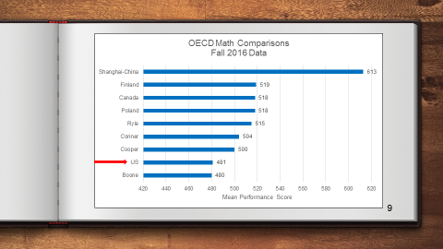

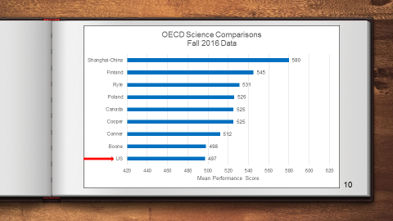

Mrs. Decker also reported on the 2017 ACT Graduating Class data with a handout and Power Point presentation. The 1,416 students are included in this report and 28% of our students met all four ACT College Readiness Benchmark Scores. This data can be reviewed in the Learning Support Services Department.

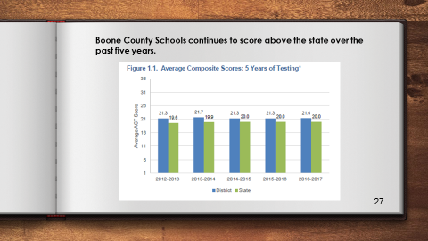

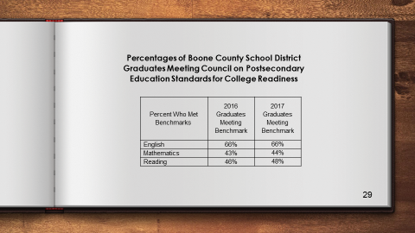

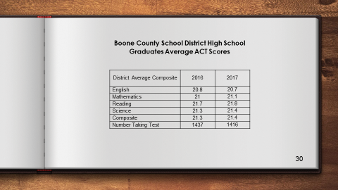

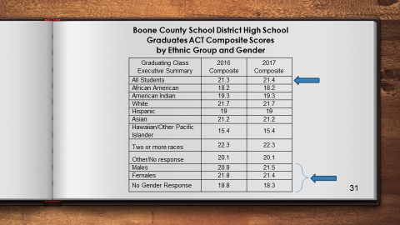

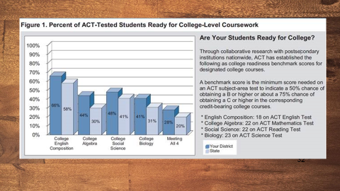

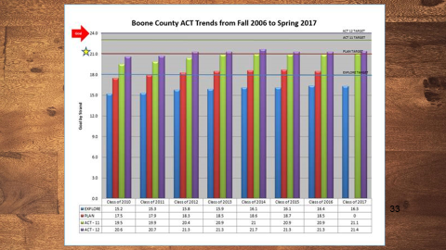

Dr. Poe announced the two public forums for the Redistricting for Ballyshannon Middle School will be held at Ralph Rush Development Center on September 26 and October 17, 2017 at 6:30 pm to 8:00 pm.

Dr. Poe announced the special called meeting for an Expulsion Hearing, will be held on September 28, 2017 at 7:00 pm, at Ralph Rush Development Center.

XI. INFORMATION, PROPOSALS, COMMUNICATIONS
XI.A. Human Resource Actions
XI.B. Worker's Compensation Claims
XI.C. Overtime Report
XI.D. Construction Status Report
XI.E. Energy Management Report
XI.F. Certification for the 2017-2018 School Year Constitutionally Protected Prayer in Public School Document
XI.G. Fernside Supporting Children and Families through Grief

XII. AUDIENCE OF CITIZENS

The following College students introduced themselves to the board and their educational majors: Emily Jackson, Taylor Spaulding, Lori Bold, Megan Miller, Kiara Campbell and Abigail Gebaver.

XIII. CLOSED EXECUTIVE SESSION PER KRS 61.810
XIII.A. No closed session

XIV. ADJOURN

- A motion was made by Karen Byrd, seconded by Maria Brown, to adjourn the meeting. Bonnie Rickert, Maria Brown, Karen Byrd, and Matt McIntire voted, “aye” MOTION: The motion passed 4-0.

Meeting was adjourned at approximately 8:47 pm.

_____________________________________
Ed Massey/Chairperson

_____________________________________
Karen Evans/Secretary

