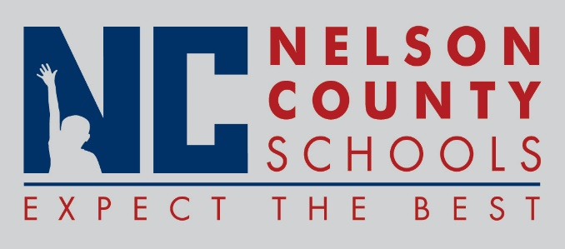

Decision Paper
To: | Nelson County Board of Education
From: | Tom Dekle
cc: | Dr. Anthony Orr, Superintendent
Date: | May 16, 2017
Re: | SUDIA School Health and Wellness Program grant

The Southeast United Dairy Industry Association, Inc. (SUDIA) will provide funds or equipment in support of our Summer Feeding Program if we agree to maximize access to low fat and fat-free dairy products, participate in the Fuel Up to Play 60 program and work in support of summer feeding, all of which we already do. In exchange SUDIA will provide ten 60 quart mobile coolers, together valued at $570, to assist with the transport of dairy products and work with us to maximize the success of our summer feeding program.
RECOMMENDATION: Approval for a Letter of Agreement with Southeast United Dairy Industry Association in support of our summer feeding program in exchange for the award of 10 mobile Igloo coolers, valued at $570.

RECOMMENDED MOTION: I move that the Nelson County Board of Education approve a Letter of Agreement with Southeast United Dairy Industry Association as presented, in support of this initiative.

