Tax Hearing Public Forum Special Board Meeting Boone County Board of Education
September 03, 2020 6:30 PM
Due to the Governor's directive of no more than 50 to gather for safety during the Covid-19 Pandemic, the meeting allowed 50 people in the room when the Board Meeting took place and added an area to view the meeting live if needed.

The Board of Education broadcast the meeting on our YouTube page.https://www.youtube.com/user/BooneCountySchools Ralph Rush Professional Development Center 99 Center Street Florence, Kentucky 41042
I. CALL TO ORDER
The Tax Hearing Public Forum Special Board Meeting of the Bounty Schools Board of Education, September 3, 2020, at 6:30 pm, was called to order by Chairperson Matt McIntire.

Attendance Taken at : 6:30 PM
Present Board Members:
Dr. Maria Brown
Ms. Karen Byrd
Mr. Troy Fryman
Mr. Matt McIntire
Mrs. Julia Pile
Karen Evans, Board Secretary
Matthew Turner, Superintendent
II. PLEDGE TO THE FLAG
The Pledge to the Flag was led by Mr. Matt McIntire, Chairperson.
III. INFORMATION ON TAX RATE LEVY (ATTACHMENTS ON WEBSITE UNDER EMEETING)
Mrs. Linda Schild, Finance Director gave the following report and reviewed all the documents published for the public on Emeeting. Each board member received a handout of the power point presentation below.
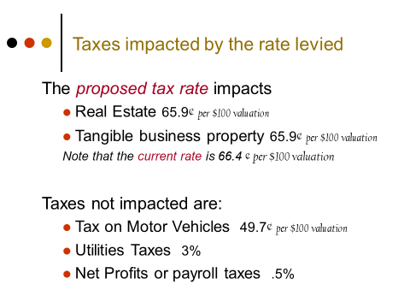

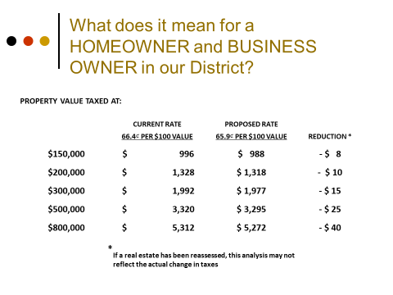
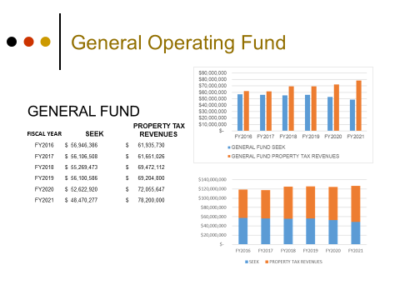

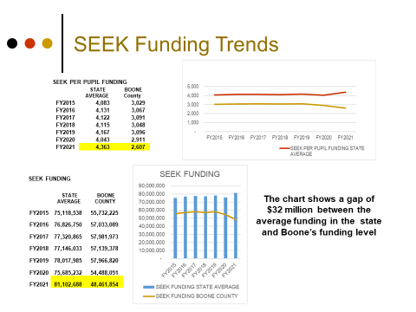

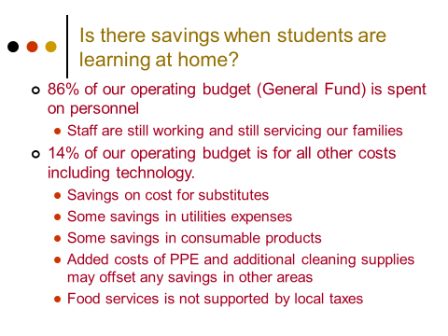

After the presentation, the meeting was open to the board members for questions. Brief of discussions: Dr. Brown discussed the substitute pool being very low and the impact of this cost due to COVID and teachers unable to work, the expense of all the digital platforms the district had to come up with for the virtual learning, safety products cost. Superintendent Turner, spoke on the unique medical expenses we are enduring and incurring the rest of the year. Julie Pile questioned the increase in students and the huge burden that SEEK puts on our district, Linda spoke on the small decline in growth, but Mike Ford stated we grow on the average of 225 to 250. Julie Pile asked for the community and parents to help keep our SEEK monies in our district, at this time our funds go to other areas, contact your legislatures and work to get the SEEK formula changed so our district gets the share of funds we should receive. Troy Fryman discussed SEEK and the unfair way the fund is distributed and he asked we form a coalition to address the issue at the state level – we need an action plan to keep our monies here for our students.
Matt McIntire, discussed the difficult time in our area and state, this will make the tax go down and the burden of the extra expenses with COVID and safety supply cost. Mr. McIntire discussed the SEEK funds are not guaranteed and we must make financial plans for this in our budgets. Mr. McIntire spoke on the need for advocacy and all to reach out to our legislatures, which will make a difference.

IV. PUBLIC HEARING
The meeting was open to the public for public comments on the Tax Rate Levy. No one spoke.
V. ADJOURN
- A motion was made by Karen Byrd, seconded by Dr. Maria Brown, to adjourn the meeting. Karen Byrd, Dr. Dr. Maria Brown, Julia Brown, Troy Fryman and Matt McIntire voted, “aye” MOTION: The motion passed 5-0.

Meeting was adjourned at approximately 6:53 pm.

____________________________________
Matt McIntire /Chairperson

_____________________________________
Karen Evans/Secretary

