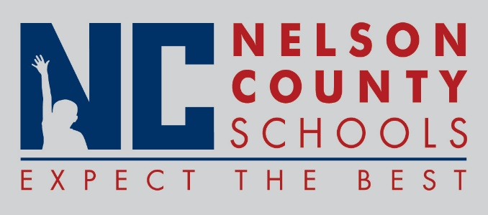

Decision Paper
To: | Nelson County Board of Education
From: | Bob Morris, Executive Director of Student Support
cc: | Dr. Anthony Orr, Superintendent
Date: | January 17, 2017
Re: | Make-Up Days for 2016-2017

Date Missed Make-Up Day
January 05, 2017 February 10, 2017
January 06, 2017 March 10, 2017

RECOMMENDATION: I recommend the Nelson County Board of Education approve this make-up days.

RECOMMENDED MOTION: I move that the Nelson County Board of Education approve this make-up days as presented.

