Workshop Special Meeting Redistricting Ballyshannon Middle School
Boone County Board of Education
August 28, 2017 6:30 PM
Ralph Rush Professional Development Center
99 Center Street
Florence, Kentucky 41042

I. CALL TO ORDER

The board workshop meeting on the redistricting of Ballyshannon Middle School on August 28, 2017 was called to order by Chairperson Ed Massey at the Ralph Rush Staff Development Center.
Attendance Taken at 6:30 PM:

Present Board Members:
Dr. Maria Brown
Ms. Karen Byrd
Mr. Ed Massey
Mr. Matt McIntire
Ms. Bonnie Rickert

Karen Evans, Board Secretary, recorded the minutes.

II. PLEDGE TO THE FLAG
The Pledge to the Flag was led by Mr. Ed Massey, Chairperson.

III. WORKSHOP ON REDISTRICTING - BALLYSHANNON MIDDLE SCHOOL

Dr. Randy Poe, Superintendent, stated the purpose of the workshop is for information purposes for the board members first view from the redistricting committee’s scenarios concerning the Ballyshannon Middle School and the redistricting purpose. There will be two public forums in the district for parents and the community members to voice their concerns and will be announced as soon as those dates are confirmed.

Eric McArtor, Deputy Superintendent COO, and redistricting committee spokesperson, gave the powerpoint presentation (see presentation following) for the workshop. Mr. McArtor discussed the presentation giving details as the possible vectors for redistricting, the charges from the board for the redistricting of Ballyshannon that the committee took into account when bringing forth the two scenarios. Mr. McArtor discussed the timeline for the redistricting, and taking the feedback from the board and possibly the revising of the scenarios from the public forum information then the goal is to present a recommendation to the board at the November board meeting. The Demographics and Growth Committee was made up of principals and parent representatives from the effected schools, GIS staff, along with district level administration teams and two board members – Dr. Maria Brown and Ed Massey. Mr. McArtor reviewed the purpose and process of the committee. Mr. McArtor discussed the committee took into consideration the balance of the enrollment of the affected schools, placing clear boundaries and looking at the future growth potential in the scenarios. See the below slides for the major subdivisions that would be impacted by the redistricting to Ballyshannon Middle School under Scenario 1B and 2 B. Mr. McArtor reviewed the socio-economic impact for the current schools and the Scenario 1B and 2B (see charts) and reviewed the maps with the board. In conclusion of the presentation, Mr. McArtor opened the presentation up to any questions from the board members. Board members discussed the maps and certain areas with Mr. Ford answering questions on the maps.

Dr. Poe, discussed the process after the workshop which the committee will relook at the scenarios and move forward with the two public hearings, the schools that will be impacted by the redistricting will have the maps displaying the subdivisions affected displayed in the school for parents and community review. The two public forums will be a time to hear comments from the public for the committee to consider before the final recommendation to the board at the November board meeting. Dr. Poe stated that as traditionally in the past 8th grade students may have the option of staying at their current school and providing their own transportation.

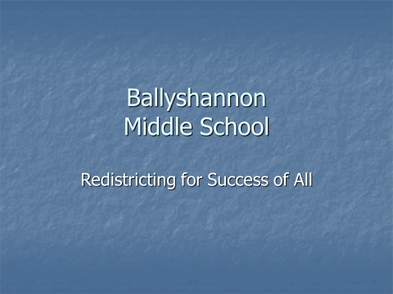

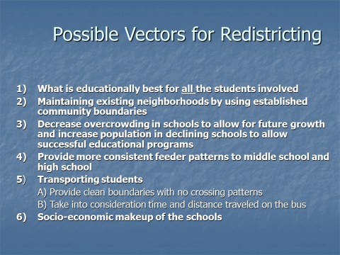

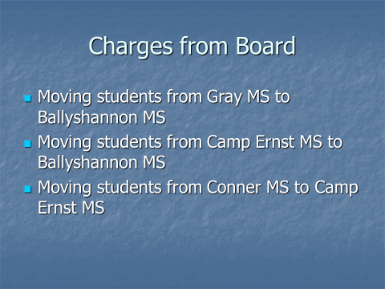

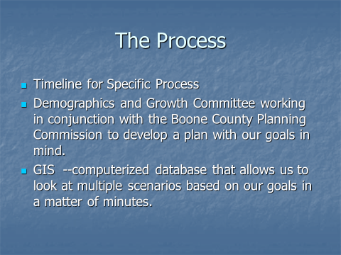

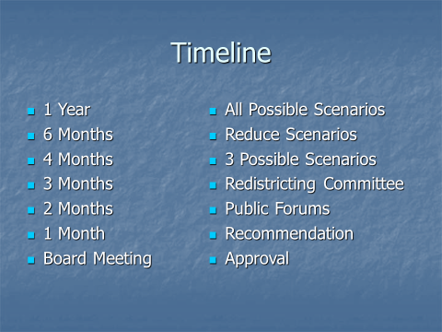

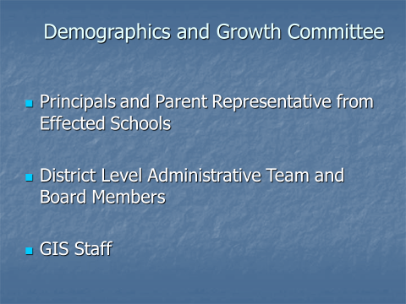

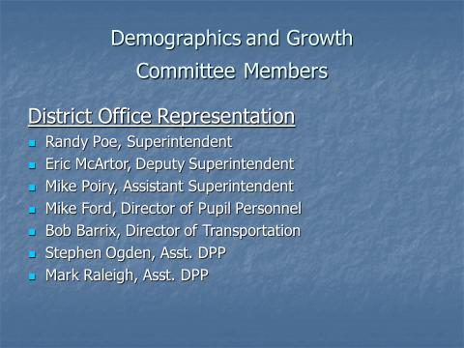

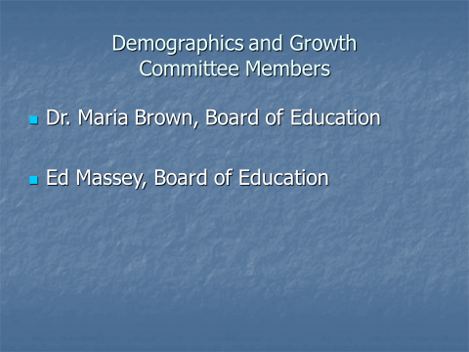

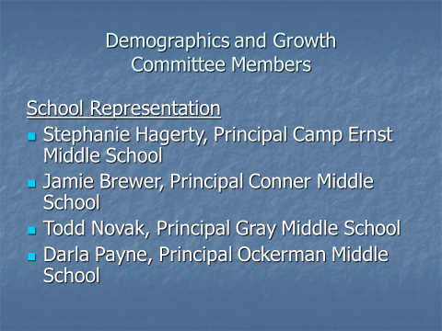
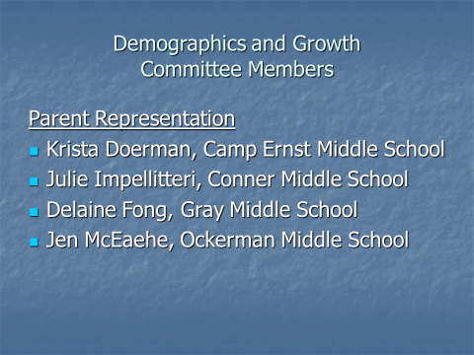

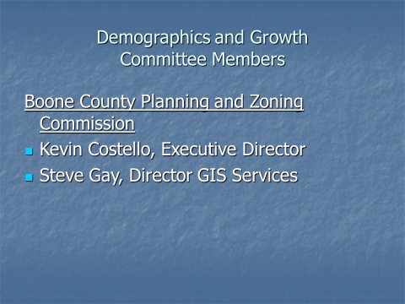
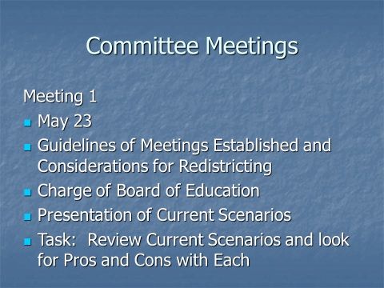

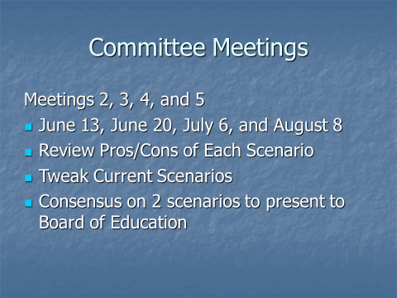

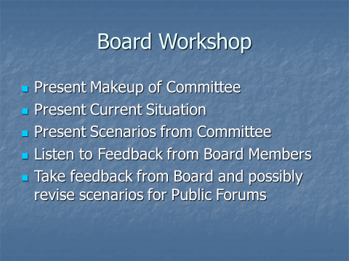

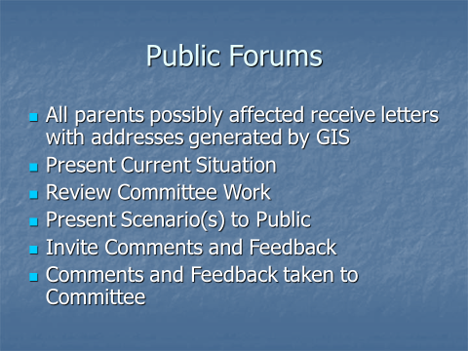

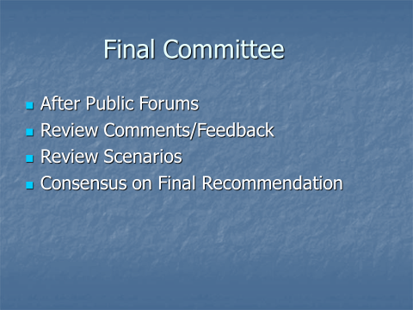

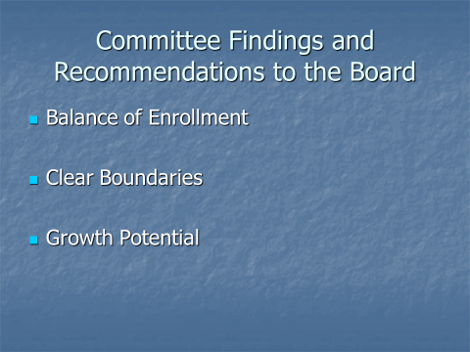

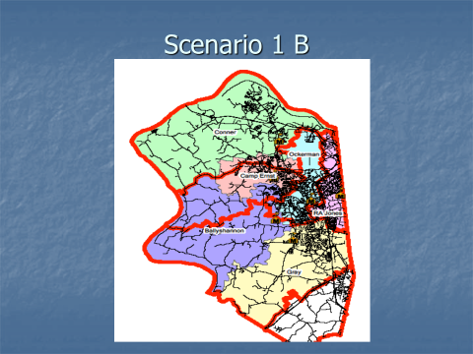

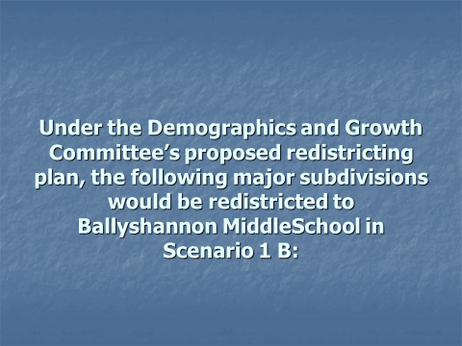

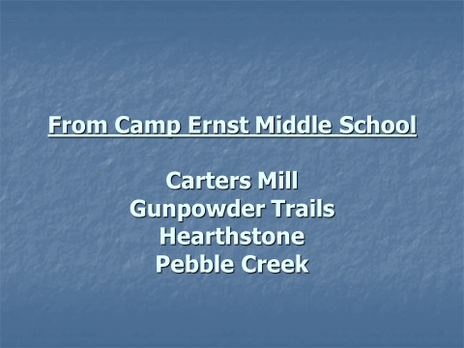
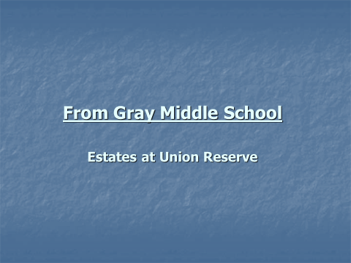

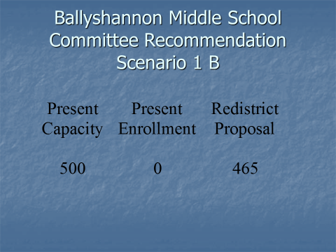

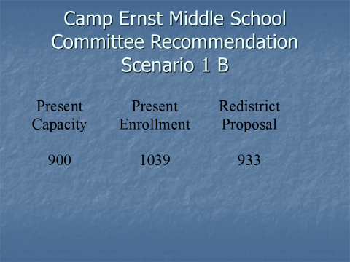

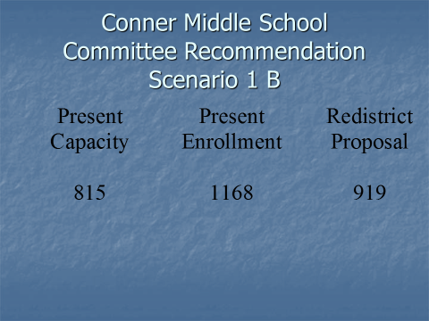

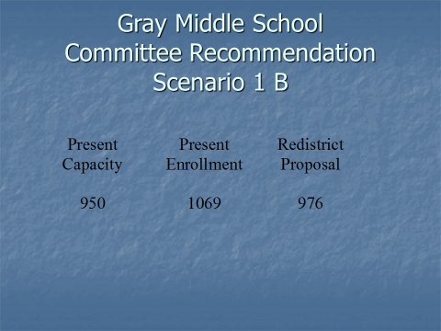
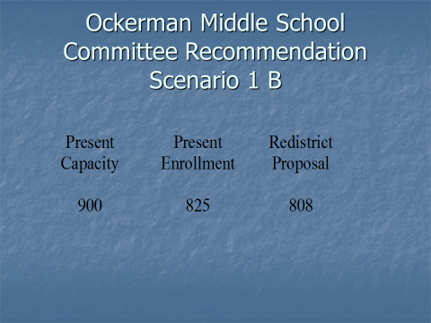
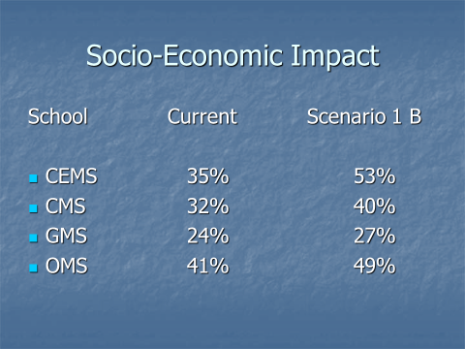

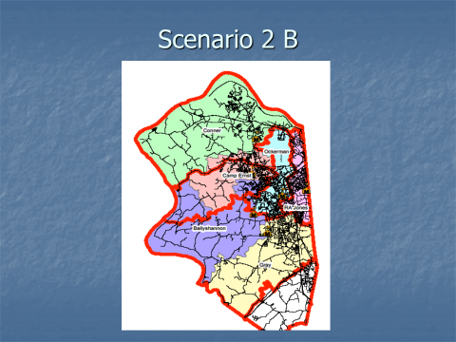

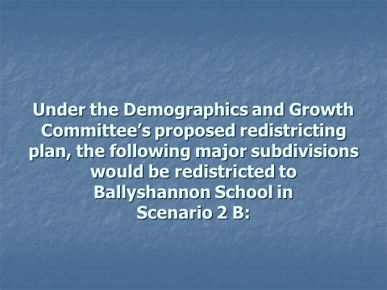

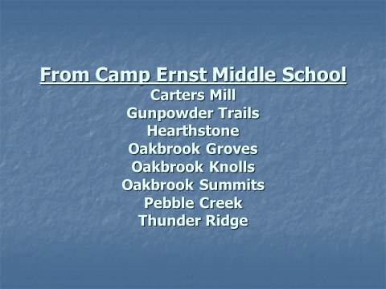

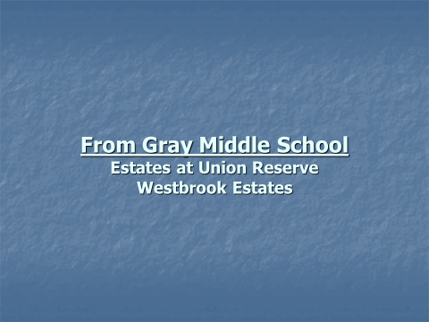

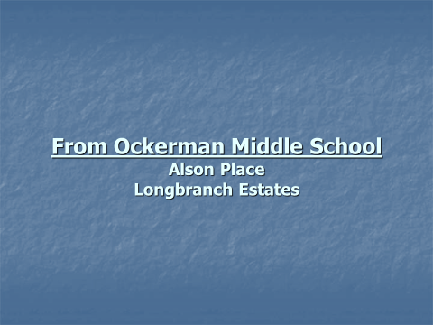

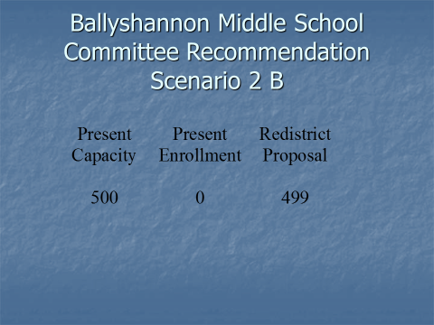

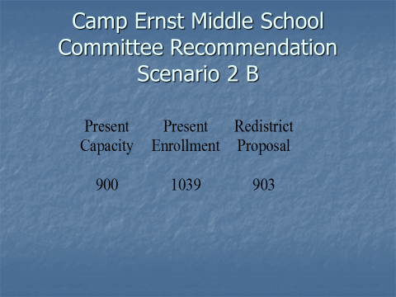

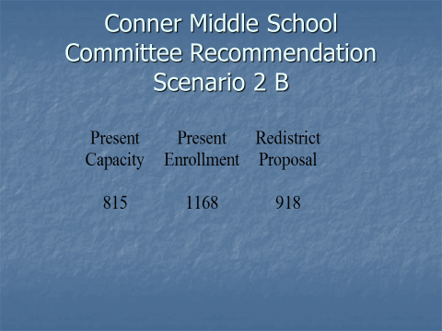

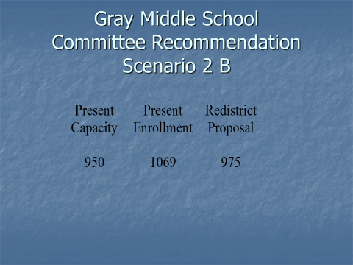

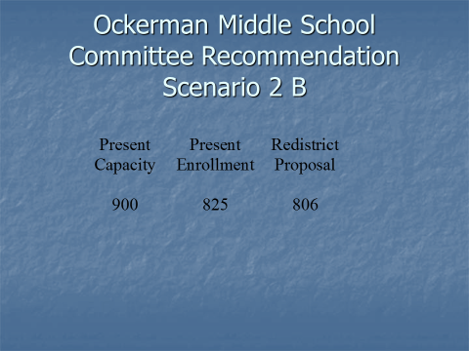

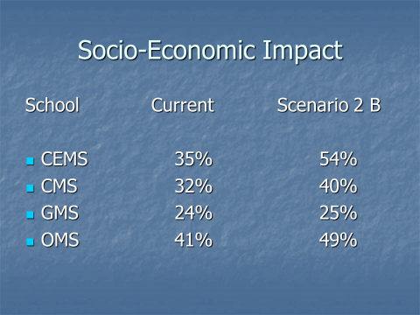

IV. ADJOURN

- A motion was made by Karen Byrd, seconded by Bonnie Rickert, to adjourn the meeting. Ed Massey, Bonnie Rickert, Karen Byrd, Ed Massey and Matt McIntire voted, “aye” MOTION: The motion passed 5-0.

Meeting was adjourned at approximately 7:08 pm

_____________________________________
Ed Massey/Chairperson

_____________________________________
Karen Evans/Secretary

