Regular Meeting Boone County Board of Education
July 21, 2016 7:30 PM
Ralph Rush Professional Development Center
99 Center Street
Florence, Kentucky 41042

I. CALL TO ORDER

The Regular meeting of the Boone County Schools Board of Education July 21, 2016 was called to order by Chairperson Dr. Maria Brown at the Ralph Rush Staff Development Center.
Attendance Taken at 7:30 PM:

Present Board Members:
Dr. Maria Brown
Ms. Karen Byrd
Mr. Ed Massey
Ms. Bonnie Rickert
Mr. Steve Templeton

Clair Parsons attended as Board Attorney
Karen Evans, Board Secretary, recorded the minutes.

II. PLEDGE TO THE FLAG
II.A. The Pledge to the Flag was be led by Chairperson Dr. Maria Brown.

III. GOOD NEWS
III.A. The board recognized Mr. Chad Brady, new Media Systems Coordinator/Webmaster.

IV. AUDIENCE OF CITIZENS
No one spoke

V. RECOMMENDED ACTION - CONSENT AGENDA

Dr. Randy Poe, Superintendent, recommended the board approve the consent agenda items A- MM for board approval, as presented.

- A motion was made by Ed Massey, seconded by, Karen Byrd to approve the consent agenda items A-MM, as presented. Bonnie Rickert disqualified herself from the June 9, 2016 board minutes she was not present. Ed Massey, Steve Templeton, Karen Byrd, Bonnie Rickert and Maria Brown voted, “aye” MOTION: The motion passed 5-0.

V.A. Minutes of the regular board meeting of June 9, 2016
The board approved the minutes of the regular board meeting of June 9, 2016, as presented.
V.B. Bill List
V.C. Treasurer's Report was given by Dr. Randy Poe, Superintendent
V.D. Leaves of Absence
The board approved the following persons submitted leave of absence requests:
Recommended by Principal/Supervisor for approval:
Collier, Teresa, Para-Educator @ New Haven Elem, 8/22/2016 - EOY
Cox, Lindsey, Teacher @ Burlington Elem, 8/15/2016 – 9/23/2016
Ellison, Katie, Speech/Language Pathologist @ North Pointe Elem, 8/22/2016 – 10/31/2016
King, Holly, Teacher @ Ockerman Elem, 8/15/2016 - EOY
O’Connor, Johannah, Teacher @ Collins Elem, 8/30/2016 – 10/6/2016
Roach, Leslie “Erin”, Teacher @ Longbranch Elem, 8/15/2016 – EOY
Skidmore, Jillian, Teacher @ Collins Elem, 9/20/2016 – 10/28/2016

Not Recommended by Principal/Supervisor for approval:
Nothing to Report
Amended Leaves:
Webster, Rose, Custodian @ R.A. Jones Middle, 6/13/2016 – 6/21/2016
Willenborg, Kevin, Custodian @ Boone County High, 5/19/2016 – 6/24/2016
Cancelled Leaves:
Nothing to Report

V.E. Adjustment to Community Education Instructor Hourly Rate
The board approved the adjustment to Community Education Instructor hourly Rate, as presented.
V.F. Northern Kentucky Cooperative for Educational Services Membership for the School Year 2016-2017
The board approved the Northern Kentucky Cooperative for Educational Services Membership for the School Year 2016-2017, as presented.
V.G. Contract with Fiscal Court to Transport Non-Public School Students 16-17
The board approved the Contract with Fiscal Court to Transport Non-Public School Students 16-17, as presented.
V.H. NKY Chamber of Commerce Membership 2016-2017
The board approved the NKY Chamber of Commerce Membership 2016-2017, in the amount of $602.00, as presented.
V.I. KSBA Custom Policy/Procedures Services 2016-2017
The board approved the KSBA Custom Policy/Procedures Services 2016-2017 in the amount of $6055.00, as presented.
V.J. NSBA National Connection Fees 2016-2017
The board approved the NSBA National Connection Fees 2016-2017 in the amount of $8620.00, as presented.
V.K. KSBA Association Membership 2016-2017
The board approved the KSBA Association Membership 2016-2017 in the amount of $8,286.84, as presented.
V.L. Conner High School Portable Classroom Professional Services
The board approved the Conner High School Portable Classroom Professional Services, as presented.
V.M. City of Florence Bus Request
The board approved the City of Florence Bus Request for the Annual Independence Day Celebration, which was pre-approved on June 28th by Dr. Brown, chairperson, due to the timing of the board meeting, as presented.
V.N. BG-1 Application Cooper High School Track Refurbishment
The board approved the BG-1 Application Cooper High School Track Refurbishment, as presented.
V.O. Cooper High School Prom Agreement 2017
The board approved the Cooper High School Prom Agreement 2017, as presented.
V.P. Duke Energy Grant of Easement- Ryle High School
The board approved the Duke Energy Grant of Easement for the installation of electric facilities at Ryle High School - Ryle High School, as presented.
V.Q. Approval of Final Project Closeout-BG-5 Florence Elementary MEP Improvements BG# 14-015
The board approved the Final Project Closeout-BG-5 Florence Elementary MEP Improvements BG# 14-015, as presented.
V.R. Collins Elementary Portable Classroom Professional Services
The board approved the Collins Elementary Portable Classroom Professional Services, as presented.
V.S. School Resource Officer Agreement-Boone County Sheriff's Office
The board approved the School Resource Officer Agreement with the Boone County Sheriff's Office for SRO's for the 2016-2017 school year, as presented.
V.T. BG-1 Application Maintenance Building Renovations
The board approved the BG-1 Application Maintenance Building Renovations, as presented.
V.U. Use of Facilities Contract for YMCA Child Care
The board approved the Use of Facilities Contract for YMCA Child Care for North Pointe Elem. and Thornwilde Elem. for the 2016-2017 School Year, as presented.
V.V. Valuation of Sanitary Sewer Easement-Ryle High School
The board approved the Valuation of Sanitary Sewer Easement in front of Ryle High School , as presented.
V.W. Lease Agreement with the City of Florence for 2016-2017- Location 269 Main Street
The board approved the Lease Agreement with the City of Florence for 2016-2017 at the location of 269 Main Street, Florence, as presented.
V.X. Bidding Documents and BG-3 Ballyshannon Middle School BG #15-279
The board approved the Bidding Documents and BG-3 Ballyshannon Middle School BG #15-279, as presented.
V.Y. Approval of Contract Closeout BG-4 Erpenbeck Elementary Controls Upgrade BG#15-065
The board approved the Approval of Contract Closeout BG-4 Erpenbeck Elementary Controls Upgrade BG#15-065, as presented.
V.Z. Revised BG-1 for Boone County High School MEP Upgrades BG#14-014
The board approved the Revised BG-1 for Boone County High School MEP Upgrades BG#14-014, as presented.
V.AA. BB&T Arena Graduation for Boone County High Schools
The board approved the authorization to proceed into agreement with BB&T Arena Graduation for Boone County High Schools for 2017 and 2018, as presented.
V.BB. Construction Manager At Risk Proposal
The board approved the Construction Manager At Risk Proposal from Kahn Construction, as presented.
V.CC. Dryer and Dishwashers Bid- DLM Enterprises
The board approved the Dryer and Dishwashers Bid award to DLM Enterprises, as presented.
V.DD. Commercial Kitchen Equipment Repair Bid Award
The board approved the Commercial Kitchen Equipment Repair Bid to Service Solutions Group and DLM Enterprises for the period of August 1, 2016 through July 31,2017, as presented.
V.EE. Refrigeration Repair Bid Award
The board approved the Refrigeration Repair Bid award to Koch Refrigeration Company and DLM Enterprises for the period of August 1, 2016 through July 21, 2017, as presented.
V.FF. Touchscreen Monitors Bid for Cafeteria locations
The board approved the Touchscreen Monitors Bid for Cafeteria locations to Pomeroy, as presented.
V.GG. Surplus Equipment
The board approved the disposal of various old equipment and declare surplus, as presented.
V.HH. Surplus Technology
The board approved and declare old technology items for disposal, as presented.
V.II. Replacement Steamer EES Bid
The board approved the replacement of the steamer at Erpenbeck Elementary be awarded to REDI, as presented.
V.JJ. Replacement Kettle Bid Conner Middle School
The board approved the Replacement Kettle Bid Conner Middle School to REDI, as presented.
V.KK. Instructional Time Adjustment for Yealey Elementary School for the 2016-2017 School Year
The board approved the Instructional Time Adjustment for Yealey Elementary School for the 2016-2017 School Year, as presented.
V.LL. Field Trips
The board approved the Field Trips, as presented.

School | Date Of Trip | Location | Reason
Camp Ernst Middle | April 20-22, 2017 | Chicago, IL | Educational
Conner High | November-December, 2016 | TBD | Possible Football Playoffs
Conner High | April 5-9, 2017 | New York | Band Performance/Educational
Conner Middle | March 23-26, 2017 | Washington DC | Educational
Conner Middle | March 3-5, 2017 | Huntsville, AL | Educational
Conner Middle | April 28-30, 2017 | Chicago, IL | Educational
Cooper High | November 10-13, 2016 | Denver, CO | NASC Leadership Conference

V.MM. Textbook Purchase Plans - BHS, RCHS, GMS
The board approved the Textbook Purchase Plans for BHS, RCHS, GMS, as presented.

- Karen Byrd noted the typo on the BB& T Arena consent item AA , it was to be 4600.00, the decimal was missing on the memo. Discussion that all high school graduation will be held at the arena, and as long as the arena will hold the guest, the students will not have the past issue of only 4 or 6 tickets to family to attend. The was not enough funds to include parking, parking will be per car at the arena for the designated graduation.

VI. RECOMMENDED ACTION - OLD BUSINESS
VI.A. No Old Business

VII. RECOMMENDED ACTION - NEW BUSINESS
VII.A. Assistant Director Pupil Personnel Additional Allocation
Dr. Randy Poe, Superintendent, recommended the board approve the Assistant Director Pupil Personnel Additional Allocation, as presented.

- A motion was made by Karen Byrd, seconded by, Ed Massey to approve the Assistant Director Pupil Personnel Additional Allocation, as presented. Ed Massey, Steve Templeton, Karen Byrd, Bonnie Rickert and Maria Brown voted, “aye” MOTION: The motion passed 5-0.

Dr. Poe discussed the growing number of students in the district along with the over 180 discipline hearings, we have just exceeded our capacity in this area to serve.

VII.B. Annual Board Policy Update First Reading
Dr. Randy Poe, Superintendent, recommended the board approve the Annual Board Policy Update First Reading, as presented.

- A motion was made by Steve Templeton, seconded by, Karen Byrd to approve the Annual Board Policy Update First Reading, as presented. Ed Massey, Steve Templeton, Karen Byrd, Bonnie Rickert and Maria Brown voted, “aye” MOTION: The motion passed 5-0.

VIII. SUPERINTENDENT'S REPORT

VIII.A. Barbara Kincaid, Director of Food Services - Wellness Report Card Nutrition and Physical Update 2016.

- Barbara Kincaid, Director of Food Services, reported on the Wellness Report Card Nutrition an Physical Update for 2016, with a power point following. The report gave the board the update on the Community Eligibility Provision, which will provide breakfast and lunch for all students at RA. Jones, Collins Elementary, and Florence Elementary. Mrs. Kincaid, discussed funding and advantages and the continuing programs.

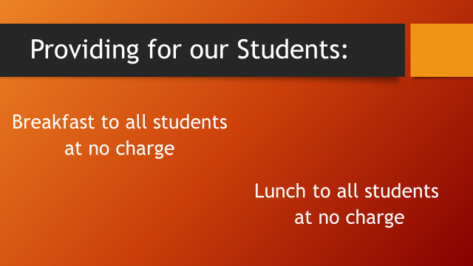

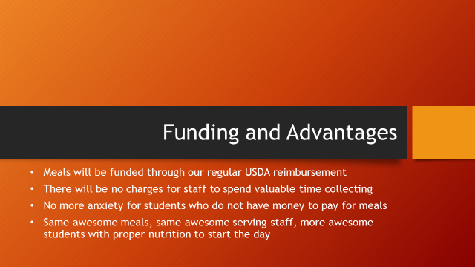

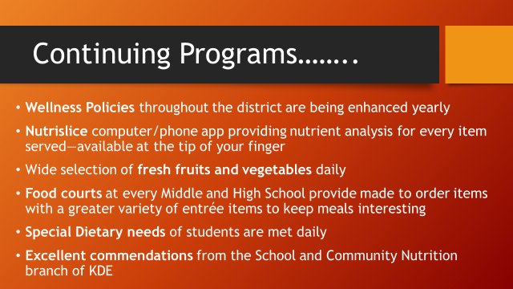

VIII.B. Dr. Randy Poe - Updated the board on the 2016 Boone County Leadership Conference that was held July 19 & 20th. The conference time was devoted to building and aligning the district Strategic Plans for the schools. The principals worked on the individual schools 5 year plan to introduce service based/project learning and incorporate PBL into the classrooms. Administrators attended sessions on World-Class Education, Happiness Advantage work, Our Students’ World lead by Sean Lloyd of Apple, Making a World Class Impact and many more.

IX. INFORMATION, PROPOSALS, COMMUNICATIONS
IX.A. Human Resource Actions
IX.B. Worker's Compensation Claims
IX.C. Overtime Report
IX.D. Construction Status Report
IX.E. Energy Management Report
IX.F. Annual Board Procedures Update

- Dr. Randy Poe announced the Boone County Businessmen Association Golf Outing which will benefited Boone County Schools on August 5th. See the website for more information.
- Ed Massey reported attending the Mental Health Training offered by Boone County District and highly recommended the program to the staff and community.
- Dr. Randy Poe announced his appointment to Vice-President of KASA for 16-17 and appointed the NKU Alumni board to serve for 16-17.
- Bonnie Rickert discussed the new State Program of Early College Program and the benefits to our high school students.
- Dr. Randy Poe congratulated Dr. Maria Brown for accepting her new positions as Associate Professor of Biology at Mt. St. Joseph.

X. AUDIENCE OF CITIZENS

College Education Majors visiting the board introduced themselves: James Miller, NKU and Benjamin Surfaca, University of the Cumberland.

XI. CLOSED EXECUTIVE SESSION PER KRS 61.810 (1)(K)

XI.A. CLOSED EXECUTIVE SESSION PER KRS 61.810 (1)(k)Superintendent Evaluation

- On a motion by Karen Byrd and a second by Bonnie Rickert, the board went into closed session to have a preliminary discussion relating to the evaluation of the superintendent pursuant to KRS 61.810, Section (1)(k), meetings specified by law to be conducted in private which is pursuant to KRS 156.557, Section 4 preliminary discussions of superintendent's evaluation. Ed Massey, Bonnie Rickert, Karen Byrd, Maria Brown and Steve Templeton voted, “aye” MOTION: The motion passed 5-0.

The meeting was adjourned at approximately 8:13 pm.
The board returned from closed executive session at approximately 9:13 pm.

No action was taken in the closed session.

- After a thorough discussion a motion was made by Karen Byrd, seconded by Bonnie Rickert for the board to approve the summative evaluation of the superintendent as Exemplary. Bonnie Rickert, Maria Brown, Karen Byrd and Steve Templeton voted, “aye” MOTION: The motion passed 5-0.

Dr. Poe thanked the board for their continued support and thanked all the administrators. He stated the evaluation rating of Exemplary was for all of the administrators and the hard work they do every day for our students.

XII. ADJOURN

- A motion was made by Karen Byrd, seconded by Steve Templeton, to adjourn the meeting. Ed Massey, Bonnie Rickert, Maria Brown, Karen Byrd and Steve Templeton voted, “aye” MOTION: The motion passed 5-0.

Meeting was adjourned at approximately 9:33 pm

_____________________________________
Maria Brown/Chairperson

_____________________________________
Karen Evans/Secretary

