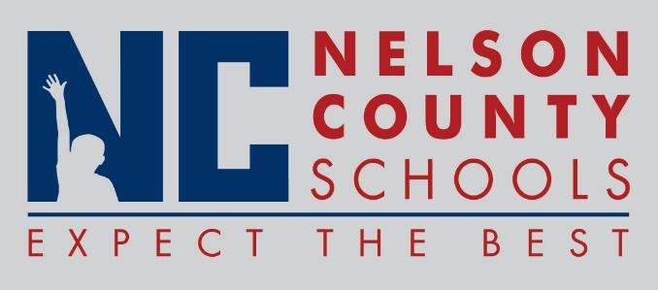

Information Paper
To: | Nelson County Board of Education
From: | Bob Morris Executive Director of Student Support
cc: | Tom Brown
Date: | Feb 20, 2018
Re: | Personnel Notifications

New Hires: Kelsey Young Teacher CCES
Austyn Cheatham Teacher OKH
Jordan Schappacher IA1 FHES
Arvin Lampkin Mech Trans
Pamela Kimball Childcare FHES
Theresa Gentry Bus Mon Trans
Courtney Palmer Cook/Baker OKH
Transfers:

Reinstatements: None

One Year Certification:

Classified Subs: Krystal Carroll, Taylor Skrine, Lori Boblitt, Ashley Glass
Certified Substitute: April Ward, Maggie Argenbright, Danielle Chladek, Amber Crowe, Emily Murphy, Erika Clark, Amanda Ballard
Student Workers:

Non-Renewals: None

Resignation:

Retirements:

Reprimands/Terminations: None

