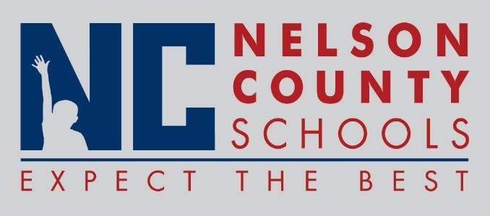

Information Paper
To: | Nelson County Board of Education
From: | Bob Morris Executive Director of Student Support
cc: | Tom Brown
Date: | Jan 16, 2018
Re: | Personnel Notifications

New Hires: Kate Regis Teacher NCHS
Lexus Perry Teacher BES
Lydia Rakes Teacher New Haven
Jordan Schappacher ESS FHES
Arvin Lampkin Mechanic Trans
Krystal Carroll FRYSC Sub CCES
Rene Shannon Teacher NCHS
Transfers:

Reinstatements: None

One Year Certification:

Classified Subs: Stacy Cornish, Felisha Brady
Certified Substitute: Dylan Beasley, Leanna Stough-Allen, Wayne Hayes, April Ward, Maggie Albright, Danielle Chaldek, Emily Murphy, Makenzie Lynch
Student Workers: Chance Mason, Kaitlyn Johnson, Alison Akridge, Regan Marchese.

Non-Renewals: None

Resignation: Kim Miller Teacher NCHS
Gary Dones Driver Trans
Emily Kelly Teacher CCES
Vicky Terstegge ESS Bos
Anthony Orr Director DIS
Mallory Proctor Teacher NH

Retirements: Linda Brown Cook/Baker BES

Reprimands/Terminations: None

