John Hardin SBDM Council
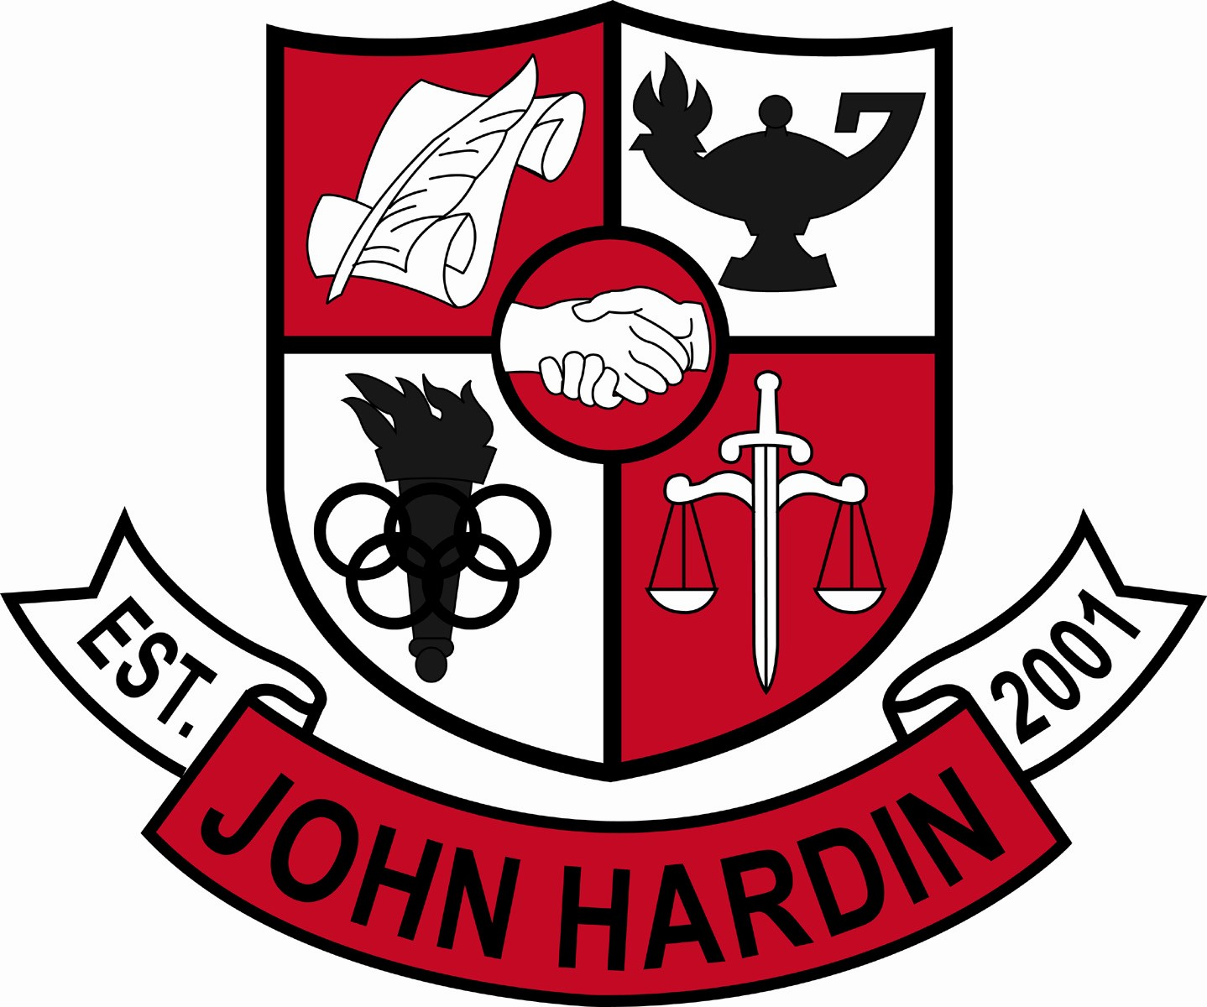
Meeting Minutes

July 9, 2015
4:00 p.m.

- Call to Order at 3:58 p.m.
Members present: Mark Wells, Aurora Selbe, Kelly Smith, Mike Robinson, Jan O’Daniel
Members absent: Alex Shearer
Visitors: Tammy Feiler
- Approval of Agenda ORDER #15-16/0001
The council approved the agenda as written.
Motion: Smith Second: O’Daniel
O’Daniel - Yes
Robinson – Yes
Selbe – Yes
Shearer – Absent
Smith – Yes
Wells - Yes
- Approval of Minutes ORDER #15-16/0002
The council approved the minutes as written.
Motion: O’Daniel Second: Robinson
O’Daniel - Yes
Robinson – Yes
Selbe – Yes
Shearer – Absent
Smith – Yes
Wells - Yes
- Principal’s Update
- Mr. Wells welcomed the new council and introduced himself. He shared his goals for John Hardin –to be an elite Kentucky school; improve relationships and do what’s best for students
- Meeting Dates – the council agreed to keep the meetings on the 2nd Thursday of the month at 4:00 p.m.
- Hiring Procedures – the handbook suggests a council member be involved in the interview process of new hires, but the previous councils have left that up the principal who compiles a committee made up of a second administrator and the department chair, at a minimum
- Minority Elections – Mr. Wells discussed the need for a minority election when Ms. Selbe spoke up to say she was classified as a minority. So the council will remain as is.
- Financial Report ORDER #15-16/0003
The Financial Report for May was reviewed and accepted.
Motion: O’Daniel Second: Robinson
O’Daniel - Yes
Robinson – Yes
Selbe – Yes
Shearer – Absent
Smith – Yes
Wells - Yes
ORDER #15-16/0004
The Financial Report for June was reviewed and accepted.
Motion: O’Daniel Second: Robinson
O’Daniel - Yes
Robinson – Yes
Selbe – Yes
Shearer – Absent
Smith – Yes
Wells - Yes
- PPA Budget for 2015-16 ORDER #15-16/0005
Mr. Wells explained the reduction in funds to the council and discussed possible ways to reduce spending. The council approved the budget as presented.
Motion: Smith Second: Selbe
O’Daniel - Yes
Robinson – Yes
Selbe – Yes
Shearer – Absent
Smith – Yes
Wells - Yes
- Title I Extension Budget ORDER #15-16/0006
The council approved the use of these funds for Homework Help salaries.
Motion: Robinson Second: ODaniel
O’Daniel - Yes
Robinson – Yes
Selbe – Yes
Shearer – Absent
Smith – Yes
Wells - Yes
- Title I Part A Budget ORDER #15-16/0007
The council approved the use of these funds for two teacher salaries, with the remaining balance to be paid from PPA.
Motion: Robinson Second: O’Daniel
O’Daniel - Yes
Robinson – Yes
Selbe – Yes
Shearer – Absent
Smith – Yes
Wells – Yes

- Room Changes ORDER #15-16/0008
The council approved the changes as follows: TVP moved from 408 to 413; using 408 for SpEd collab classroom; using 313 for No Red Ink English Lab along with yearbook; 101 will be used 2nd and 3rd trimester for two blocks a day for Early Childhood Education classes through FCS dept.; and 102 will be used for a reading classroom.
Motion: Robinson Second: O’Daniel
O’Daniel - Yes
Robinson – Yes
Selbe – Yes
Shearer – Absent
Smith – Yes
Wells – Yes
- Art Position – fulltime ORDER #15-16/0009
Additional Extension money was made available to fund a portion of an English position which allowed us to make the art position full-time instead of cutting to halftime. The council approved staffing change.
Motion: Selbe Second: Smith
O’Daniel - Yes
Robinson – Yes
Selbe – Yes
Shearer – Absent
Smith – Yes
Wells - Yes
- Personnel
Hired: Mark Wells as principal; Melissa Field and Caitlyn Hornback for English; Erin Harris for Special Education; Tammy Feiler as Office Manager; Maggie Vogel as Bookkeeper; Derek Bell for Boys Soccer; Jay Coppersmith from .5 to full asst Boys Soccer; Jennifer Cobb as asst Girls Soccer; Dawn Duda as asst Volleyball; Aunna Burford as freshmen Volleyball; Kelly Hobbs as Cheer co-coach; Josh Jaggers as an asst football coach; Dany Pacheco and Chris Hoskinson for custodian postions.
Vacancies: Art teacher; Assistant Principal; Cheer Co-Coach; asst Band Director #3; asst Girls Soccer (portion of head coach stipend)
- Questions and Concerns from Council
- Cheer Coach retention? Anything we can do? There has been a lack of applicants but feel good about the hiring of Kelly Hobbs
- Dress Code inconsistency?? The admin team will be meeting before school starts and that is on the agenda. Looking at ways to improve inforcement
- Absent students getting a “0” as a placeholder? Can it be changed to “Ab” or “missing”? Grade entry consistency is one thing that will discussed with staff on opening day. Monitoring will be done to ensure the consistency.
- What can be done about AP classes to offer more to students? The council voted at the end of the year to give 5 additional points to the final grade for all AP classes.
- Other schools have club meetings during the day, why can’t we? We had that in the past and it was not an effective use of time for the entire student body.
- Can someone set up a table at Open House? They need to come see Mr. Wells and explain the purpose of the table and the decision will be handled on an individual basis

- Agenda Items for Next Meeting
- None discussed
- Adjourn
The meeting was adjourned at 4:55 p.m. The motion was made by Ms. O’Daniel and seconded by Mr. Robinson.

