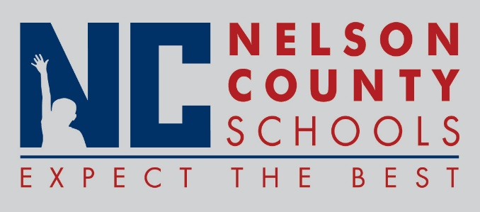

Decision Paper
To: | Nelson County Board of Education
From: | Dr. Anthony Orr, Superintendent
Date: | January 19, 2016
Re: | Leadership Lab Program

The Nelson County Schools will implement a professional learning program referred to herein as the Nelson County Schools Leadership Lab. The goals of the Leadership Lab are:
- Recruit high-quality certified staff
- Improve teacher retention
- Reduce emergency certifications
- Build teacher leadership capacity
- Build instructional leadership capacity
- Improve and stabilize student achievement
- Build momentum for positive district and school culture shifts

RECOMMENDATION: I recommend the Nelson County Board of Education approve the Leadership Lab Program to begin the 2016-17 School Year.

RECOMMENDED MOTION: I move that the Nelson County Board of Education approve the Leadership Lab Program to begin the 2016-17 School Year.

