Regular Meeting Boone County Board of Education
June 9, 2016 7:30 PM
Ralph Rush Professional Development Center
99 Center Street
Florence, Kentucky 41042

I. CALL TO ORDER

The Regular meeting of the Boone County Schools Board of Education June 9, 2016 was called to order by Chairperson Dr. Maria Brown at the Ralph Rush Staff Development Center.
Attendance Taken at 7:30 PM:

Present Board Members:
Dr. Maria Brown
Ms. Karen Byrd
Mr. Ed Massey
Mr. Steve Templeton

Absent Board Members:
Mrs. Bonnie Rickert informed the board she was unable to attend.
Gerry Dusing attended as Board Attorney
Karen Evans, Board Secretary, recorded the minutes.

II. PLEDGE TO THE FLAG
The Pledge to the Flag was led by Dr. Maria Brown, Chairperson

III. GOOD NEWS
III.A. The board recognized the 2016 Early College Student's Recognition recipients:

Bales,Emily N
Bradford,Cora
Brock,Nicholas
Bruce,Nicole Mabel
Courtney,Brianna Nicole
Crupper,Kathryn Anne
Dilts,Kindall Nicole
Ellis,Mitchell Ryan
Fannin,Zachary Kevin
Fellows,Alexis Pia
French,Andrew Preston
Garnett,Wil David
Gott, Ryan
Hall,Jeffrey Carter
Hines,Iann Patrick
Inabnit,Meghan Ann
Keller,Alexandrea Elizabeth
Keller,Arielle Jean
Kemmerer,Jessica Naomi
Mercado,Janisha Lee
Morin,Kennedy Elizabeth
O'Day,Hannah Cora
Owens,Abbey Jean
Padgett,Kyler Dalton
Ryle,Logan Marie
Stillwell,Casey
Taulbee,Megan Lynn
Wagner,Kaitlyn Marie
Winchester,Jayna E

III.B. The board recognized Ms. Regina Egbers recipient of the 2016 KET Innovative Teacher Award.
III.C. The board announced and recognized Jack and Ellen Steele recipients of the 2016 State PTA Teachers of the Year Award. The Steeles were out of town and unable to attend.
III.D. Power of One Video produced by Erpenbeck Elementary.
III.E. The board introduced and recognized the new Transportation Director, Mr. Bob Barrix.

Dr. Poe, introduced Ms. Mary Wilson as the newly appointed BCEA Vice-president.

IV. AUDIENCE OF CITIZENS
A parent asked why the Early College Certificate holders were not recognized at some of their graduation. Dr. Poe explained they should have been recognized and he thought they were, they will in the future and apologized there was not anything at their individual graduations.

V. RECOMMENDED ACTION - CONSENT AGENDA
Dr. Randy Poe, Superintendent, recommended the board approve the consent agenda items A-X for board approval, as presented.

- A motion was made by Karen Byrd, seconded by, Ed Massey to approve the consent agenda items A-X, as presented. Ed Massey, Steve Templeton, Karen Byrd, and Maria Brown voted, “aye” MOTION: The motion passed 4-0.

V.A. Minutes of the regular board meeting of May 12, 2016.
The board approved the minutes of the regular board meeting of May 12, 2016, as presented.
V.B. Bill List
V.C. Treasurer's Report – Report given by Mrs. Linda Schild.
V.D. Leaves of Absence
The following persons submitted leave of absence requests were approved:
Recommended by Principal/Supervisor for approval:
Barth, James, Custodian @ Boone County High, 5/6/2016 – 5/13/2016
Humbert, Bill @ Custodian @ Goodridge Elem, 4/14/2016 – 7/6/2016
Murrey, Kathleen, Café Aide @ Camp Ernst Middle School, 4/21/2016 - EOY
Payne, Steven, Custodian @ Transportation, 4/14/2016 – 4/29/2016
Willenborg, Kevin, Custodian @ Boone County High, 5/19/2016 -6/22/2016
Not Recommended by Principal/Supervisor for approval:
Nothing to Report
Amended Leaves:
Holman, Jessica, Teacher @ Boone County High, 5/3/2016 – 5/27/2016
Porter, Jessica, Secretary @ Maintenance, 10/9/2015 – 6/3/2016
Roach, Erin, Teacher @ Longbranch Elem, 1/4/2016 - EOY
Straub, Terry, Secretary @ Transportation, 4/18/2016 – 5/13/2016
Trella, Caitlin, Speech Pathologist @ Goodridge Elem, 5/11/2016 – 6/27/2016
Winstel, Amy, Teacher @ Ryle High School, 2/23/2016 – 5/27/2016
Cancelled Leaves:
Nothing to Report

V.E. Kentucky Chamber Membership 2016-2017
The board approved the Kentucky Chamber Membership for 2016-2017 for $2025.00, as presented.
V.F. KASA and AASA Membership for 2016-2017
The board approved the KASA and AASA membership for 2016-2017 for Randy Poe in the amount of $1105.14, as presented.
V.G. District Technology Plan for 2016-2017 school year
The board approved the District Technology Plan for 2016-2017 school year, as presented.
V.H. Setting of Board Meeting Dates for 2016-2017
The board approved the Setting of Board Meeting Dates for 2016-2017, as presented.
V.I. Indirect Cost Rates for the 2017 Fiscal Year
The board approved the Indirect Cost Rates for the 2017 Fiscal Year, as presented.
V.J. Modification of Job Descriptions on Contracted Days
The board approved the Modification of Job Descriptions on Contracted Days, as presented.
V.K. Sales Campaign Approval
The board approved the Sales Campaigns, as presented.
V.L. Revised BG-1 for Stephens Elementary Chiller
The board approved the Revised BG-1 for Stephens Elementary Chiller, as presented.
V.M. Design Development, BG-2 and BG-3 Conner Middle School HVAC Phase II BG#16-172
The board approved the Design Development, BG-2 and BG-3 Conner Middle School HVAC Phase II BG#16-172, as presented.
V.N. Stephens Elementary Equipment Maintenance Agreement
The board approved the Stephens Elementary Equipment Maintenance Agreement with Millennium Business Systems, as presented.
V.O. Brake Parts Bid Renewal
The board approved the brake parts bid renewal to various vendors, as presented.
V.P. Filters and Filter Supplies Bid Renewal
The board approved the filters and filter supplies bid renewal to various vendors, as presented.
V.Q. Automotive Fluids Bid Renewal
The board approved the Automotive Fluids bid renewal to Glockner Oil Co, as presented.
V.R. Insurance Policy Renewals
The board approved the insurance policies bid award to Roeding Group for the 2015-2016 fiscal year, as presented.
V.S. Field Trip Request
The board approved the Field Trip Request, as presented.
School | Date Of Trip | Location | Reason
Cooper High School | September 28-October 1, 2016 | Chicago, IL | Educational
Yealey Elementary | April 17-19, 2017 | Townsend, TN | Educational
Camp Ernst Middle School | April 20-23, 2017 | Washington DC | Educational

V.T. Textbook Purchases- Elementary Schools
The board approved the Textbook purchases for Burlington Elem., Florence Elem., Yealey Elem., Longbranch Elem., Thornwilde Elem., Goodridge Elem., New Haven Elem., Kelly Elem., and Burlington Elem., as presented.
V.U. Instructional Time Adjustment for Burlington Elementary School for the 2016-2017 School Year
The board approved the Instructional Time Adjustment for Burlington Elementary School for the 2016-2017 School Year, as presented.
V.V. Revised BG-1 for Conner Middle School-HVAC Upgrades BG#16-087
The board approved the revised BG-1 for Conner Middle School-HVAC Upgrades BG#16-087, as presented.
V.W. School Resource Officer Agreement and BOE 2016-2017
For the board to approve the School Resource Officer and Board of Education 2016-2017 Agreement, as presented.
V.X. Community Education Memorandum of Agreement FY17
For the board to approve the Community Education Memorandum of Agreement FY17, as presented.

VI. RECOMMENDED ACTION - OLD BUSINESS
VI.A. No Old Business

VII. RECOMMENDED ACTION - NEW BUSINESS
VII.A. 2016-2017 and 2017-2018 Salary Schedules
Dr. Poe, Superintendent, recommended the board approve the 2016-2017 and 2017-2018 Salary Schedules, as presented.

2. A motion was made by Ed Massey, seconded by, Steve Templeton to approve the 2016-2017 and 2017-2018 Salary Schedules, as presented. Ed Massey, Steve Templeton, Karen Byrd, and Maria Brown voted, “aye” MOTION: The motion passed 4-0.

VII.B. Extension and Amendment of Superintendent's Contract to June 30, 2020
Dr. Poe, Superintendent, recommended the board approve the Extension and Amendment of Superintendent's Contract to June 30, 2020, as presented.

- A motion was made by Ed Massey, seconded by, Karen Byrd to approve the Extension and Amendment of Superintendent's Contract to June 30, 2020, as presented. Ed Massey, Steve Templeton, Karen Byrd, and Maria Brown voted, “aye” MOTION: The motion passed 4-0.

Dr. Poe thanked the board for and spoke on his appreciation to work with such a tremendous board.

VIII. SUPERINTENDENT'S REPORT

VIII.A. Eric McArtor Update on End of Year/Summer Projects
Eric McArtor, Deputy Superintendent COO, discussed the various summer construction and maintenance projects throughout the district. Mr. McArtor reported on the major construction project at Ryle High School with 12 additional classrooms, addition and enlargement of the cafeteria, which is on target. New Haven Elementary refurbishing project, Conner Middle Schools HVAC project will be completed, New Maintenance building will be done by the end of summer and the road way will be completed in the Fall, Transportation will be getting a new Fuel Tank, Center Street Property project is underway and this will be a new parking lot for Ralph Rush, maintenance has 60+ projects for the summer. Along with the summer projects, there will be 2 mobile units at Ryle to elevate some of the construction interruptions, 2 mobile units at Conner High School due to increased enrollment and one mobile unit will be replaced at Collins Elementary. The sound system at Ralph Rush is scheduled to be upgraded by the end of summer.

VIII.B. Report & Update on EL Students, Growth and Celebrations 2016 by Dr. Geniene Delahunty.
Dr. Delahunty, EL Coordinator, gave a powerpoint presentation and handouts to all the board members on EL Student’s, Growth and Celebrations for the 2015-2016 school year..

Student’s from the EL program, Rrika Nakatsuka from Stephens Elementary, Kaho Ichikawa from Conner Middle School, and Francesca Simm from Cooper High School gave student testimonials to the board on how important the program is to each student. PowerPoint follows:

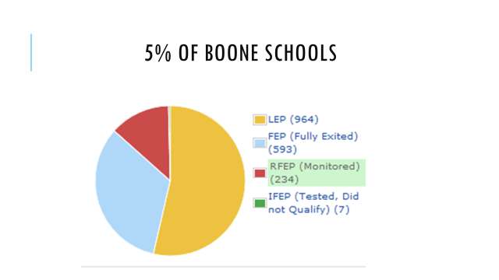

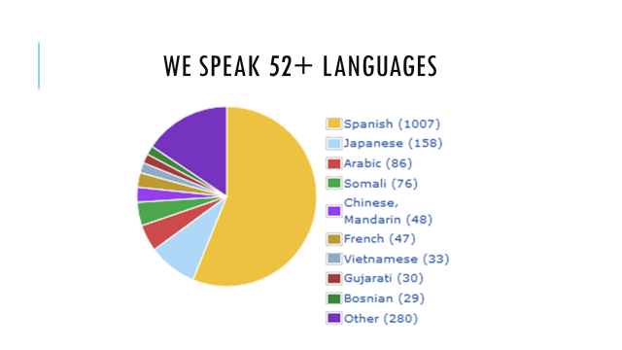

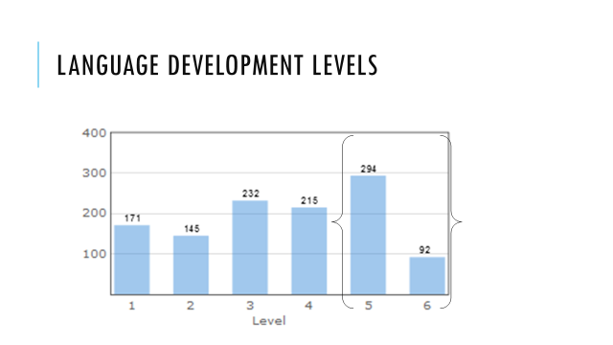
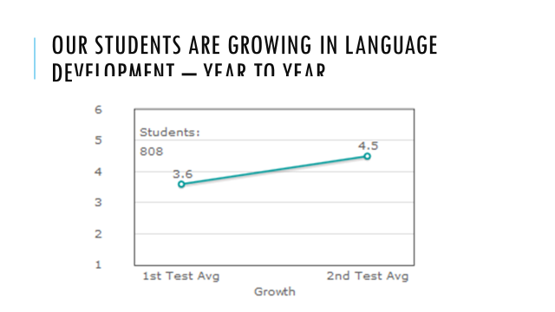
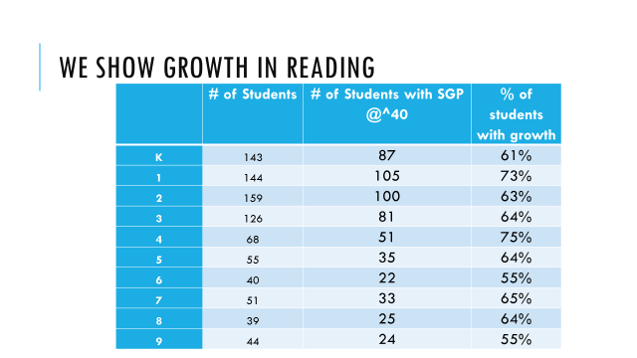

IX. INFORMATION, PROPOSALS, COMMUNICATIONS
IX.A. Human Resource Actions
IX.B. Worker's Compensation Claims
IX.C. Overtime Report
IX.D. Construction Status Report
IX.E. Energy Management Report
IX.F. Copy of Letter Provided to Student/Parent regarding KHEAA and Credit Hours concerning KEES May 2016

- Dr. Karen Cheser, Deputy Superintendent CAO, discussed the details to the board members of the annual Leadership Conference seminars and workshops on global competencies, project based learning with administrative teams and a deeper understanding of the Strategic Plan for the district. The Boone Leadership Conference will be July 19th and 20th and will be held at the Galt House.
- Ed Massey and Karen Byrd will be attending the NSBA Advocacy Conference in Washington, DC on June 10-13th, 2016. Both board members will be educational concerns to Washington and will have a chance to meet with legislatures.
- Dr. Poe reported that he will serve on the Superintendent’s Panel for the International Thought Exchange Festival in Dallas. Dr. Poe was asked and the ITE will be paying the expenses. This Festival panel will be on the work of the Happiness Advantage by Shawn Achor.
- Dr. Brown reported on the upcoming dates for the KSBA Summer Conference, which will be July 7-9, 2016.

AMENDED AGENDA:

Ed Massey recommended the board amend the agenda and add under New Business Item to include the approval of one board member and expenses to attend the KSBA July Conference, as presented.

- A motion was made by Steve Templeton, seconded by Karen Byrd, to amend the agenda and add under New Business Item to include the approval of one board member and expenses to attend the KSBA July Conference, as presented. Ed Massey, Steve Templeton, Karen Byrd, and Maria Brown voted, “aye” MOTION: The motion passed 4 -0.

Ed Massey recommended the board to approve one board member and the expenses to attend the KSBA July Conference, as presented.

- A motion was made by Karen Byrd, seconded by Steve Templeton, to approve one board member and the expenses to attend the KSBA July conference, as presented. Ed Massey, Steve Templeton, Karen Byrd, and Maria Brown voted, “aye” MOTION: The motion passed 4 -0.

X. AUDIENCE OF CITIZENS
No one spoke.

XI. CLOSED EXECUTIVE SESSION PER KRS 61.810
XI.A. No closed session

XII. ADJOURN

- A motion was made by Karen Byrd, seconded by Ed Massey, to adjourn the meeting. Maria Brown, Karen Byrd, Ed Massey and Steve Templeton voted, “aye” MOTION: The motion passed 4-0.

Meeting was adjourned at approximately 8:34 pm

_____________________________________
Dr. Maria Brown/Chairperson

_____________________________________
Karen Evans/Secretary

