John Hardin SBDM Council
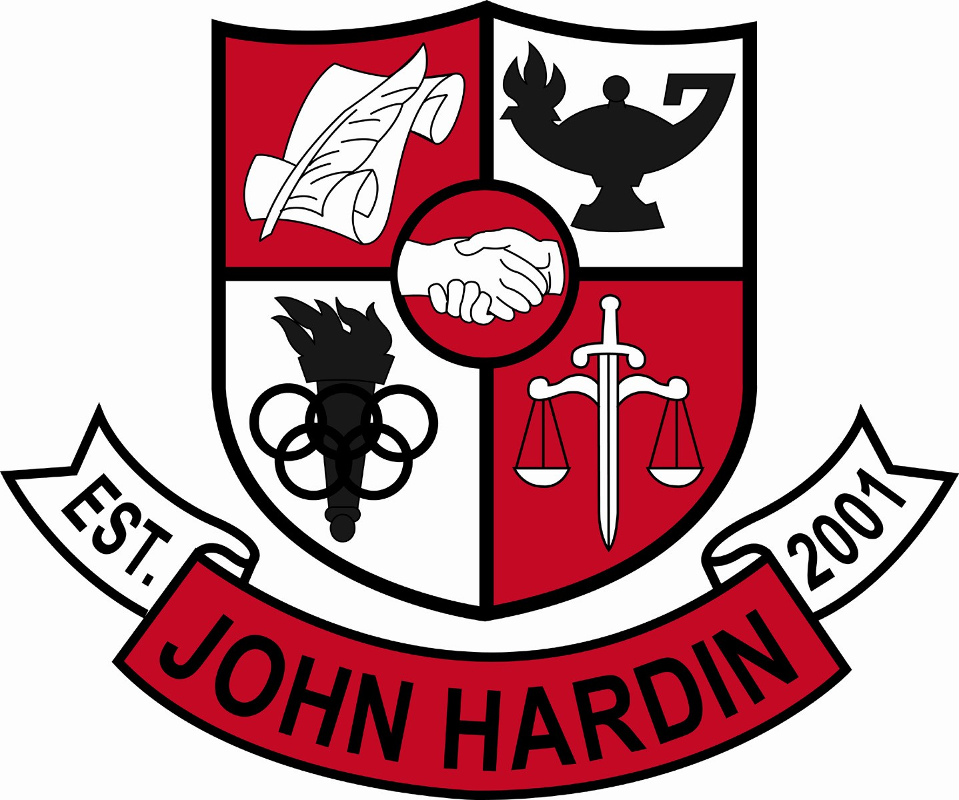
Meeting Minutes

October 13, 2016
4:00 p.m.

- Call to Order at 4:10
Members present: Mark Wells, Alex Shearer, Aurora Selbe, Jan O’Daniel, Kelly Smith, and Michael Moritz.
Visitors: Chris Reed and Maggie Vogel
- Approval of Agenda ORDER #16-17/0019
The council approved the agenda as written.
Motion: Selbe Second: O’Daniel
Selbe – Yes
O’Daniel – Yes
Shearer– Yes
Wells – Yes
Smith - Yes
Moritz – Yes
- Approval of Minutes ORDER #16-17/0020
The council approved the minutes as written.
Motion: Moritz Second: Selbe
O’Daniel – Yes
Selbe– Yes
Wells – Yes
Shearer – Yes
Smith - Yes
Moritz – Yes
- Good News Report –
  - Student Recognition – Kevin Young named as a National Merit Semifinalist.
  - Test Scores – Improved in achievement.
- Public Comment – No comments
- Principal’s Update
  - Junior Practice ACT – A new program, CERT, which parallels the ACT was administered to the junior class using the same procedures as the ACT given in March. Each student will receive individual results with a login enabling them to access explanations to why a question was missed, videos, and additional practice exams.
  - Midterms – Midterms went well. Meetings were held with core departments to analyze data.
  - School Spirit – School spirit has increased this year amongst both students and staff.
  - SBDM Member Requirements Form – Forms must be completed and turned into Ms. Feiler.
  - Test Score Analysis – Meetings will be held to discuss the break down with each department.
  - Social Media Policy – A policy will not be created but guidelines will be added
to the athletic handbook.
  - SBDM Needs List – The Needs List is due earlier this year.
- Financial Report ORDER #16-17/0021
The Financial Report for August was approved as written.
Motion: Shearer Second: O’Daniel
O’Daniel – Yes
Selbe– Yes
Wells – Yes
Shearer – Yes
Smith - Yes
Moritz – Yes
- Financial Report ORDER #16-17/0022
The Financial Report for September was approved as written.
Motion: Smith Second: Selbe
O’Daniel – Yes
Selbe– Yes
Wells – Yes
Shearer – Yes
Smith - Yes
Moritz – Yes
- Personnel
Hired: Kristie Smith for Freshmen Girls Basketball Coach; Dawn Humfleet for Freshmen Volleyball Coach, 50% Stipend; Lakeshia Bell for Boys Cheerleading Coach
Vacancies: Freshmen Volleyball Coach; 50% Stipend; Freshmen Baseball Coach
- New Business
- Agenda Items for Next Meeting
  - PBIS
  - SBDM Needs List
  - Scheduling – New Course Additions/Deletions
- Adjourn
The meeting was adjourned at 4:56 p.m. The motion was made by Mr. Shearer and seconded by Ms. O’Daniel

