Director of District Support Services
Board Report - October 2022
Submitted by Katrina Rechtin

Director of Pupil Personnel

BISD 2020-21 Enrollment Information
(Numbers pulled from Infinite Campus on October 19, 2022)
GES |  | BMS/BHS
Preschool | 53 | 6 | 30
K | 33 | 7 | 41
1 | 46 | 8 | 46
2 | 37 | 9 | 73
3 | 34 | 10 | 64
4 | 34 | 11 | 66
5 | 40 | 12 | 42
Total | 277 | Total | 362
BISD Total Enrollment Preschool - 12th Grade: 639

BISD Attendance
 | GES | BMS/BHS
August (8/17-8/31) | 95.75% | 94.63%
September (9/1 - 9/30) | 95.24% | 91.94%
October (10/1 - 10/19) | 95.23% | 92.18%
August 17th - October 19th | 95.37% | 92.69%

- This school year our district will have an attendance audit with KDE. They have now scheduled our attendance audit for January 2023. The audits are conducted on a five year rotation cycle. I am looking forward to working with KDE to ensure we have the correct practices and procedures in place.
- In collaboration with Mrs. Middleton and building principals, we are establishing clear guidelines for our non-resident enrollment process and specific timelines. We will continue to finalize policies and procedures.
District Assessment Coordinator
- Fall MAP administration is complete in both buildings. Buildings are reviewing data to guide instructional decisions for all students.
- The district assessment calendar can be accessed HERE.
- KSA results are available. We are reviewing results to determine next steps. The results can be found on the School Report Card WEBSITE
- Kindergarten teachers and the GES Building Assessment Coordinator, Sara Teegarden, have completed the Brigance assessment administration. Preliminary results are shown below:
2022 Brigance Kindergarten Screen Data
(Data pulled from Online Management System - State will report final numbers in December)
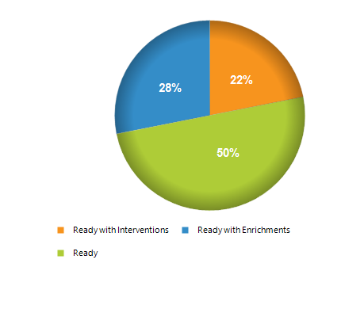
GES Kindergarten Brigance Screener Overall School Percentage (32 Students)
Ready with Enrichments - 28%
Ready - 50%
Ready with Interventions - 22%
Total Readiness Score - 78%

- I will begin to break down our readiness scores by prior learning placement since the assessment window has closed.

Infinite Campus District Coordinator
- Training for Infinite Campus building coaches and attendance clerks is going well and is ongoing.
- The annual update in Infinite Campus will be in place for the 2023-24 school year. We are working now to solidify a process to have all parent portals active and set up before the spring semester.

