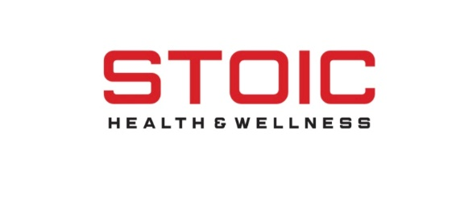
STOIC Health and Wellness
Memorandum of Understanding: 2022-2023
The Collaborative Service Agreement between the staff of STOIC Health and Wellness and Boone County Schools will have the following components:
- The goal is to facilitate the provision of individual counseling, case management, and mentorship to students who are referred by the Boone County School District or its agents and qualify under Medicaid, private insurance and/or fee for service with STOIC Health and Wellness.
- STOIC Health and Wellness’s therapists, case managers, and mentors will provide intake and on-going services to Boone County School District students in a variety of environments (I.e. Alternative to Suspension, After-School Programs, School-based collaboration, Community-based, job-training, etc.).
- STOIC Health and Wellness therapists and staff will be credentialed with their licensure boards and/or maintain appropriate credentials and qualifications per state regulations and provide copies of licenses and evidence of qualifications as requested.
- STOIC Health and Wellness will ensure compliance with all existing federal, state, and local laws and regulations governing the scope of practice of mental health professionals.
- STOIC Health and Wellness will provide a list of therapists and/or other personnel and their role, who will be working with students in the Boone County School District, by the first day of school and updated if changes are made during the term of the agreement.
- STOIC Health and Wellness will comply with state regulations which may include background checks, fingerprinting, child abuse and neglect check, etc as required by the Boone County School District for outside providers working with students in the District.
- STOIC Health and Wellness will primarily provide services at one of their physical locations. Any service overlap in the school setting will be approved by individual schools prior to services being rendered.
- STOIC Health and Wellness will maintain confidentiality according to HIPAA standards.
- During the term of this agreement, the Boone County School District agrees to:
- Identify students for counseling, case management, and mentorship services.
- Collaborate with STOIC Health and Wellness staff on transportation options for the Alternative to Suspension and After-School Programs.
- Comply with FERPA standards.
- Provide a district liaison for questions and concerns from providers.
- The Boone County School District is not responsible for payment for services provided by STOIC Health and Wellness.
- The terms of this agreement are valid for one calendar year. It is contingent on approval from the Boone County Board of Education.

X______________________________________ X____________________________________________
Brett Blevins, CEO Boone County School District Representative
STOIC Health and Wellness

