ENCLOSURE K
July 31, 2023
OLDHAM COUNTY BOARD OF EDUCATION
CONCERN
Consider approval of continuation of substitute teacher pay incentive program.
DISCUSSION
Last year the substitute teacher incentive program was changed as follows:
- Any substitute teacher who worked 10 or more full days during any calendar month received an additional $100 for that month. The pay was reflected in the paystub on the 15th of the following month. The program started in August and ran through May. The program lasted 10 months and had potential earnings of up to $1,000 per substitute for the school year.
- The tracking of days was completed by our Substitute Teacher Coordinator who tracked the days and then provided a list of all eligible substitutes to the payroll department at the end of each month.
RECOMMENDATION
Approve the continuation of the monthly incentive program of paying substitute teachers a $100 for each month they work 10 or more full days during a calendar month. This program will run from August 2023 through May 2024.

On a motion by _______________, seconded by _______________, the Board approved the continuation of the monthly incentive program of paying substitute teachers a $100 for each month they work 10 or more full days during a calendar month. This program will run from August 2023 through May 2024.

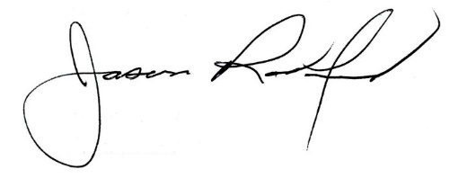
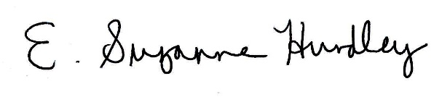

Suzanne Hundley, Board Chair Jason Radford, Superintendent/Secretary

