Dr. Antonia Szymanski
Western Kentucky University
School of Teacher Education
1906 College Heights Blvd.
Bowling Green, KY 42101

January 9, 2020

Dear Western Kentucky University:
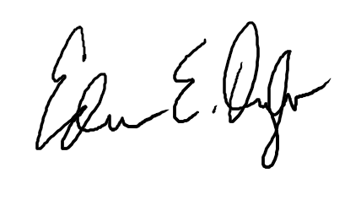
Pending Board approval, as superintendent of Todd County School District, I authorize Dr. Antonia Szymanski to conduct research with the teachers and students of the district as a part of the Spencer Foundation Large Grant project. Her research will include surveys of teachers in the district and may include interviews of teachers and observations of classrooms and meetings. Her research team will also observe, and survey students of teachers involved in the project. If there are any questions, please feel free to contact me for more information.

Edwin Oyler
Superintendent
Todd County School District

