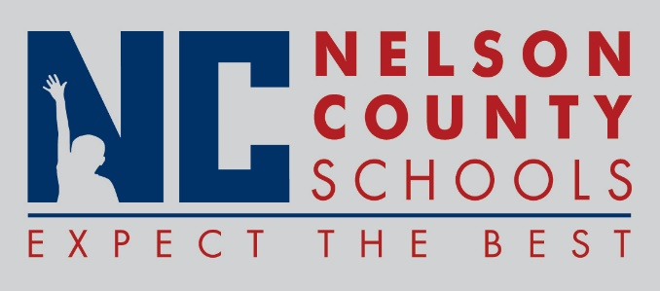

Decision Paper
To: | Nelson County Board of Education
From: | Tim Hockensmith, Chief Operating Officer
cc: | Dr. Anthony Orr, Superintendent
Date: | October 20, 2015
Re: | Drink Vending/Concession Contract 2016-2020

RECOMMENDATION: I recommend the Nelson Co Board of Education approve the contract for drink vending/concessions to Pepsi-Cola effective October 20, 2015 through June 30, 2020.

RECOMMENDED MOTION: I move that the Nelson County Board of Education approve the contract for drink vending/concessions with Pepsi-Cola effective October 20, 2015 through June 30, 2020.

