THIS IS A DECISION PAPER
TO: HARDIN COUNTY BOARD OF EDUCATION
FROM: Teresa Morgan, SUPERINTENDENT
DATE: December 20th, 2018
SUBJECT: APPROVAL CPTED CHECKLIST AND REVISED BOOSTERAGREEMENT FOR THE NHHS INDOOR HITTING FACILITY
FACTS:
The CPTED checklist is required paperwork for KDE. It is a security assessment completed on the building. In addition, KDE required that sheeting and an ADA compliant sidewalk be added to the project which the boosters are agreeing to fund.
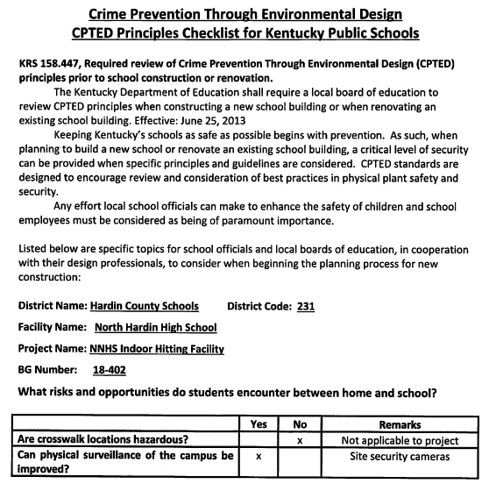
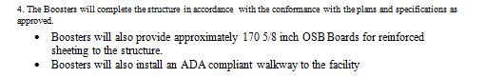
RECOMMENDATION
I RECOMMEND THE BOARD APPROVE THE CPTED CHECK LIST AND REVISED BOOSTER AGREEMENT FOR THE NHHS INDOOR HITTING PROJECT.
RECOMMENDED MOTION
I MOVE THE BOARD APPROVE THE CPTED CHECK LIST AND REVISED BOOSTER AGREEMENT FOR THE NHHS INDOOR HITTING PROJECT.

