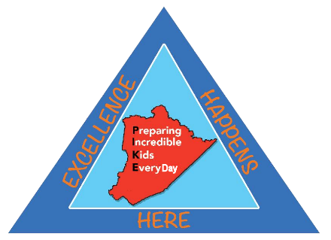
PIKE COUNTY SCHOOL DISTRICT
316 South Mayo Trail Pikeville, KY 41501

CONTRACTUAL AGREEMENT

The Pike County School District hereby enters into a contractual agreement with Pikeville Independent School District for provision of Hearing Impaired services.
The effective dates of the services are August 1, 2017 to June 30, 2018. If there arises a need for review of the terms of this contract prior to June 30, 2018, either school district may request a meeting to be held with at least two weeks’ notice to the other district.
Services to be provided and the respective district responsibilities are listed below:
Pikeville Independent School District shall reimburse Pike County School District the sum of $42.15 per hour for services rendered by the Pike County School District’s Hearing Impaired Teacher, Todd King, to students in the Pikeville Independent School District on an as needed basis, as determined by both parties.
Pikeville Independent School District shall reimburse Pike County School District the sum of $ .40 cents per mile for travel expenses incurred by the Hearing Impaired teacher for travel involved in providing services to students in the Pikeville Independent School District.
Pikeville Independent School District shall provide the Hearing Impaired teacher with student(s) IEP, medical records and other documentation deemed necessary by Pike County School District and its Hearing Impaired teacher to aide in providing adequate services to students in accordance with guidelines of the Kentucky Department of Education, Exceptional Children Services.
Either school district may request that this contract be terminated. If termination is desired, a written notice of termination shall be sent by certified letter to the other school district at least thirty (30) days prior to date of termination.
_______________________ ________________________
Superintendent’s Signature (Superintendent’s Signature)
Pikeville Independent School District Pike County School District

Date: ________________________ Date: ________________________

