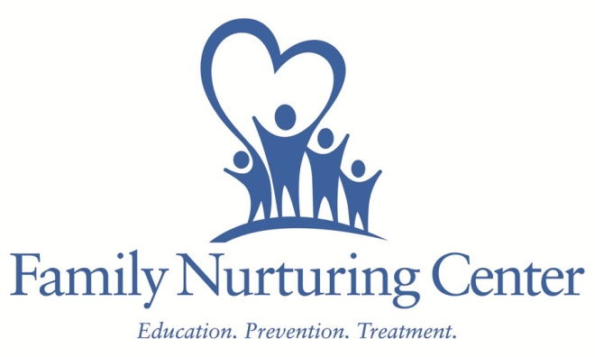
Memorandum of Understanding
Parties: Family Nurturing Center and Boone County Schools
The purpose of this memorandum of understanding is to outline the roles and responsibilities of each party in the provision of on-site Prevention Education Services: Parenting Education, Stewards of Children Training, Kids on the Block Education on Child Abuse/Neglect and Kids on the Block Bullying Prevention Program. Through the generosity of funders including Boone County Fiscal Court, United Way of Greater Cincinnati, Child Victims Trust Fund, Prevent Child Abuse Kentucky and local foundations and donors, the Family Nurturing Center will provide these Prevention Services at no cost to school or the students.
Family Nurturing Center agrees to:
- Provide qualified staff to present parenting education at all Boone County Schools
- Provide authorized facilitators to provide 2 hour training on ways to protect children from child sexual abuse to all adults within the Boone County Schools.
- Provide Kids on the Block education programs on Child Abuse/Neglect and Bullying Prevention at all Boone County Schools.
- Collaborate with school personnel to ensure effective service provision.
- Provide paperwork and program information for relevant parties.
Boone County Schools agree to:
- Provide space on site at designated schools and allow students and/or parents to attend the program.
- Refer parents to parent education programs.
- Collaborate with Family Nurturing Center to ensure effective service provision.
This agreement is effective on date of signature and ongoing, but may be cancelled with 15 days written notice by either party.

Family Nurturing Center Authorized Representative Boone County Schools Authorized Representative

Date Date

